⼯
业 智 能 创 新 时 代
焊锡返修工具
Solder repair tool

Company mission: Redeﬁne Made in China with high-quality products.
Product concept: Keep improving, technological innovation, and pursue excellence.
Service concept: Everything for customers, everything for customers, d all customers.
CMPANY PROFILE
7-77 ESDStatic electricity monitoring system
8-81 Electrostatic tester

Electronic tools seri
8
8
2-85 Electric screw driver
6-89 Screw arranging machine/tin oven

QUALITY
GUARANTEE

Soldering Station
989D
High-eﬃciency constant
temperature soldering station
※
※
※
※
※
※
※
With sensor closed loop, microcomputer zero-trigger temperature control, high power, rapid warming, precise and stable temperature.
With LCD liquid crystal screen temperature and air volume dual display, it is more intuitive and convenient;
With three-channel quick temperature setting, it is convenient to set the temperature;
Air ﬂow rate is adjustable, airﬂow is large and soft, and the temperature is easy to adjust, so it can be used for a variety of purposes;
Automatic cold air function is provided by the system to prolong the life of the heater and protect the hot air gun;
With advanced iron alloy chassis, the body is compact, beautiful and occupies a small area.
Brushless fans are used for extremely long life and low noise.
Standard optional
accessories
LT908D handle
C1321 Plug-in heating core
Speciﬁcation:
Operating voltage
AC220V/50HZ/AC110V/60HZ
Maximum instantaneous power
Above earth resistance of soldering iron
Temperature calibration method
Temperature range
70W
﹤2Ω
9
00 Series soldering iron tip
Digital correction
100~450°C
±2°C
Temperature stability (no load)
Above earth potential of soldering iron
Overall dimensions
﹤ 2mV
L153mm*W121mm*H98mm
Weight
About 1.4Kg

01
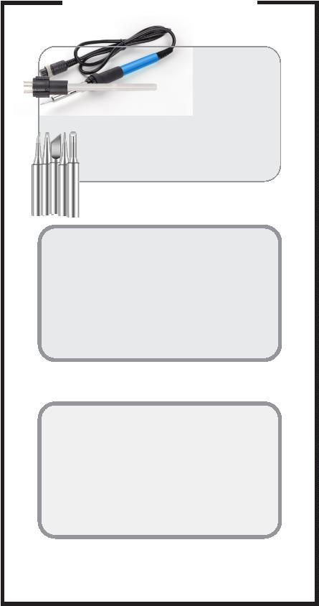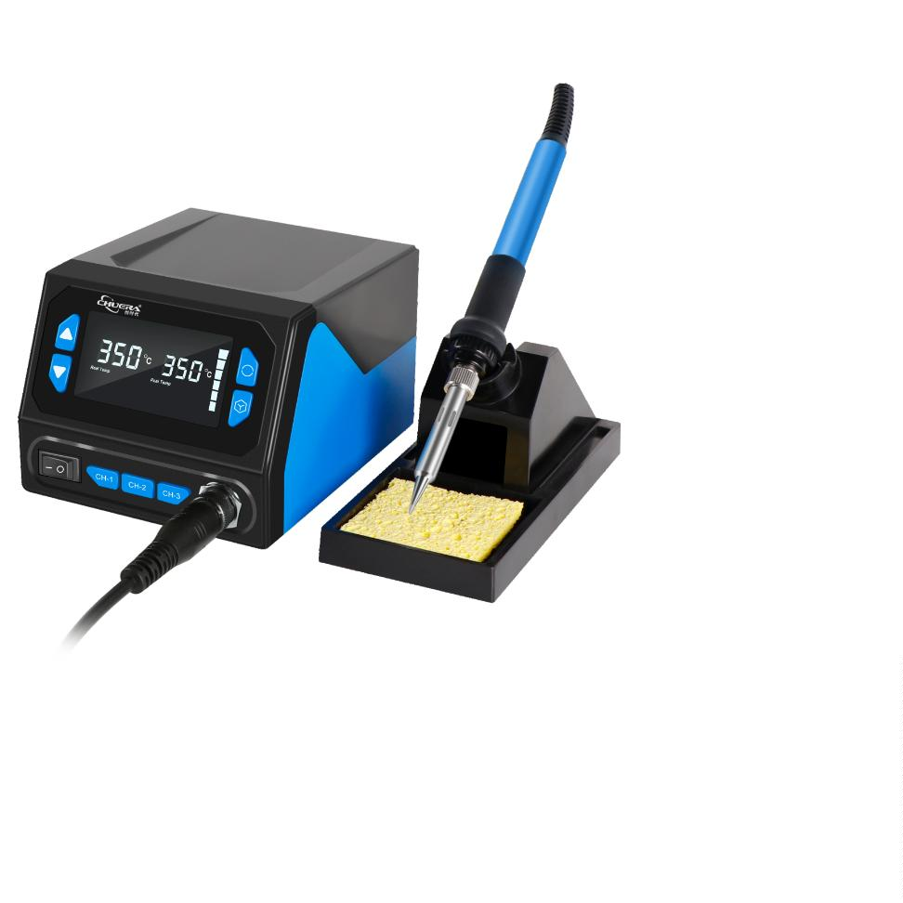

®
Soldering Station
969A
High-eﬃciency constant
temperature soldering station
Features:
※
※
※
※
※
※
※
Rotary temperature control, convenient and fast;
Standard plug-in heating core is easy to replace and maintain;
The handle adopts high-temperature resistant accessories and has a longer service life;
Split design, easy to place, multiple options of soldering tips, easy to replace;
The handle design is lightweight and will not cause fatigue after long-term use;
With CAL temperature calibration hole, the temperature can be calibrated by itself;
Two temperature scales, Celsius/Fahrenheit, are easy to use.
Speciﬁcation:
Operating Voltage:
AC220V/50HZ
200~480℃
≤5W
75W
±2℃
﹤2Ω
﹤2 mV
Potentiometer calibration
L141×W112×H86mm
1.8Kg
Operating temperature range:
No-load standby power:
Maximum instantaneous power:
Temperature stability (no load):
Soldering iron resistance to ground:
Soldering iron potential to ground:
Temperature correction method:
Dimensions:
Optional accessories:
Weight:
Packing size:
Carton size:
Packing speciﬁcations:
265*205*118mm
555×425×375mm
12 sets/carton
LT909A handle
C1321 900 Series
Plug-in heating core soldering iron tip
969D
High-eﬃciency constant
temperature soldering station
Features:
※
※
The temperature is increased or decreased by ±1℃ by using the trinity digital display;
The sleep function is equipped as standard, and it enters the sleep standby state after
0 minutes of non-use;
2
※
※
※
The handle is made of high-temperature resistant ﬁttings for longer service life;
Temperature calibration is performed by keying in the correction value;
With a split design, placement is easy, a variety of soldering iron tips can be selected,
and replacement is easy.
Celsius / Fahrenheit can be freely switched and sleep can be turned on or oﬀ;
※
Speciﬁcations:
Operating Voltage:
AC220V/50HZ
200~480℃
≤5W
75W
±2℃
﹤2Ω
﹤2 mV
Digital correction
L141×W112×H86mm
2Kg
Operating temperature range:
No-load standby power:
Maximum instantaneous power:
Temperature stability (no load):
Soldering iron resistance to ground:
Soldering iron potential to ground:
Temperature correction method:
Dimensions:
Optional accessories:
Weight:
Packing size:
Carton size:
Packing speciﬁcations:
265*205*118mm
555×425×375mm
12 sets/carton
LT909D handle
C1321
900 Series
Plug-in heating core soldering iron tip
0
2

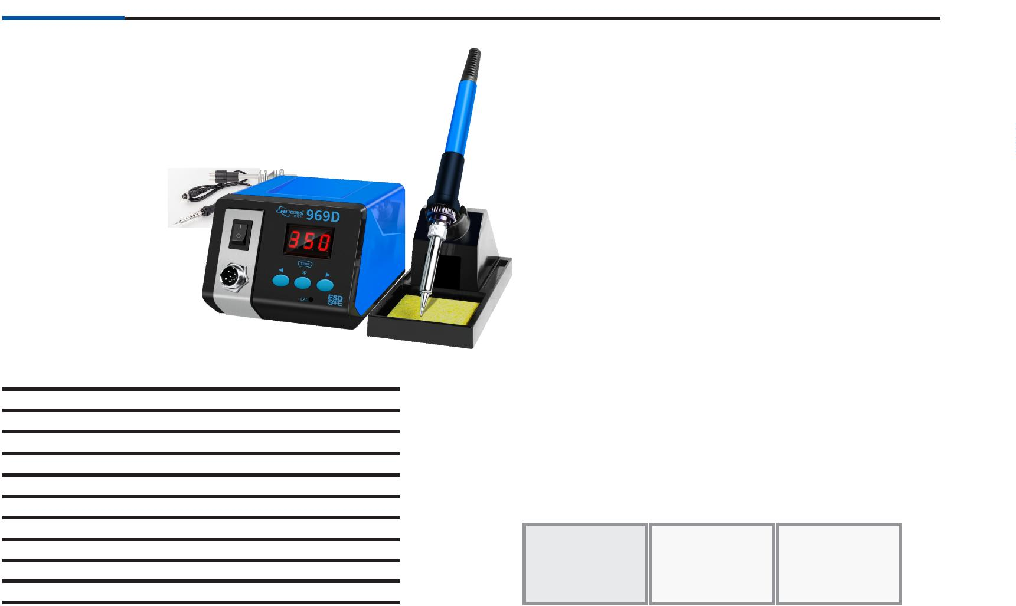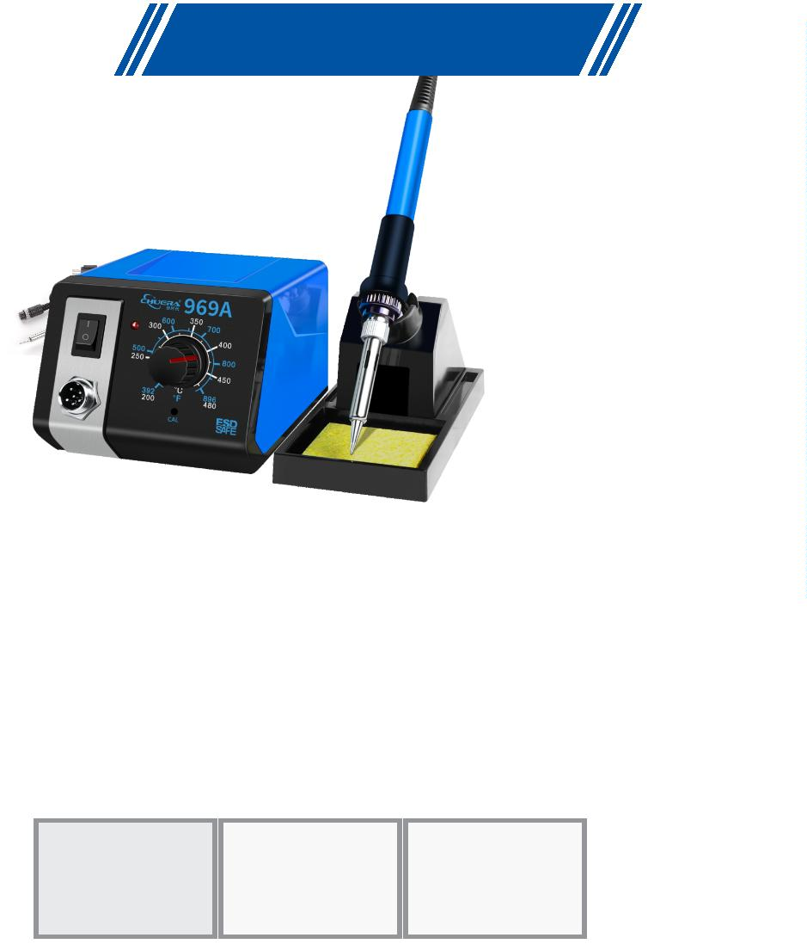

®
Soldering Station
951
Lead-free constant
temperature soldering station
Features:
※With the integrated design of the heating core soldering iron tip, it is faster to heat up, faster
to return to the temperature, and more accurate;
※
Plug-and-play soldering iron tip is easy to replace, and can accurately sense the
temperature change of the soldering joint;
※
※
※
The temperature is increased or decreased by ±1℃ by using the trinity digital display;
With digital calibration temperature, the operation is easy;
The sleep function is equipped as standard, \ to extend the service life of the heating core
welding nozzle;
※Celsius / Fahrenheit can be freely switched;
※Particularly suitable for lead-free soldering, ESD design.
Speciﬁcations:
Operating voltage:
Temperature range:
AC220V/50HZ AC110V/60HZ
0~550℃（Adjustible）
5
7
2
±
5W
4V
2℃
Maximum power of the whole machine:
Heating element working voltage:
Temperature stability (no load):
Soldering iron resistance to ground:
Soldering iron potential to ground:
Temperature correction method:
Optional accessories:
﹤
﹤
2Ω
2
mV
Digital correction
Soldering iron heating component:Electromagnetic induction plug-in
L141×W112×H86mm
Dimensions:
Weight:
Package size:
Carton size:
Packing speciﬁcations:
T12 handle
T12 Series
soldering iron tip
2
2
5
1
Kg
65×205×118mm
55×425×375mm
2 sets/carton
T12
Lead-free constant
temperature soldering station
Features:
※The heating core and soldering iron head are designed in an integrated manner,
which can heat up quickly and return to temperature more accurately;
※The soldering iron tip is pluggable and easy to replace, and can accurately sense the
temperature changes of the solder joints;
※
※
※
※
※
※
LCD display, dual digital display of real-time temperature and set temperature;
5 storage temperature memory modes, one-button switching;
Digital calibration temperature, easy to operate;
Sleep time and shutdown time can be set;
Celsius and Fahrenheit can be switched by yourself;
Especially suitable for lead-free soldering and ESD design.
Speciﬁcations:
Operating voltage:
Temperature range:
AC220V/50HZ AC110V/60HZ
50~550℃（Adjustible）
Maximum power of the whole machine: 75W
Heating element working voltage:
Temperature stability (no load):
Soldering iron resistance to ground:
Soldering iron potential to ground:
24V
±2℃
﹤2Ω
﹤2 mV
Optional accessories:
Temperature correction method: Button type (memory & storage )
Soldering iron heating component:Electromagnetic induction plug-in
Dimensions:
Weight:
L130*W90*H40mm
0.8Kg
T12 handle
T12 Series
soldering iron tip
Package size:
Carton size:
Packing speciﬁcations:
207×132×128mm
430×415×410mm
18 sets/carton

03
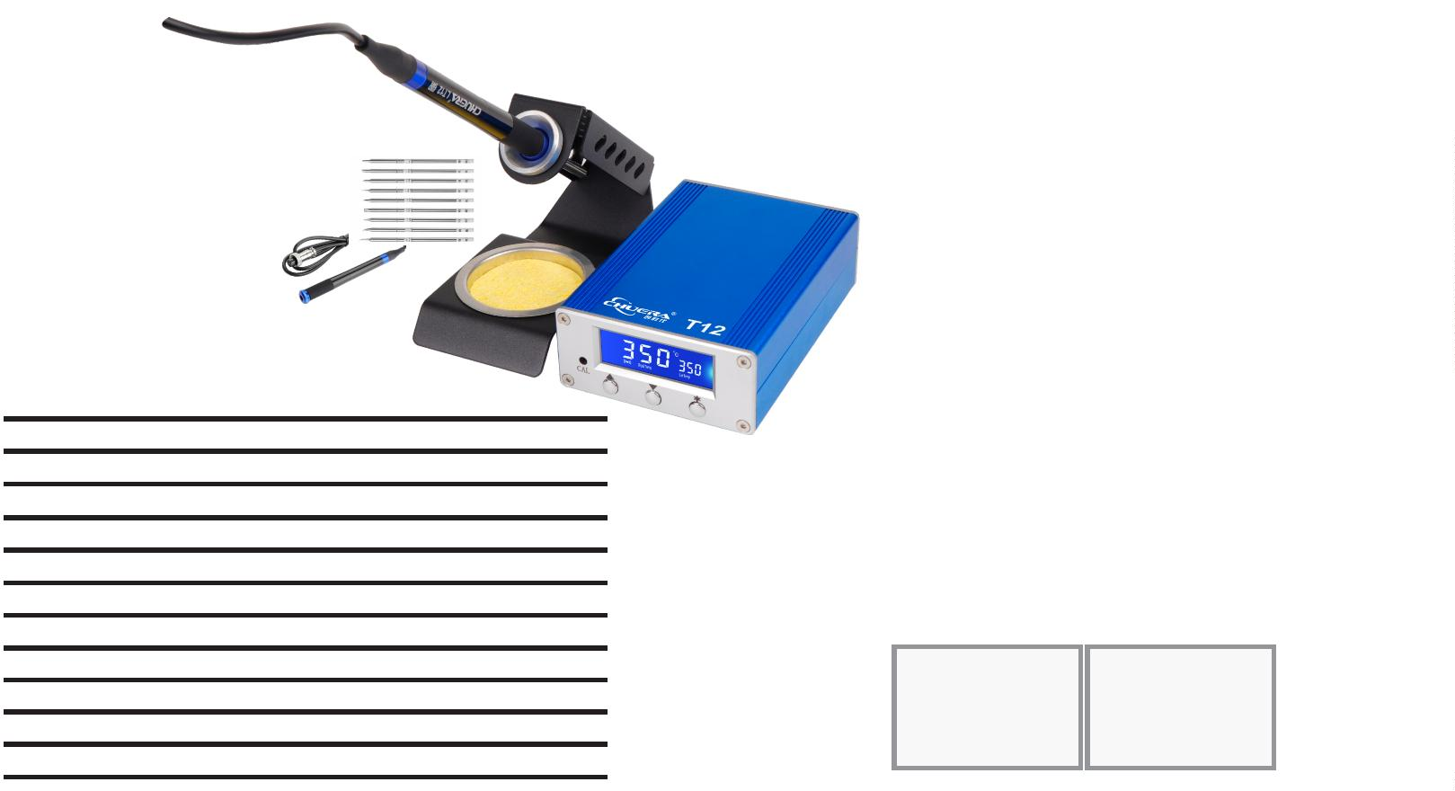

®
Soldering Station
203H
High-frequency eddy current
lead-free soldering station
Features:
※High-frequency eddy current heating, fast heating and temperature
recovery, enabling lead-free welding;
※
Sensor front design, accurate temperature control and rapid
temperature recovery;
※Microcomputer control, with automatic sleep function to save energy;
※
Password temperature lock function effectively protects the production
process;
※
Push-button temperature adjustment, digital temperature calibration,
simple and convenient operation.
Speciﬁcations:
Operating voltage:
Operating temperature range:
Maximum instantaneous power:
Temperature stability (no load):
AC220V/50HZ
50~600℃
90W
Optional accessories:
Soldering iron resistance to ground: ±2℃
Soldering iron potential to ground:
Temperature correction method:
Dimensions:
Weight:
Package size:
﹤2Ω
﹤2mV
Digital correction
L150×W130×H100mm
About 3.23Kg
240×230×130cm
505×490×280mm
LT 202 handle
VH 90 heating core
200 Series
soldering iron tip
Carton size:
Packing speciﬁcations:
8
sets/carton
205
High-power lead-free soldering station
Features:
※
High-frequency eddy current heating, fast heating and temperature
recovery, enabling lead-free welding;
※
Microcomputer control, push-button temperature adjustment, digital
temperature calibration, and equipped with automatic sleep and
automatic shutdown functions;
※
※
※
150W high-power design, the maximum conventional soldering iron tip
can be used first is 8mm;
Password temperature lock function effectively protects the production
process;
Heating core plug-in design makes maintenance more convenient.
Speciﬁcations:
Operating voltage:
AC220V/50HZ
50~600℃
150W
±2℃
﹤2Ω
Operating temperature range:
Maximum instantaneous power:
Temperature stability (no load):
Soldering iron resistance to ground:
Soldering iron potential to ground:
Temperature correction method:
Dimensions:
Optional accessories:
﹤2mV
Digital correction
L195×W130×H100mm
4.66Kg
Weight:
LT 301 handle
150W Plug-in
heating core
500 Series
soldering iron tip
Package size:
Carton size:
Packing speciﬁcations:
300×285×145mm
595×320×460mm
6 sets/carton
0
4

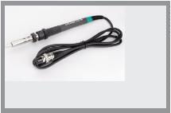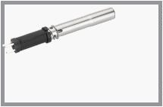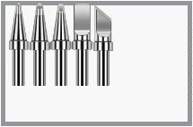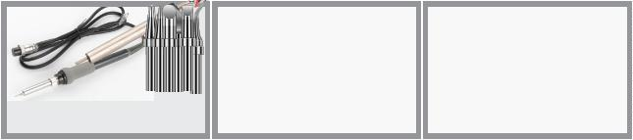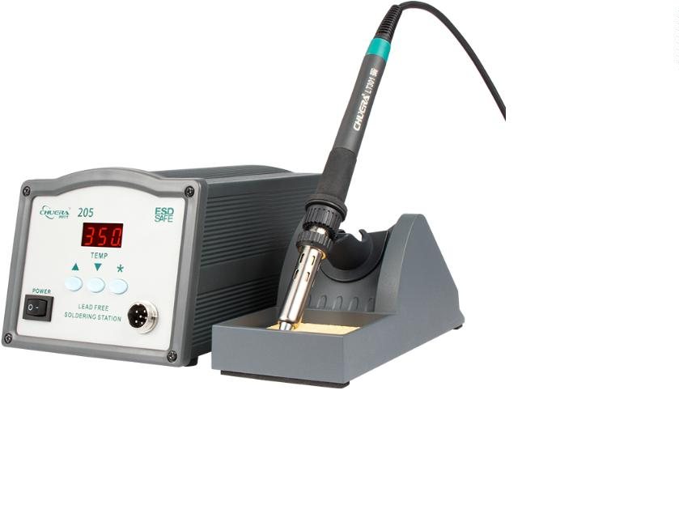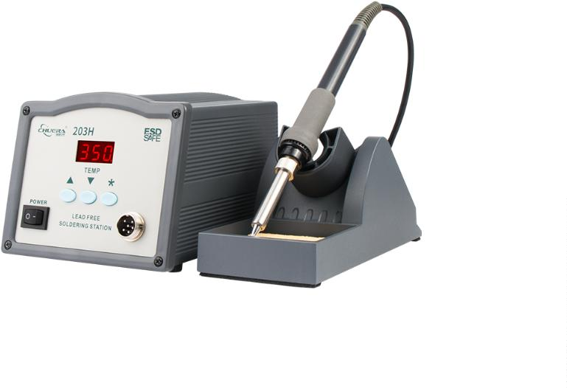

®
Soldering Station
309D
Intelligent digital display lead-
free soldering station
Features:
※Plug-in heating core saves time and eﬀort and is more convenient to replace
※
Sensor front design, accurate temperature control and rapid temperature
recovery;
※
Dual temperature digital display of real-time temperature and set
temperature;
※
※
※
※
※
Has automatic sleep function to save energy;
Digital temperature calibration, simple and convenient operation;
Temperature locking function ensures the welding process;
Extra-large LCD screen, working status is clear at a glance;
Intelligent temperature alarm, ultra-high or ultra-low buzzer reminder
function.
Speciﬁcations:
Operating voltage:
AC220V/50HZ
50~550℃
90W
±2℃
﹤2Ω
Operating temperature range:
Maximum instantaneous power:
Temperature stability (no load):
Soldering iron resistance to ground:
Soldering iron potential to ground:
Temperature correction method:
Dimensions:
Weight:
Package size:
Carton size:
Packing speciﬁcations:
Optional accessories:
﹤2 mV
Digital correction
L195×W130×H100mm
About 3.42Kg
240×230×130mm
505×490×280mm
8 sets/carton
LT 309 handle
CH 90 heating core
200 Series
soldering iron tip
315D
High-power intelligent lead-
free soldering station
Features:
※
High-frequency eddy current heating, fast heating and temperature recovery,
enabling lead-free welding;
※
Microcomputer control, push-button temperature adjustment, digital
temperature calibration, and automatic sleep and automatic shutdown
functions;
※
※
※
※
Dual temperature digital display on the LCD screen, self-set upper and lower
temperature alarm ranges, alarm when exceeding the process range;
The maximum power can reach 150W, and the conventional soldering iron tip
can be up to 10mm;
Password temperature lock function eﬀectively protects the production
process;
Heating core plug-in design makes maintenance more convenient.
Speciﬁcations:
Operating voltage:
AC220V/50HZ
50~550℃
150W
±2℃
﹤2Ω
﹤2 mV
Digital correction
L195×W130×H100mm
Operating temperature range:
Maximum instantaneous power:
Temperature stability (no load):
Soldering iron resistance to ground:
Soldering iron potential to ground:
Temperature correction method:
Dimensions:
Optional accessories:
Weight:
About 4.64Kg
Package size:
Carton size:
Packing speciﬁcations:

300×285×145mm
595×320×460mm
6 sets/carton
LT 305 handle
VH 150 heating core
500 Series
soldering iron tip
05
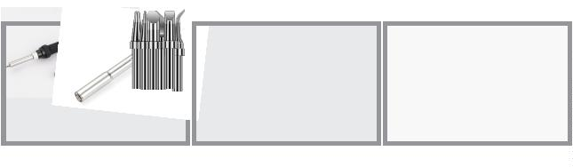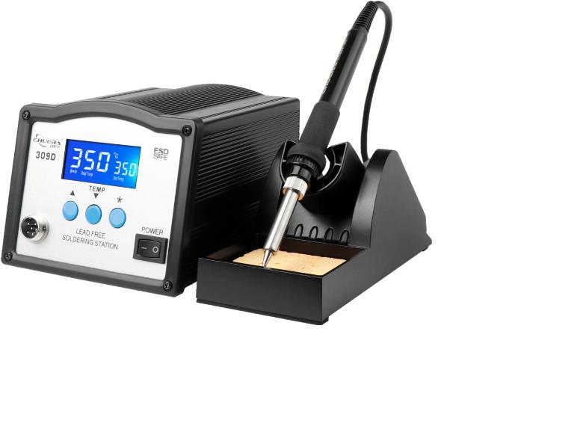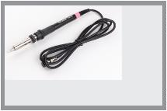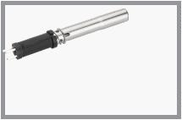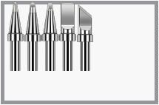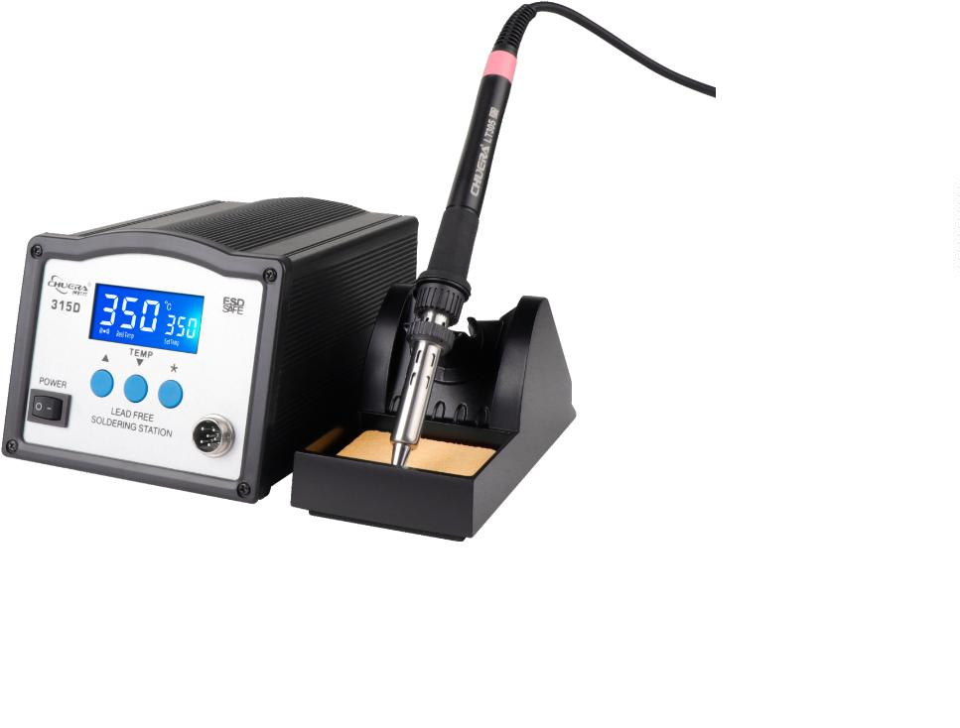

®
Soldering Station
316D
High-power intelligent lead-
free soldering station
Features:
※
High-frequency eddy current heating, fast heating and temperature recovery,
enabling lead-free welding;
※
Microcomputer control, push-button temperature adjustment, digital
temperature calibration, and automatic sleep and automatic shutdown
functions;
※
※
※
※
Dual temperature digital display on the LCD screen, self-set upper and lower
temperature alarm ranges, alarm when exceeding the process range;
The maximum power can reach 320W, and the conventional soldering iron tip
can be up to 10mm;
Password temperature lock function eﬀectively protects the production
process;
Heating core plug-in design makes maintenance more convenient.
Speciﬁcations:
Operating voltage:
AC220V/50HZ
50~550℃
320W
±2℃
﹤2Ω
Operating temperature range:
Maximum instantaneous power:
Temperature stability (no load):
Soldering iron resistance to ground:
Soldering iron potential to ground:
Temperature correction method:
Dimensions:
Weight:
Package size:
Carton size:
Packing speciﬁcations:
Optional accessories:
﹤2 mV
Digital correction
L235×W115×H160mm
About 3.59Kg
320×260×220mm
565×345×600mm
4 sets/carton
LT 306
handle
VH 320 Plug-in
heating core
501 Series
soldering iron tip
206D
High-power intelligent lead-
free soldering station
Features:
※
High-frequency eddy current heating, fast heating and temperature recovery,
enabling lead-free welding;
※
Microcomputer control, push-button temperature adjustment, digital
temperature calibration, and automatic sleep and automatic shutdown
functions;
※
※
※
※
Dual temperature digital display on the LCD screen, self-set upper and lower
temperature alarm ranges, alarm when exceeding the process range;
The maximum power can reach 260W, and the conventional soldering iron tip
can be up to 10mm;
Password temperature lock function eﬀectively protects the production
process;
Heating core plug-in design makes maintenance more convenient.
Speciﬁcations:
Operating voltage:
AC220V/50HZ
50~550℃
260W
±2℃
﹤2Ω
Operating temperature range:
Maximum instantaneous power:
Temperature stability (no load):
Soldering iron resistance to ground:
Soldering iron potential to ground:
Temperature correction method:
Dimensions:
Weight:
Package size:
Carton size:
Packing speciﬁcations:
Optional accessories:
﹤2mV
Digital correction
L200×W130×H100mm
About 4.64Kg
300×285×145mm
595×320×460mm
6 sets/carton
LT 206 handle VH200C heating core
500 Series
soldering iron tip
0
6

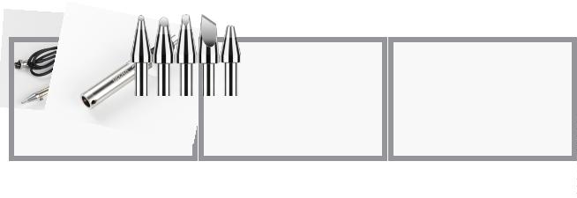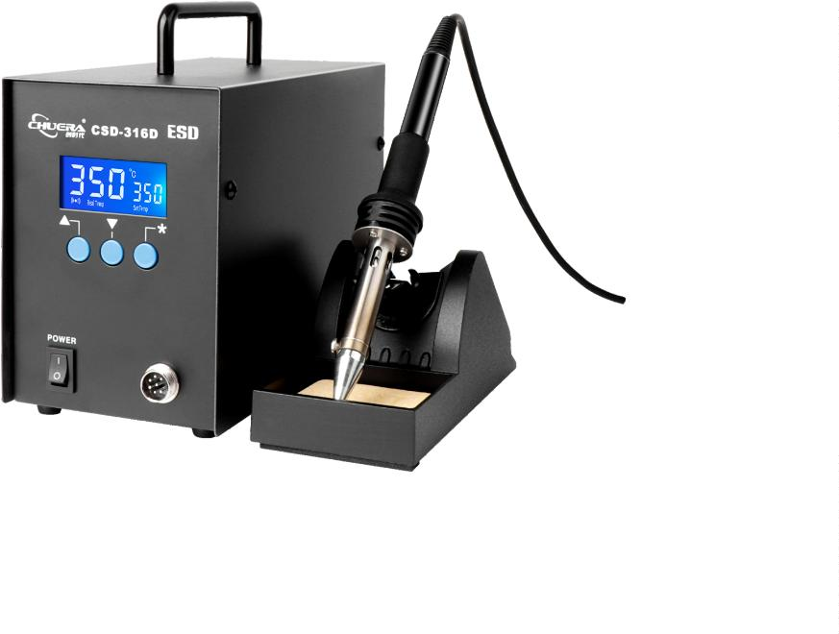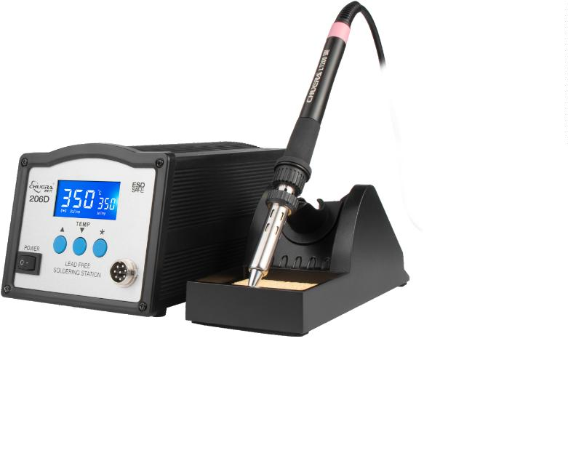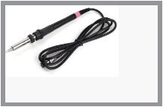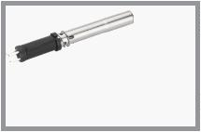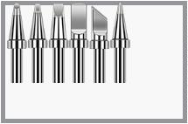

®
Automatically send tin
375A+/375B+
/
375C+/375D+
3
75A+Foot steps out of tin
Lead-free automatic
soldering station
Features:
※
With ceramic plug-and-play heating core, replacement is convenient and maintenance is simple;
※
Automatic and manual tin feeding modes can be selected, and the number of tin discharges can be
set;
※
※
※
Tin discharge speed, tin discharge length and tin discharge time are all adjustable;
An adjustable tin recovery function is provided to minimize the waste of tin soldering;
With electrostatic prevention design, it can prevent sensitive electronic parts from being damaged
by static electricity;
※
※
It can be used separately as a lead-free soldering station, and can be equipped with a pedal switch
or a manual tin discharge switch to make soldering ﬂexible and convenient;
For the soldering iron heaters, ceramic heaters are used. RTD sensor is used to control the
temperature, the heating speed is very fast and the temperature is stable. The heating voltage is
2
4V, which is safe and reliable, and it is easy to use with a variety of long-life soldering tips;
Speciﬁcations:
3
75B+Foot steps out of tin
Operating voltage:
Temperature range:
AC220V/50HZ AC110V/60HZ
200~480℃
Maximum power of the whole machine: 75W
Heating element working voltage:
Temperature stability (no load):
24V
±2℃
Soldering iron resistance to ground: ﹤2Ω
Soldering iron potential to ground:
Temperature adjustment:
Motor:
﹤2 mV
Knob type
Stepper motor
Tin output speed:
Tin output:
Tin out interval time:
Return time:
Tin out mode:
Tin wire diameter:
Weight:
About 2.7mm/s~27mm/s(36°/s~360°/s)
0~150mm
0~2.7s
0~0.9s(about 0~25mm ﬁxed velocity:360°/s)
Automatic(1~9)/manual(0)
0.5 / 0.6 / 0.8 / 1.0/ 1.2/ 1.4/ 1.6mm
About 3.32Kg
3
75C+Hand press out tin
Package size:
Carton size:
280×230×190mm
575×480×400mm
Packing speciﬁcations:
8 sets/carton
Optional accessories:
LT907C handle
C1321 Plug-in heating core 900 Series soldering iron tip
CSD-373-1
Automatic tin outlet tube
CSD-373-2
Automatic tin outlet tube
CSD-373-3
Universal tin outlet tube
3
75D+Use foot pedal or Hand press out tin
CSD-375-1
Foot switch
Optional manual tin removal, accessories: manual tin removal guide CSD-373-2

07
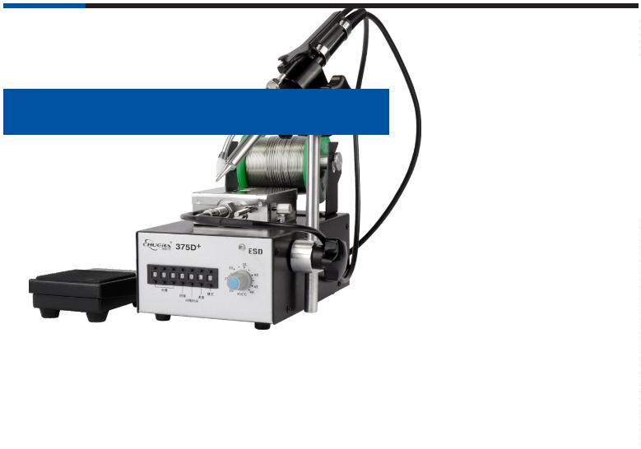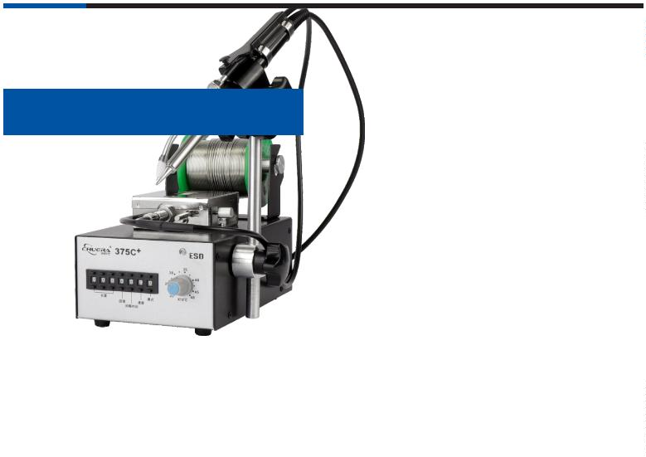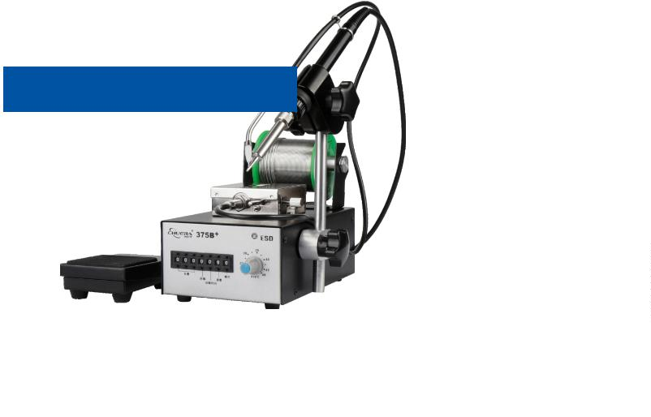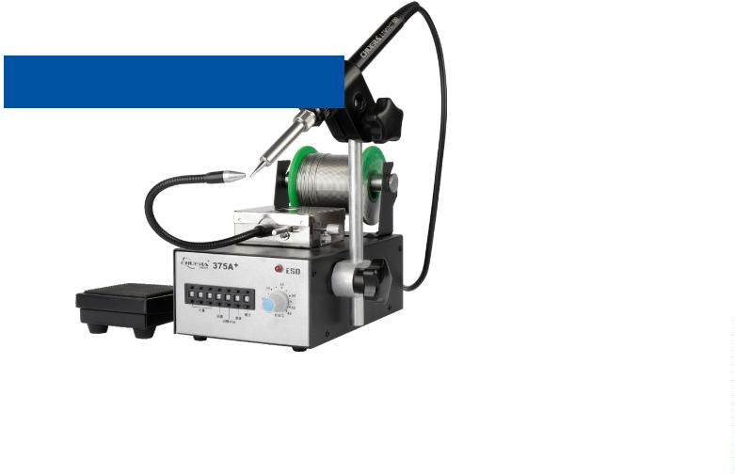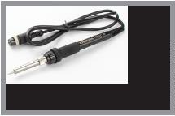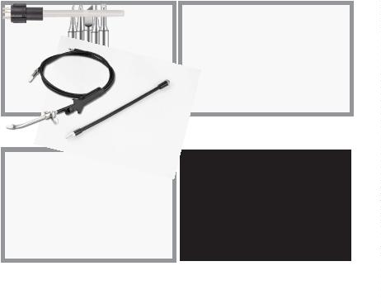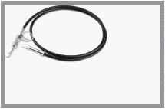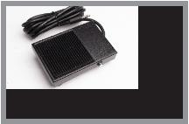

®
Automatically send tin
385A+/385B+
/
385C+/385D+
3
85A+Foot steps out of tin
Lead-free automatic
soldering station
Features:
※The LCD display temperature adjustment is more accurate and the tin delivery setting is more convenient;
※
※
※
※
With ceramic plug-and-play heating core, replacement is convenient and maintenance is simple;
Automatic and manual tin feeding modes can be selected, and the number of tin discharges can be set;
Tin discharge speed, tin discharge length and tin discharge time are all adjustable;
An adjustable tin recovery function is provided to minimize the waste of tin soldering;
※Password-type temperature lock function eﬀectively protects the production process;
※
※
※
With electrostatic prevention design, it can prevent sensitive electronic parts from being damaged by static
electricity;
It can be used separately as a lead-free soldering station, and can be equipped with a pedal switch or a manual
tin discharge switch to make soldering ﬂexible and convenient;
For the soldering iron heaters, ceramic heaters are used. RTD sensor is used to control the temperature, the
heating speed is very fast and the temperature is stable. The heating voltage is 24V, which is safe and reliable,
and it is easy to use with a variety of long-life soldering tips;
3
85B+Foot steps out of tin
Speciﬁcations:
Operating voltage:
Temperature range:
AC220V/50HZ AC110V/60HZ
200~480℃
Maximum power of the whole machine: 75W
Heating element working voltage:
Temperature stability (no load):
24V
±2℃
Soldering iron resistance to ground: ﹤2Ω
Soldering iron potential to ground:
Temperature adjustment:
Motor:
﹤2 mV
Knob type
Stepper motor
Tin output speed:
Tin output:
Tin out interval time:
Return time:
Tin out mode:
Tin wire diameter:
Weight:
About 2.7mm/s~27mm/s(36°/s~360°/s)
0~150mm
0~2.7s
0~0.9s(about 0~25mm ﬁxed velocity:360°/s)
Automatic(1~9)/manual(0)
0.5 / 0.6 / 0.8 / 1.0/ 1.2/ 1.4/ 1.6mm
About 3.35Kg
3
85C+Hand press out tin
Package size:
Carton size:
280×230×190mm
575×480×400mm
Packing speciﬁcations:
8 sets/carton
Optional accessories:
LT907C handle
C1321 Plug-in heating core 900 Series soldering iron tip
CSD-373-1
Automatic tin outlet tube
CSD-373-2
Automatic tin outlet tube
CSD-373-3
Universal tin outlet tube
385C+Use foot pedal or Hand press out tin
CSD-375-1
Foot switch
Optional manual tin removal, accessories: manual tin removal guide CSD-373-2
0
8

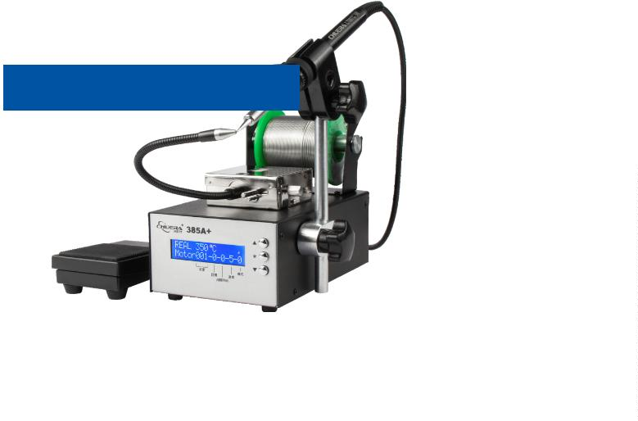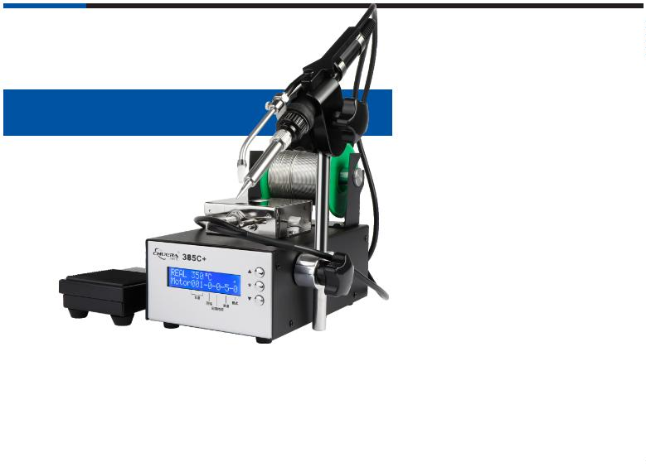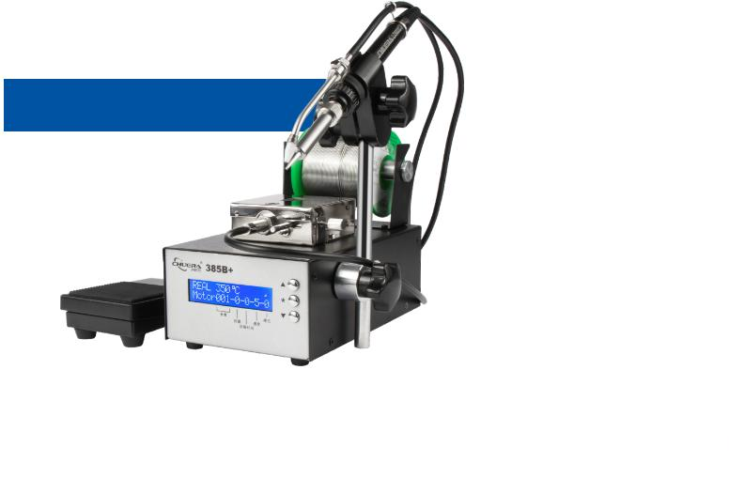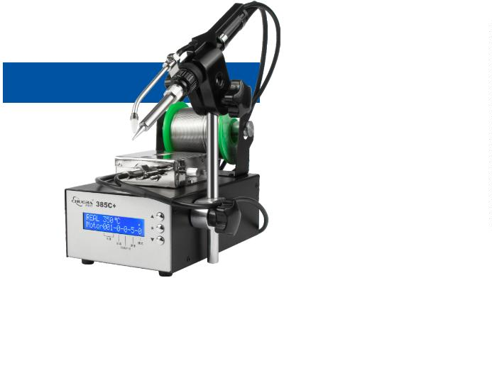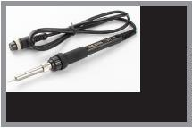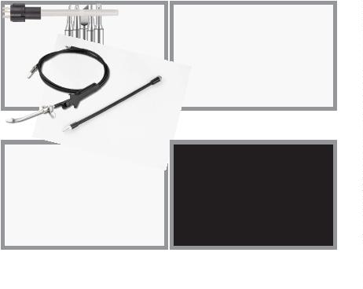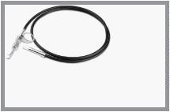

®
Automatically send tin
376D+
Automatic tin feeding lead-free
soldering station
Features:
※High-frequency vortex heating, K-type sensor temperature control, fast heating and temperature recovery
speed;
※Microcomputer control, push-button temperature adjustment, digital calibration and automatic sleep
function;
※Automatic and manual tin delivery modes are available, and the number of tin delivery times can be set;
※The tin removal speed, tin removal length, and tin removal time are all adjustable, and it is equipped with an
adjustable tin return function to reduce soldering waste;
※
It can be used as a lead-free soldering station alone, and can be equipped with a foot switch or a manual tin
outlet switch and a universal adjustment mechanism to make welding ﬂexible and convenient.
Speciﬁcations:
Operating voltage:
AC220V/50HZ AC110V/60HZ
Temperature range:
Maximum instantaneous power:
Temperature stability (no load):
50~600℃
90W
±2℃
Soldering iron resistance to ground: ﹤2Ω
Soldering iron potential to ground: ﹤2 mV
Optional accessories:
Temperature correction method:
Motor:
Digital correction
Stepper motor
Tin output speed:
Tin output:
About 2.7mm/s~27mm/s
0~150mm
Return time:
Tin out mode:
0~0.9s(About 0~25mm)
Automatic(1~9)/manual(0)
LT 201 handle
VH 90 heating core
200 Series soldering iron tip
Tin wire diameter:
Weight:
0.6 / 0.8 / 1.0/ 1.2/ 1.4mm（Adjustable）
About 5.02Kg
Package size:
Carton size:
Packing speciﬁcations:
335×265×265
565×345×600mm
4 sets/carton
CSD-373-1
CSD-373-2
Manual tin outlet tube
Optional manual tin removal, accessories: manual tin removal guide CSD-373-2
CSD-376-1
Automatic tin outlet tube
376DI
Automatic tin feeding lead-free soldering station
Features:
※
High-frequency vortex heating, K-type sensor temperature control, fast heating and temperature recovery
speed;
※Microcomputer control, push-button temperature adjustment, digital calibration and automatic sleep
function;
※Automatic and manual tin delivery modes are available, and the number of tin delivery times can be set;
※The tin removal speed, tin removal length, and tin removal time are all adjustable, and it is equipped with an
adjustable tin return function to reduce soldering waste;
※
It can be used as a lead-free soldering station alone, and can be equipped with a foot switch or a manual tin
outlet switch and a universal adjustment mechanism to make welding ﬂexible and convenient.
Speciﬁcations:
Operating voltage:
AC220V/50HZ AC110V/60HZ
Temperature range:
Maximum instantaneous power:
Temperature stability (no load):
50~600℃
90W
±2℃
Soldering iron resistance to ground: ﹤2Ω
Soldering iron potential to ground: ﹤2 mV
Temperature correction method:
Motor:
Digital correction
Stepper motor
Optional accessories:
Tin output speed:
Tin output:
About 2.7mm/s~27mm/s
0~150mm
Return time:
Tin out mode:
Tin wire diameter:
0~0.9s(About 0~25mm)
Automatic(1~9)/manual(0)
0.6 / 0.8 / 1.0/ 1.2/1.4mm
LT 201 handle
VH 90 heating core
200 Series soldering iron tip
（Not adjustable after selection）
Weight:
About 5Kg
Package size:
Carton size:
Packing speciﬁcations:
335×265×265
565×345×600mm
4 sets/carton
CSD-373-1
Automatic tin outlet tube
CSD-373-2
Manual tin outlet tube
CSD-376-1
Optional manual tin removal, accessories: manual tin removal guide CSD-373-2

09
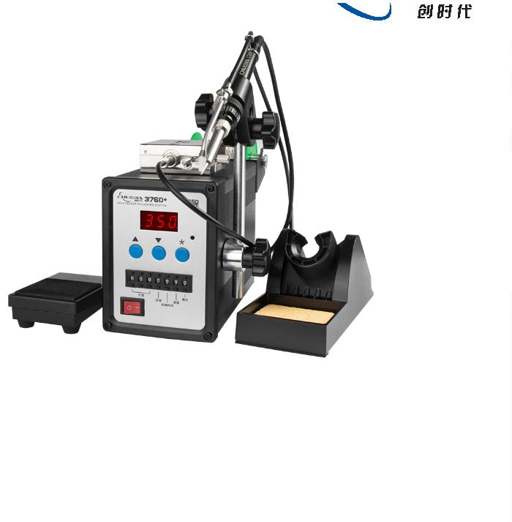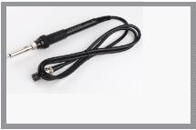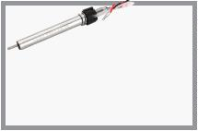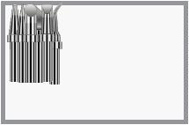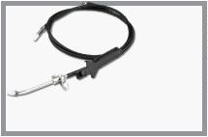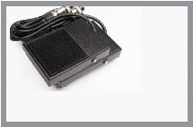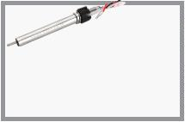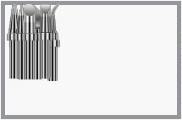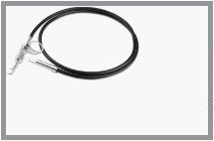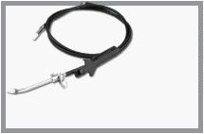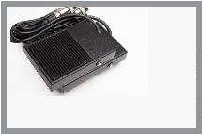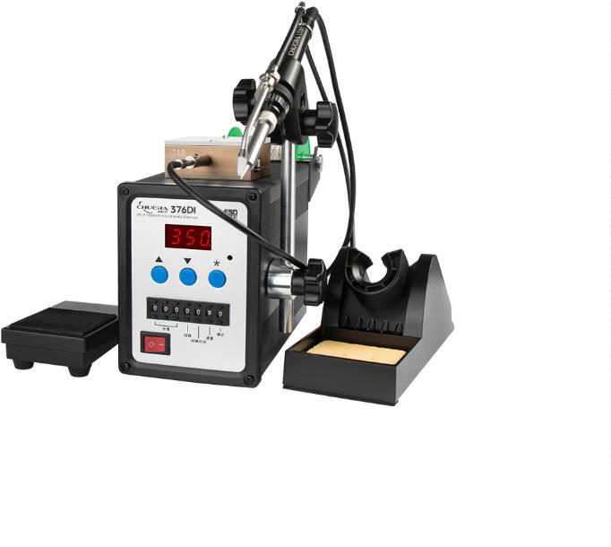

®
Automatically send tin
379D+
Automatic tin feeding lead-free soldering station
Features:
※
※
※
※
※
High-frequency vortex heating, K-type sensor temperature control, fast heating and temperature
recovery speed;
Microcomputer control, push-button temperature adjustment, digital calibration and automatic
sleep function;
Automatic and manual tin delivery modes are available, and the number of tin delivery times can be
set;
The tin removal speed, tin removal length, and tin removal time are all adjustable, and it is
equipped with an adjustable tin return function to reduce soldering waste;
It can be used as a lead-free soldering station alone, and can be equipped with a foot switch or a
manual tin outlet switch and a universal adjustment mechanism to make welding ﬂexible and
convenient.
Speciﬁcations:
Operating voltage:
Temperature range:
Maximum instantaneous power:
Temperature stability (no load):
AC220V/50HZ
50~600℃
150W
±2℃
Soldering iron resistance to ground:﹤2Ω
Soldering iron potential to ground: ﹤2 mV
Optional accessories:
Temperature correction method:
Motor:
Digital correction
Stepper motor
Tin output speed:
Tin output:
About 2.7mm/s~27mm/s
0~150mm
Return time:
Tin out mode:
Tin wire diameter:
Weight:
0~0.9s(About 0~25mm)
Automatic(1~9)/manual(0)
0.6 / 0.8 / 1.0/ 1.2/1.4mm
About 6.94Kg
Lt305 handle
VH 150 heating core
500 Series soldering iron tip
Package size:
Carton size:
Packing speciﬁcations:
335×265×265
565×345×600mm
4 sets/carton
CSD-373-1
Automatic tin outlet tube
CSD-373-2
Manual tin outlet tube
Optional manual tin removal, accessories: manual tin removal guide CSD-373-2
CSD-376-1
379DI
Automatic tin feeding lead-free soldering station
Features:
※
※
※
※
※
High-frequency vortex heating, K-type sensor temperature control, fast heating and temperature
recovery speed;
Microcomputer control, push-button temperature adjustment, digital calibration and automatic
sleep function;
Automatic and manual tin delivery modes are available, and the number of tin delivery times can be
set;
The tin removal speed, tin removal length, and tin removal time are all adjustable, and it is
equipped with an adjustable tin return function to reduce soldering waste;
It can be used as a lead-free soldering station alone, and can be equipped with a foot switch or a
manual tin outlet switch and a universal adjustment mechanism to make welding ﬂexible and
convenient.
Speciﬁcations:
Operating voltage:
Temperature range:
Maximum instantaneous power:
Temperature stability (no load):
AC220V/50HZ
50~600℃
150W
±2℃
Soldering iron resistance to ground: ﹤2Ω
Soldering iron potential to ground: ﹤2 mV
Temperature correction method:
Motor:
Digital correction
Stepper motor
Optional accessories:
Tin output speed:
Tin output:
About 2.7mm/s~27mm/s
0~150mm
Return time:
Tin out mode:
Tin wire diameter:
0~0.9s(About 0~25mm)
Automatic(1~9)/manual(0)
0.6 / 0.8 / 1.0/ 1.2/1.4mm
Lt305 handle
Vh150 heating core
500 Series soldering iron tip
（Not adjustable after selection）
Weight:
About 6.94Kg
Package size:
Carton size:
Packing speciﬁcations:
335×265×265
565×345×600mm
4 sets/carton
CSD-373-1
Automatic tin outlet tube
CSD-373-2
Manual tin outlet tube
Optional manual tin removal, accessories: manual tin removal guide CSD-373-2
CSD-376-1
1
0

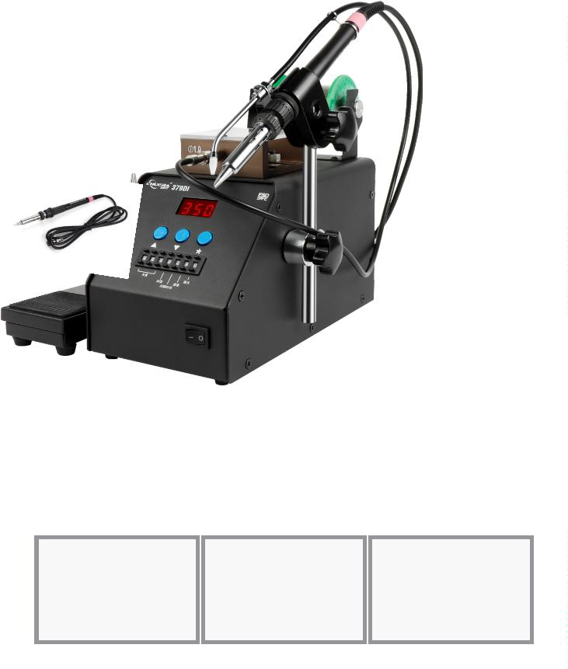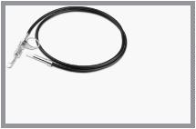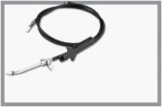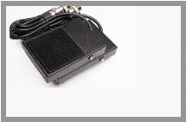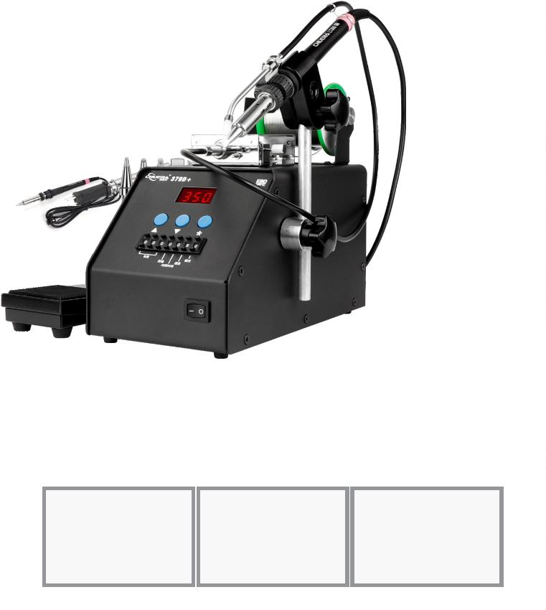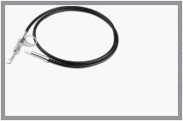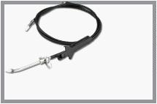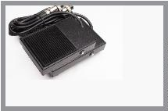

®
Automatically send tin
3800
Automatic tin feeding lead-free soldering station
Features:
※High-frequency vortex heating, K-type sensor temperature control, fast heating and temperature recovery
speed;
※Microcomputer control, push-button temperature adjustment, digital calibration and automatic sleep
function;
※Automatic and manual tin delivery modes are available, and the number of tin delivery times can be set;
※The tin removal speed, tin removal length, and tin removal time are all adjustable, and it is equipped with
an adjustable tin return function to reduce soldering waste;
※It can be used as a lead-free soldering station alone, and can be equipped with a foot switch or a manual
tin outlet switch and a universal adjustment mechanism to make welding ﬂexible and convenient.
※The knob is used to adjust the tin discharging speed and length, which is quick and easy to operate.
Speciﬁcations:
Operating voltage:
Temperature range:
AC220V/50HZ AC110V/60HZ
50~600℃
Maximum instantaneous power:
Temperature stability (no load):
130W
±2℃
Soldering iron resistance to ground: ﹤2Ω
Soldering iron potential to ground: ﹤2 mV
Optional accessories:
Temperature correction method:
Motor:
Digital correction
Stepper motor
Tin output speed:
Tin output:
About 2.7mm/s~27mm/s
0~150mm
Return time:
Tin out mode:
Tin wire diameter:
Weight:
0~0.9s(About 0~25mm)
Automatic(1~9)/manual(0)
0.6/0.8/1.0/1.2/1.4mm
About 5Kg
LT 308 handle
VH 130 heating core
200 Series soldering iron tip
Package size:
Carton size:
Packing speciﬁcations:
335*265*265mm
565×345×600mm
4 sets/carton
CSD-373-1
Automatic tin outlet tube
CSD-373-2
Manual tin outlet tube
CSD-376-1
373
Automatic tin feeding system
Features:
※
Two methods of automatic tin dispensing and manual tin
dispensing are available;
Foot switch and manual tin discharging switch are optional;
Fully automatic tin discharging function, adjustable, tin
discharging speed, tin discharging amount, tin discharging
interval and equipped with automatic tin return function;
※
※
※
The automatic tin discharging system is suitable for a variety of
soldering irons and soldering stations to improve work efficiency.
Speciﬁcations:
Power consumption:
Motor power:
Tin delivery time:
Tin delivery speed:
5W
DC24V 3.2W
0~3.5s
14~35mm/S
Amount of tin delivered: 0~123mm
Amount of tin returned: Adjustable
Tin wire diameter:
Dimensions:
Weight:
0.6 / 0.8 / 1.0/ 1.2/ 1.4 / 1.6mm
L215×W107×H110mm
about1.76Kg
Optional accessories:
Package Size:
Carton size:
280×230×190mm
575×480×400mm
Packing speciﬁcations: 4 sets/carton
CSD-373-1
Automatic tin outlet tube
CSD-373-3
Foot switch
Optional manual tin removal, accessories: manual tin removal guide CSD-373-2

11
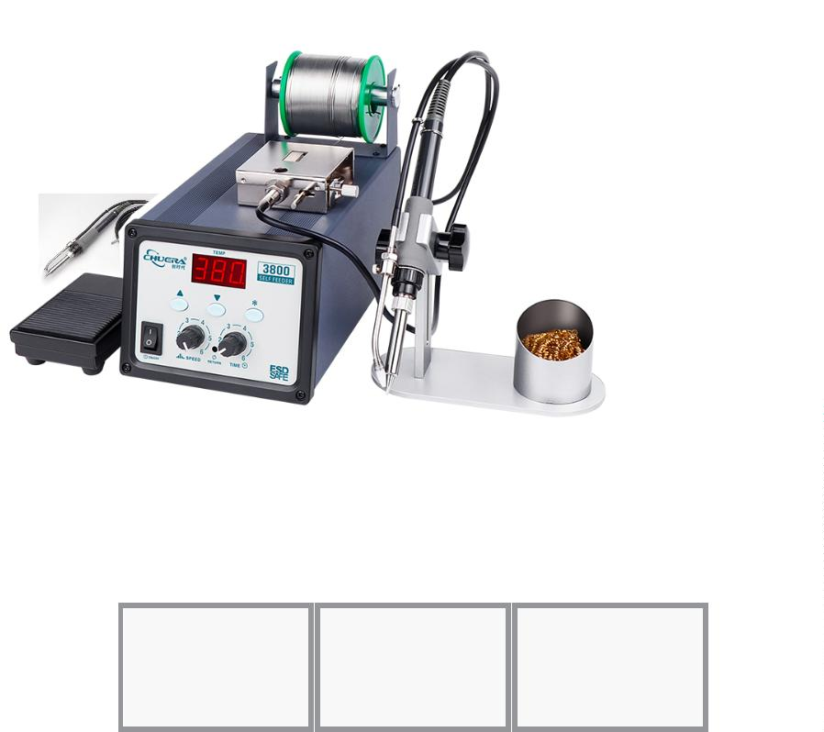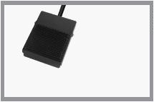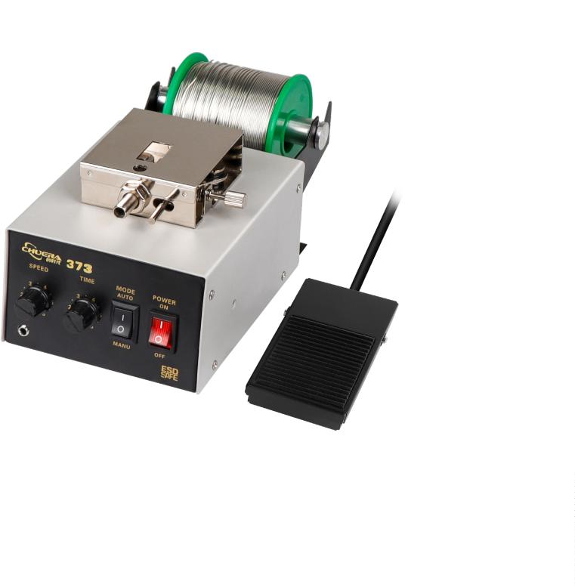

®
Automatically send tin
371V
Automatic tin feeding and
cutting system
Features:
※
Fully automatic tin discharging, simple and convenient operation,
LED digital display of each parameter;
Fully automatic micro-hole tin breaking to prevent tin explosion
※
during welding;
※
※
Can be used alone for tin breaking and drilling;
The tin discharging speed is adjustable in 10 degrees, suitable for
different occasions;
※
※
※
It has the function of returning tin, saving solder and delivering
accurate tin amount;
Multiple working modes, intelligent multiple continuous tin delivery
settings;
Anti-static design can prevent sensitive electronic parts from being
damaged by static electricity.
Speciﬁcations:
Operating voltage:
No-load standby power:
AC220V/50HZ
≤5W
Maximum instantaneous power: 30W
Applicable tin wire diameter:
Dimensions:
Weight:
0.6-1.6mm（Tin wire diameter adjustable）
L78mm ×W120mm ×H185mm
About1.7Kg
Optional accessories:
Package size:
335×265×265
Carton size:
Packing speciﬁcations:
565×345×600mm
4 sets/carton
CSD-373-1
Automatic tin outlet tube
CSD-373-3
Foot switch
Optional manual tin removal, accessories: manual tin removal guide CSD-373-2
372C
Automatic tin breaking machine
Features:
※
※
Automatic tin discharge, simple and convenient operation;
With the fully automatic microporous tin breaking, the tin breaking
phenomenon during soldering is prevented;
※
The original state of the flux inside the tin wire can be maintained,
which not only eliminates the spattering of lead-free tin wire
during high-temperature soldering, but also ensures the original
soldering fluidity of lead-free tin wire, and the soldering quality is
excellent.
Speciﬁcations:
Host power supply:
Tin delivery speed:
Temperature shift:
Solder diameter:
DC24V/75mA
30mm/s
±2 degrees (no load)
0.6/0.8/1.0/1.2/1.4mm
（Tin wire diameter is not adjustable）
Dimensions:
Weight:
Package size:
Carton size:
L180mm ×W80mm ×H110mm
about1.6Kg
335×265×265
Optional accessories:
565×345×600mm
Packing speciﬁcations: 4 sets/carton
CSD-373-1
Automatic tin outlet tube
Optional manual tin removal, accessories: manual tin removal guide CSD-373-2
CSD-373-3
Foot switch
1
2

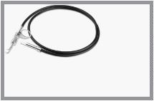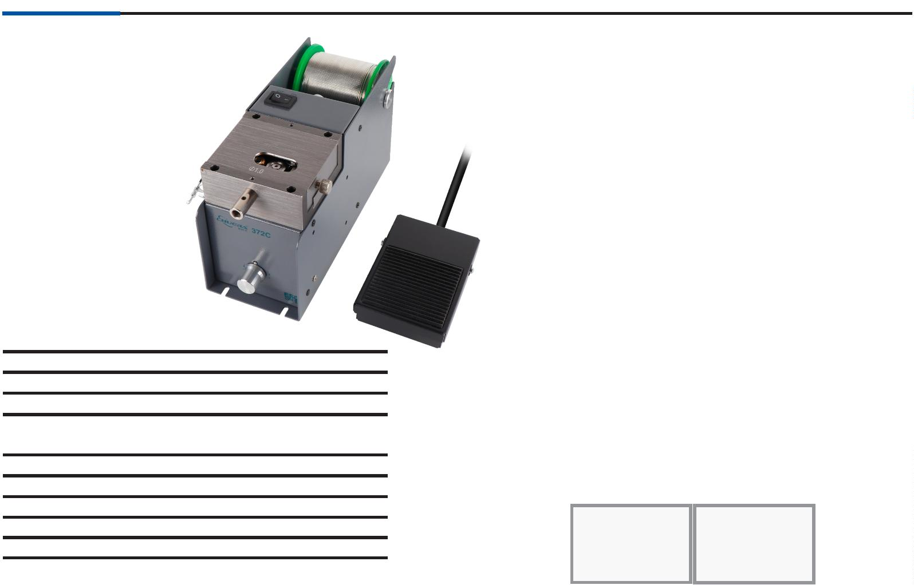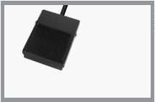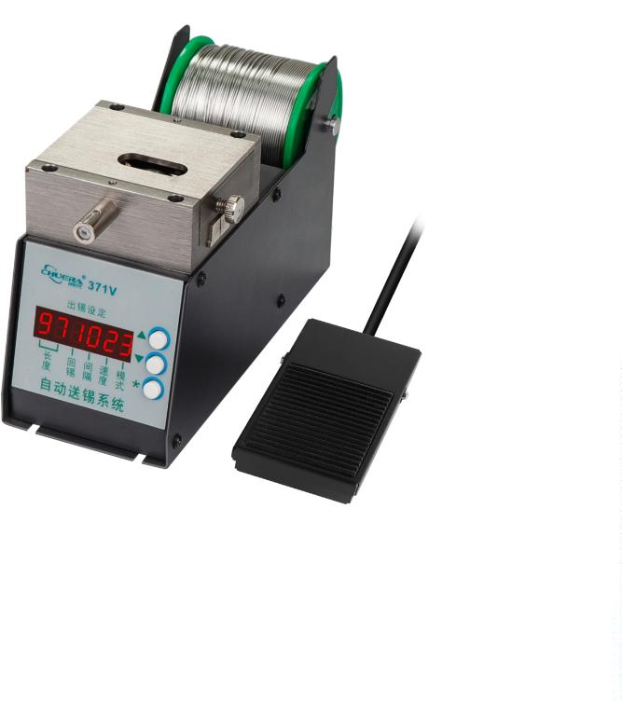

®
Automatically send tin
380D
Semi-automatic tin soldering machine
※
※
With PLC touch screen, it is easy and convenient to operate;
Tin soldering temperature, tin soldering time, tin feeding speed, tin feeding amount, and tin recovery can be
adjusted;
※
※
※
With the soldering process set up, there is no need for a professional solderer, and it is quick for novices to
get started;
The password protection function is provided by the PLC system to protect the welding process from being
adjusted randomly;
With high-frequency eddy current heating high-power soldering station, the temperature rise and
temperature return speed are fast, and lead-free soldering is realized;
※
※
※
Soldering iron tip is split, which is versatile, cost-effective and can be bought from the market;
For different products, you only need to change the fixture, so the cost is low and versatility is high;
Automatic smoking version is also available, and there is also an option for higher welding power.
Speciﬁcations:
Product number
Drive mode
C HUERA-380D
Electric
Start mode
Foot
Operating Voltage
Soldering station power
Temperature range
Temperature error
Standard soldering tip
220V / 50HZ
150W，high frequency
50 - 600
℃
± 2 ℃（No load）
500 Series (universal type)
Inner diameter of tin outlet nozzle 06. / 08. / 10. / 12. / 14. / 16.mm
Dimensions
Total Weight
L480mm * W350mm * H315mm
20Kg

13
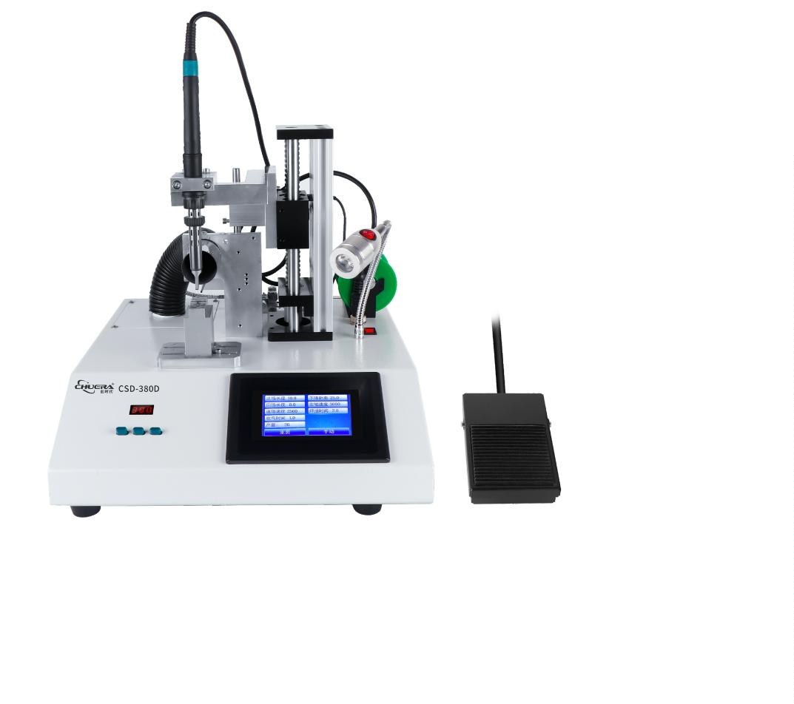

®
Tool series
9
00M series lead-free soldering iron tip
★
★ 900M outer diameterф6.5mm
★
The soldering iron tip is tin-plated only
on the bevel part
Suitable for 936/937 and various resistive ceramic
heating welding stations
1
4

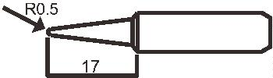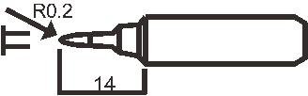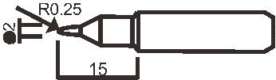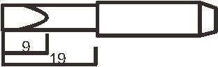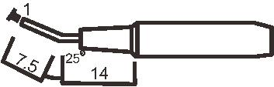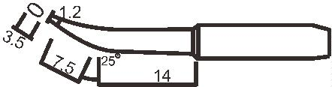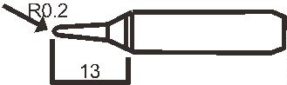
®
Tool series
Lead-free soldering iron tip with external heaters
★
Suitable for 30W, 40W and 60W external
heating soldering irons
7
0mm
75mm
80m m
6
5m m
1
.5mm
1
.0mm
.8mm
4mm
4mm
4mm
5mm
0.5mm
6mm
2
5mm
4mm
4mm
4
5ꢀ
5
7
mm
7mm
15mm
.5mm
D4-B(30W)
0m m
D5-BC(40W)
D6-BBBB(60W)
80m m
D4-D (30W)
70m m
7
5mm
7
5
mm
0
45ꢀ
6mm
4
5ꢀ
4
mm
7
mm
5
.5mm
D4-BB(30W)
0m m
D4-K (30W)
75mm
D5-C(40W)
75mm
D6-BC
(60W)
7
1.5mm
4.0mm
8
0m m
0
.5mm
1
.2mm
5mm
5mm
4
5ꢀ
mm
6mm
1
0mm
5mm
8mm
7
D4-BBBB(30W)
0m m
D5-B(40W)
75mm
D5-D(40W)
75mm
D6-C(60W)
0m m
7
8
1
.4mm
4
mm
0
.5mm
5mm
4
5ꢀ
0.5mm
5mm
3.5mm
6mm
1
0mm
7mm
D5-K (40W)
80m m
D4-BBC(30W)
0m m
16mm
D5-BB(40W)
D6-D(60W)
80m m
7
7
5mm
4
4
mm
4
0mm
5ꢀ
0
.5mm
5mm 1.5mm
6mm
0.5mm
6mm
1
7
^{.0mm} D4-BC(30W)
10mm
10mm
9
.5mm
D5-BBBB(40W)
5mm
D6-B(60W)
80m m
ꢀD6-BB(60W)
80m m
7
0m m
7
mm
4
5ꢀ
mm
5mm
1.2mm
6mm
2.0mm
6mm
4
5ꢀ
4
1
2mm
8mm
1
4mm
D4-C(30W)
ꢀD6-BC(60W)
D5-BBC(40W)
D6-BB(60W)
2
00 series lead-free soldering iron tip
-
B
-H
-4C
-
1.2D
-
2B
K
-J
-
-
0.8C
-
1.6D
-
SK
-
1C
2C
-2.4D
-3.2D
-
-
I
-
-
5D
LI
-
3C
★
200 series soldering iron tips are suitable for CSD309D、990、203、204、376Dl
Quick 3202、3112、3100、3101、3102、203D、203、203H、204、204H、303 etc.

15


®
Tool series
5
01 series lead-free
500 series lead-free
soldering iron tip
soldering iron tip
5
01-5B
500-B
500-1.6D
4
7.60
∅
1,0
2
5.60
∅
5.00
0
,6
1
8,5
21,0
1
9,5
21,0
上锡⻑ꢌ：
H=8.0mm
5
5
00-2B
500-2.4D
5
01-3C
5
2.00
∅2,0
3
0.00
∅
3.00
1
,0
18,5
21,0
1
9,5
21,0
上锡⻑ꢌ：
H=8.0mm
00-8C
500-3.2D
5
01-4C
∅
8,0
5
2.00
3
0.00
4
3ꢀ
∅
4.00
1,2
500-4D
1,4
2
1,0
18,5
21,0
1
9.5
4
.00
⻑
上锡 ꢌ：
H=8.0mm
5
00-6C
5
01-5C
52.00
∅6,0
3
0.00
4
3ꢀ
∅
5.00
20,5
21,0
21,0
2
1,0
1
9,5
5
.00
上锡⻑ꢌ：
H=8.0mm
500-5C
5,0
5
00-5D
∅
5
01-6C
5
2.00
30.00
4
5ꢀ
∅
6.00
2,0
20,5
2
1,0
1
9.5
6
.00
上锡 ꢌ：
⻑
H=8.0mm
500-4C
∅4,0
500-I
5
5
01-5D
4
7.60
45ꢀ
2
5.60
21,0
21,0
21,0
1
9.5
19,5
5
.00上锡⻑ꢌ：
H=8.0mm
500-3C
3,0
500-K
2
.50
∅
01-K
4
5ꢀ
2,3
5
4.00
3
2.00
21,0
2
1,5
1
9.5
5
00-2C
2,0
500-SK
3
.50
∅
4
5ꢀ
2
1,0
21,0
1
9.5
★
★
500 series soldering iron tips are suitable for CSD205/315D
501 series soldering iron tips are suitable for CSD316D
1
6

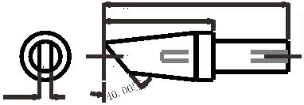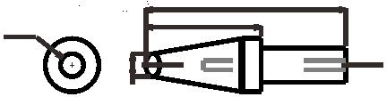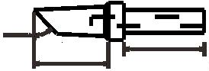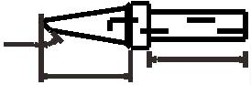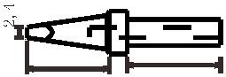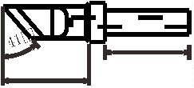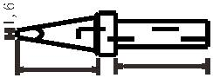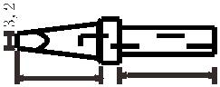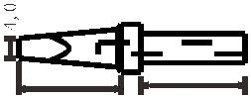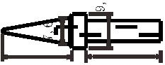

®
Tool series
T12 Series
Lead-free and environmentally-
friendly soldering iron tip
Suitable for T12 constant temperature soldering station
305 Series
Lead-free and environmentally-
friendly soldering iron tip
WXP Series
Soldering iron tip for tin
soldering machine
Suitable for CH-02 tin soldering machine intelligent thermostat
600 Series
Soldering iron tip for tin
soldering machine
Suitable for 600W tin soldering machine intelligent thermostat

17
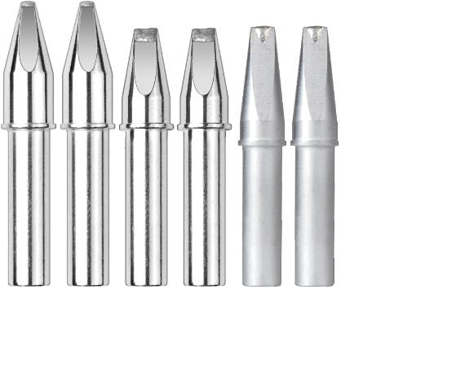

®
Tool series
9
11 series lead-free soldering iron tip
D type high frequency soldering iron tip
PC type high frequency soldering iron tip
DV 1 type high frequency soldering iron tip
DV 2 type high frequency soldering iron tip
N type high frequency soldering iron tip
1
8

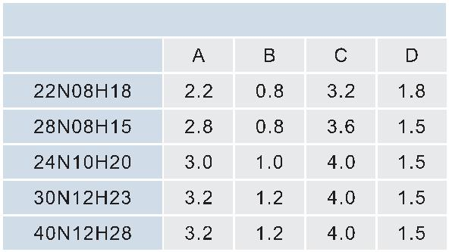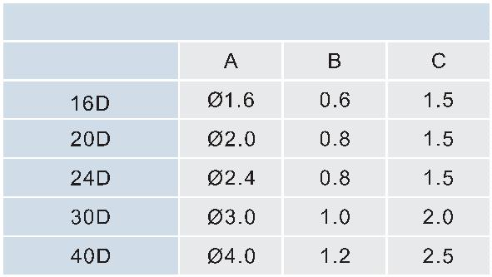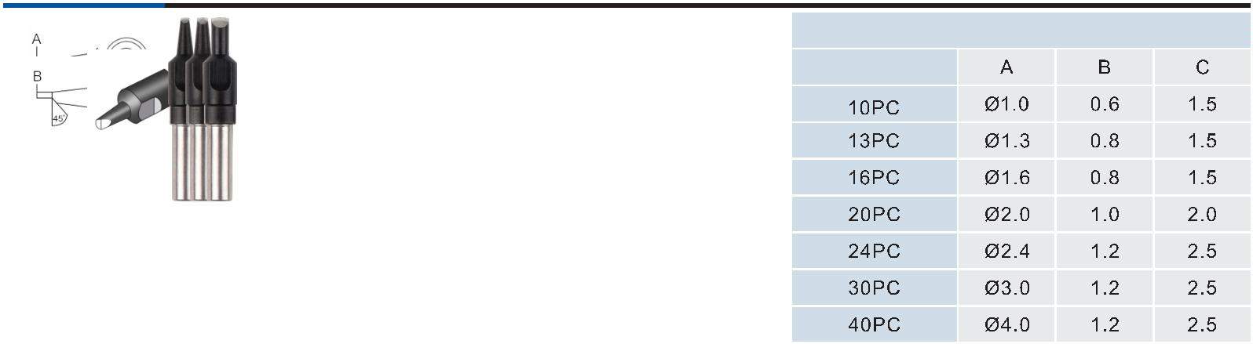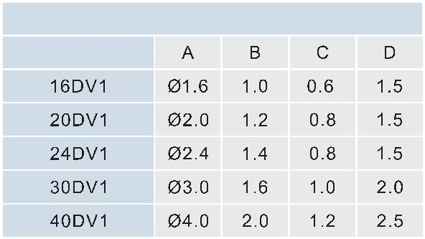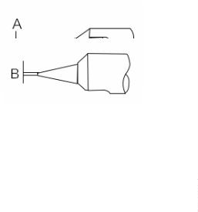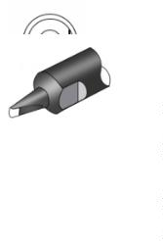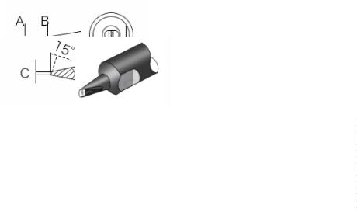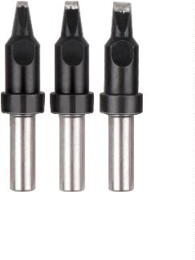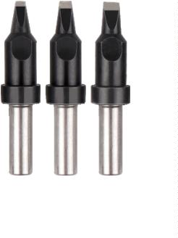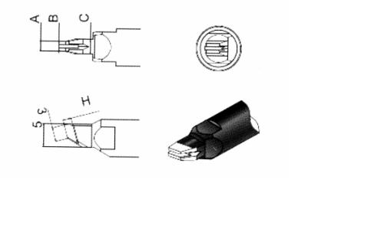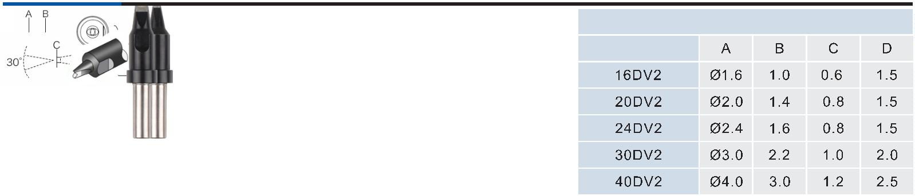

®
Tool series
9
11G series lead-free soldering iron tip
★
Suitable for 30W, 40W and 60W external
heating soldering irons
D type high frequency soldering iron tip
PC type high frequency soldering iron tip
DV 1 type high frequency soldering iron tip
DV 2 type high frequency soldering iron tip
N type high frequency soldering iron tip

19
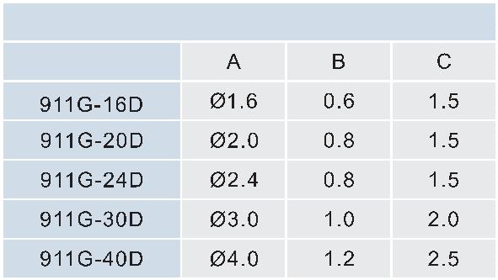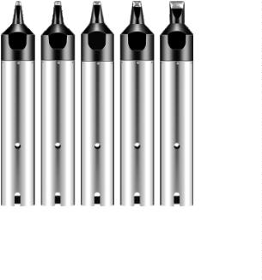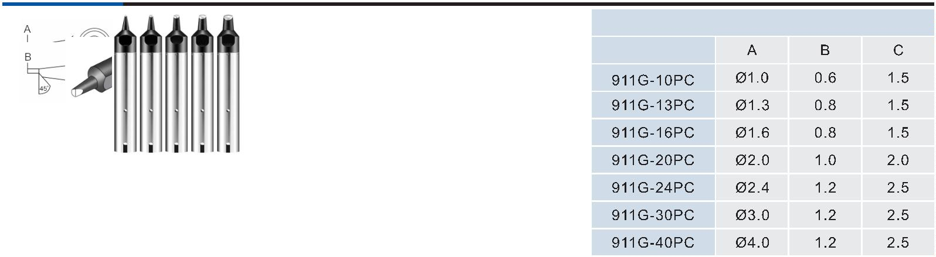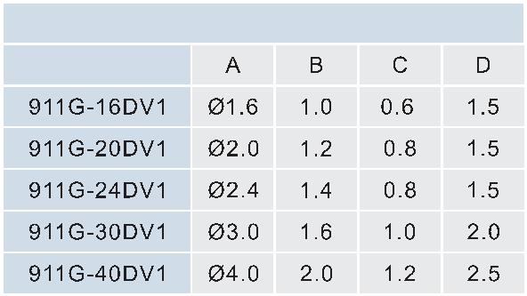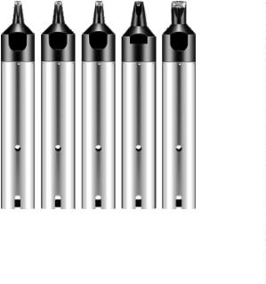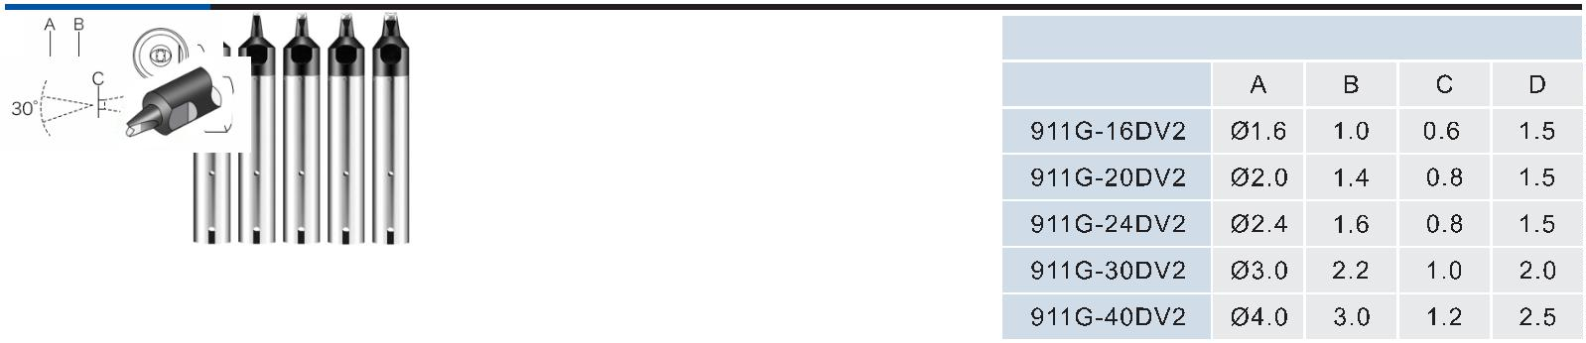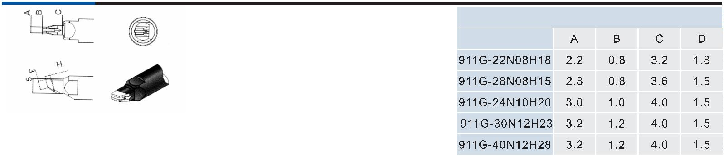

®
Tool series
5
01G series lead-free soldering iron tip
D type high frequency soldering iron tip
PC type high frequency soldering iron tip
DV 1 type high frequency soldering iron tip
DV 2 type high frequency soldering iron tip
N type high frequency soldering iron tip
2
0

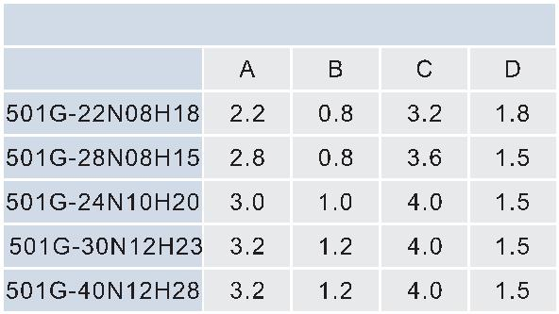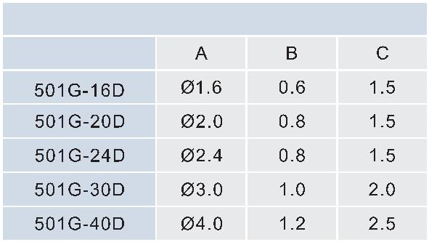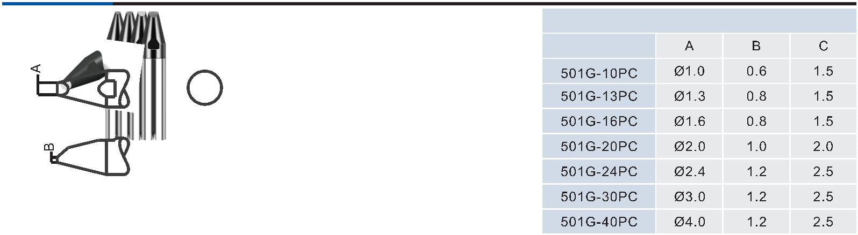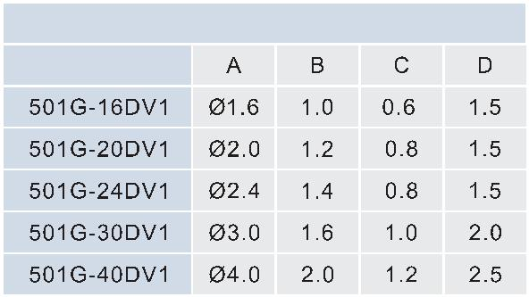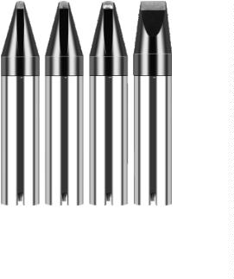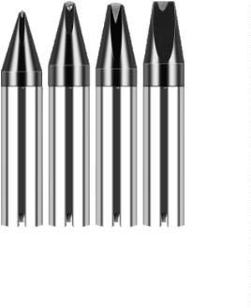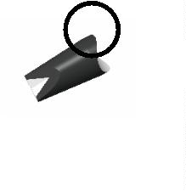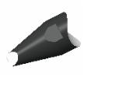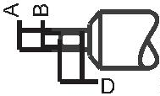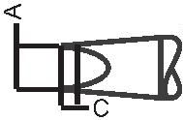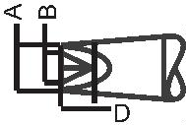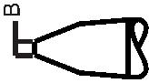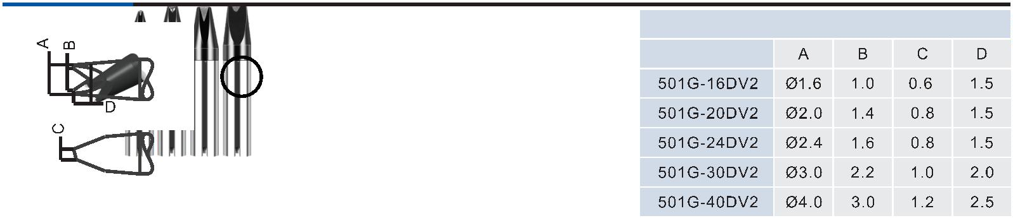

®
Tool series
LHT series lead-free soldering iron tip
D type low frequency soldering iron tip
PC type high frequency soldering iron tip
Dv1 type low frequency soldering iron tip
Dv2 type low frequency soldering iron tip
N type low frequency soldering iron tip

21
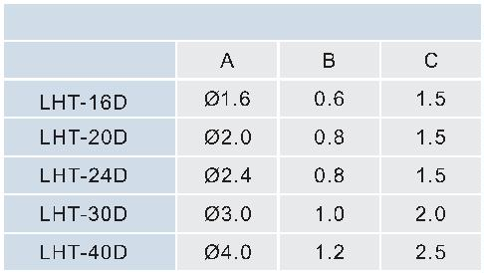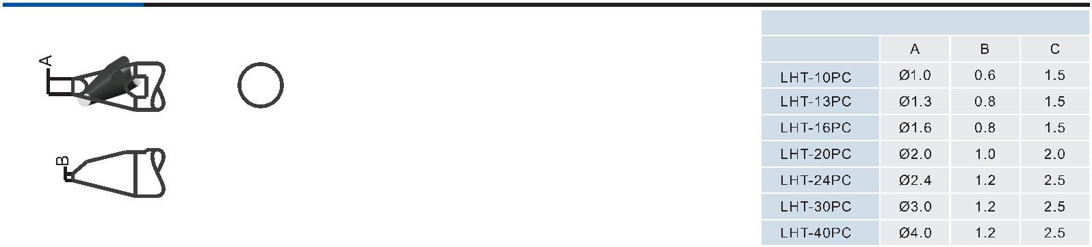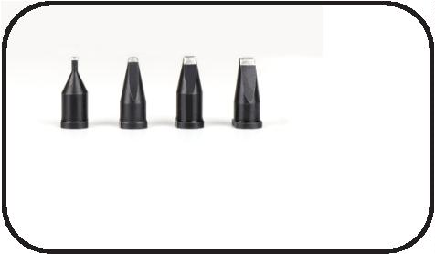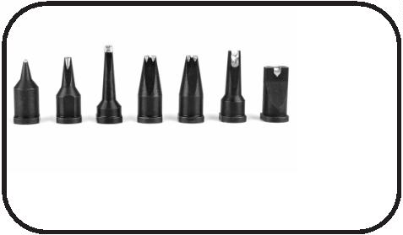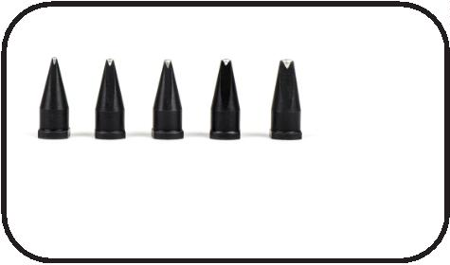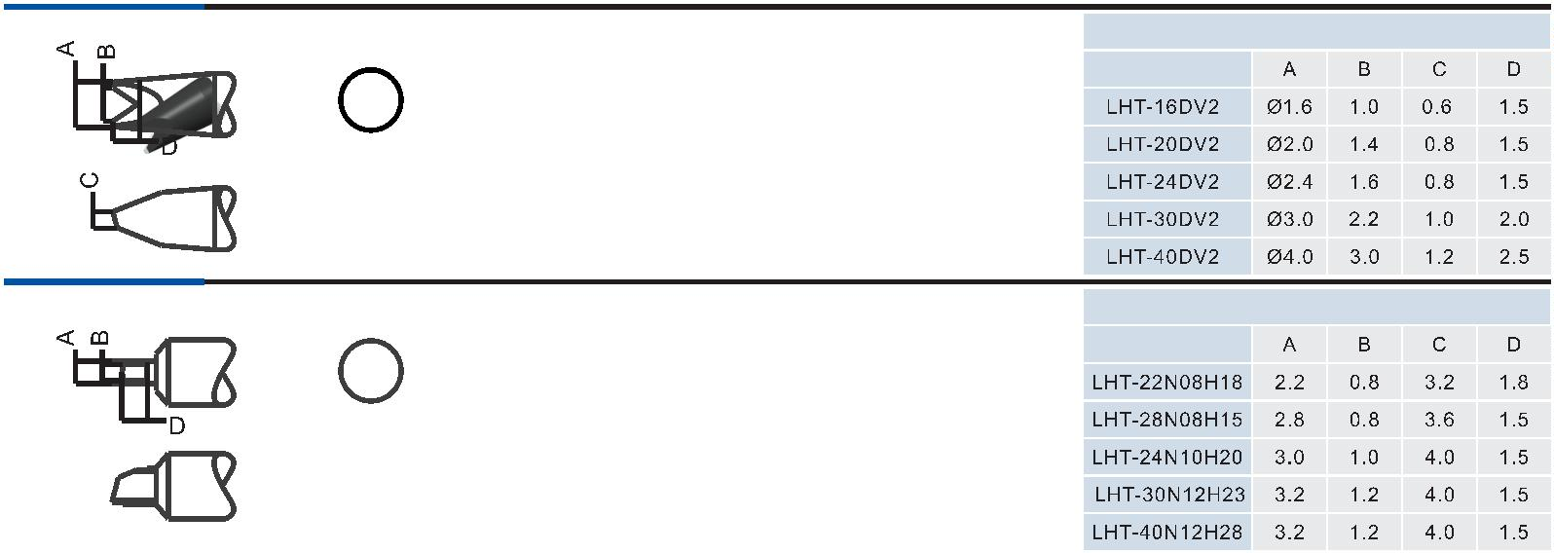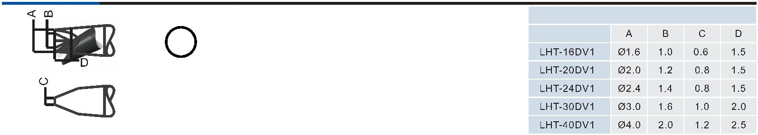

®
Constant temperature controller
CH-150
High-frequency thermostat
※
With high-frequency eddy current heating, the temperature rise and temperature return speed are fast, and lead-free soldering is
realized;
※
※
※
※
※
With a liquid crystal display, real-time temperature and set temperature double digital display is realized;
With microcomputer control, push-button temperature adjustment, digital temperature calibration;
With the password-type temperature locking function, the production process is effectively safeguarded;
With plug-and-play design of heating core, maintenance is more convenient;
With temperature alarm output, the upper and lower temperature alarm ranges can be set by you. If the process range is exceeded,
an alarm is generated and a signal is output.
1
30
Standard optional
accessories
9
11G-150W handle
VH150C Heating core
Speciﬁcation:
9
11G Series soldering tip
Operating voltage
AC220V/50HZ/AC110V/60HZ
150W
Maximum instantaneous power
Soldering iron resistance to ground
Temperature correction method
Temperature tuowei
﹤
2Ω
Digital correction
50~550°C
CH003/CH003Q
CH004Q handle collet
Temperature stability (no load)
Soldering iron potential to ground
Dimensions
±2°C
﹤2mV
L125*W130*H260mm
Optional accessories:
11-150W Saigon handle (white/black), using soldering iron tip
911/911H series, heating core VH150C/VH150H
9
Weight
About 5.53Kg
2
2

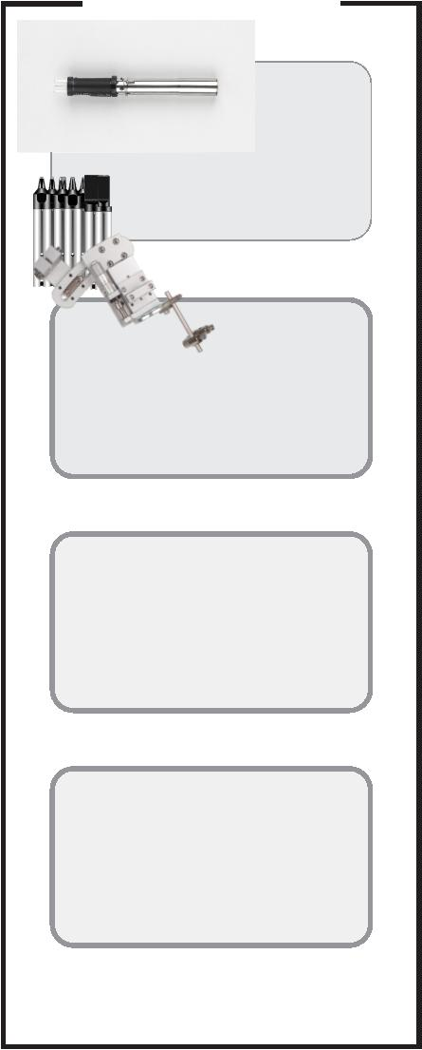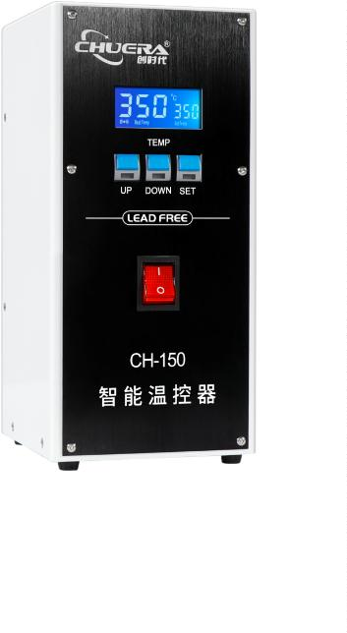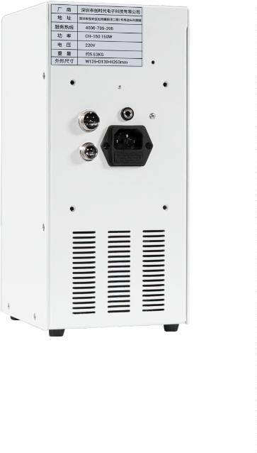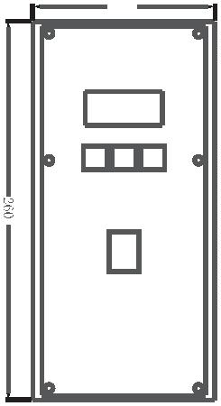

®
Constant temperature controller
CH-200
High-frequency thermostat
※
With high-frequency eddy current heating, the temperature rise and temperature return speed are fast, and lead-free soldering is
realized;
※
※
※
※
※
With a liquid crystal display, real-time temperature and set temperature double digital display is realized;
With microcomputer control, push-button temperature adjustment, digital temperature calibration;
With the password-type temperature locking function, the production process is effectively safeguarded;
With plug-and-play design of heating core, maintenance is more convenient;
With temperature alarm output, the upper and lower temperature alarm ranges can be set by you. If the process range is exceeded,
an alarm is generated and a signal is output.
1
30
Standard optional
accessories
9
11G-200W handle
VH200C Heating core
Speciﬁcations:
9
11G Series soldering tip
Operating voltage
AC220V/50HZ/AC110V/60HZ
Maximum instantaneous power
Soldering iron resistance to ground
Temperature correction method
Temperature tuowei
200W
﹤ 2Ω
Digital correction
50~550°C
±2°C
CH003/CH003Q
CH004Q handle collet
Temperature stability (no load)
Soldering iron potential to ground
Dimensions
﹤ 2mV
L125*W130*H260mm
Optional accessories:
11-200W Saigon handle (white/black), using soldering iron tip
911/911H series, heating core VH200C/VH200H
9
Weight
About 5.87Kg

23
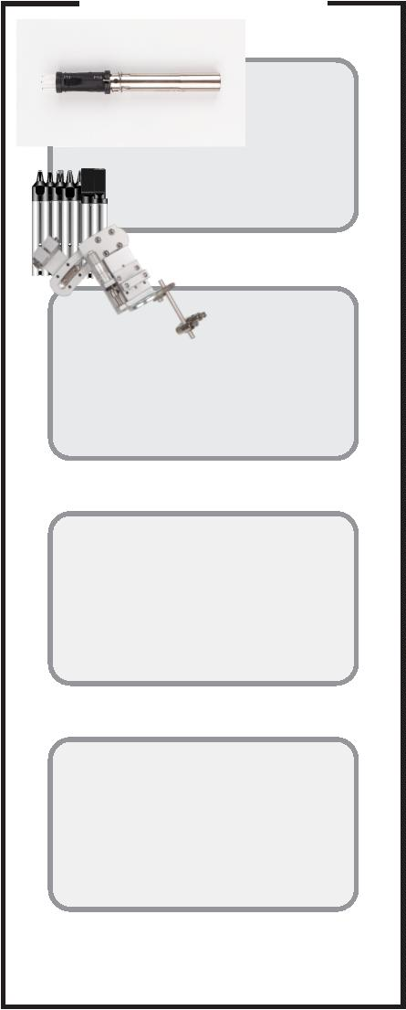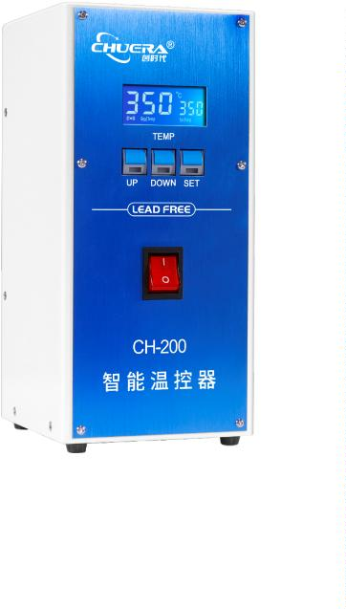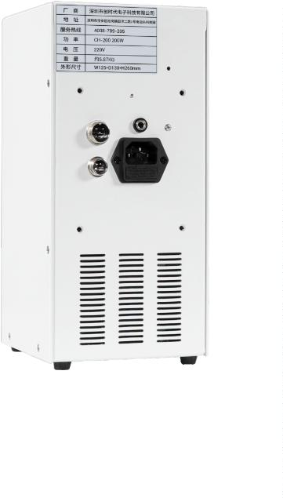
®
Constant temperature controller
CH-320
High-frequency thermostat
※
With high-frequency eddy current heating, the temperature rise and temperature return speed are fast, and lead-free soldering is
realized;
※
※
※
※
※
Extra-large LCD display, dual digital display of real-time temperature and set temperature;
With microcomputer control, push-button temperature adjustment, digital temperature calibration;
With the password-type temperature locking function, the production process is effectively safeguarded;
With plug-and-play design of heating core, maintenance is more convenient;
With temperature alarm output, the upper and lower temperature alarm ranges can be set by you. If the process range is exceeded,
an alarm is generated and a signal is output.
1
30
Standard optional
accessories
5
01G-320W handle
VH320C Heating core
Speciﬁcations:
Operating voltage
AC220V/50HZ/AC110V/60HZ
Maximum instantaneous power
Soldering iron resistance to ground
Temperature correction method
Temperature tuowei
320W
﹤ 2Ω
5
01G Series soldering tip
Digital correction
50~550°C
Temperature stability (no load)
Soldering iron potential to ground
Dimensions
±2°C
Fixing hole diameter φ20mm
﹤ 2mV
CH003/CH003Q
CH004Q handle collet
L125*W130*H260mm
Weight
About 5.26Kg
2
4

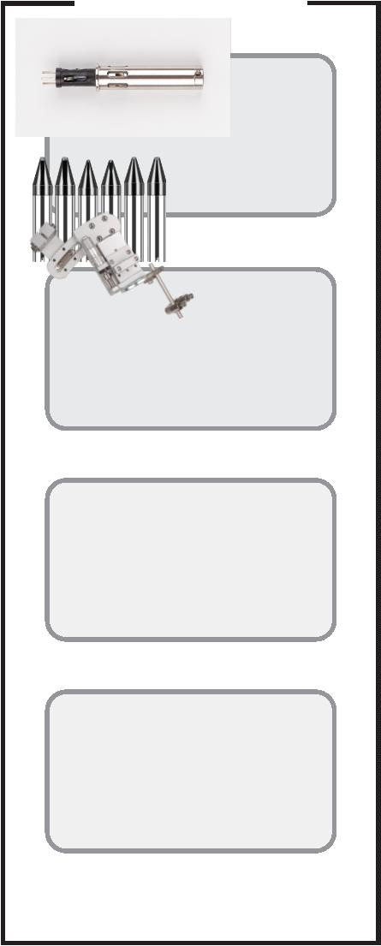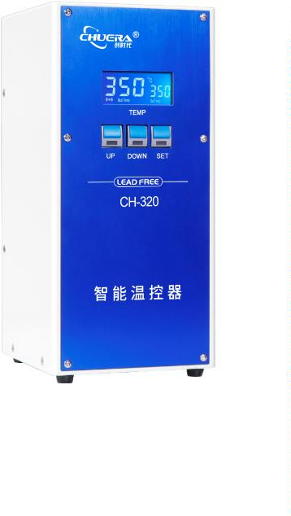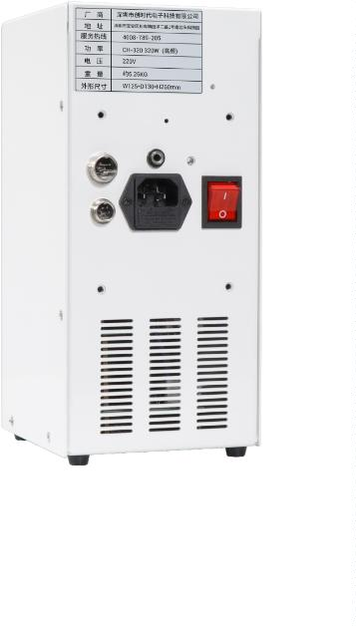

®
Constant temperature controller
CH-600
High-frequency thermostat
※
With high-frequency eddy current heating, the temperature rise and temperature return speed are fast, and lead-free soldering is
realized;
※
※
※
※
※
Extra-large LCD display, dual digital display of real-time temperature and set temperature;
With microcomputer control, push-button temperature adjustment, digital temperature calibration;
With the password-type temperature locking function, the production process is effectively safeguarded;
With plug-and-play design of heating core, maintenance is more convenient;
With temperature alarm output, the upper and lower temperature alarm ranges can be set by you. If the process range is exceeded,
an alarm is generated and a signal is output.
1
30
Standard optional
accessories
LT600W handle
VH600C Heating core
Speciﬁcations:
Operating voltage
AC220V/50HZ/AC110V/60HZ
Maximum instantaneous power
Soldering iron resistance to ground
Temperature correction method
Temperature tuowei
600W
﹤2Ω
6
00 Series soldering tip
Digital correction
50~550°C
Temperature stability (no load)
Soldering iron potential to ground
Dimensions
±2°C
Fixing hole diameter φ20mm
﹤2mV
CH003/CH003Q handle collet
L125*W130*H260mm
About 5.26Kg
Weight

25
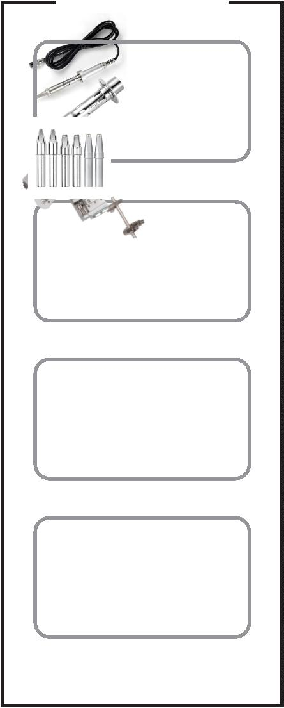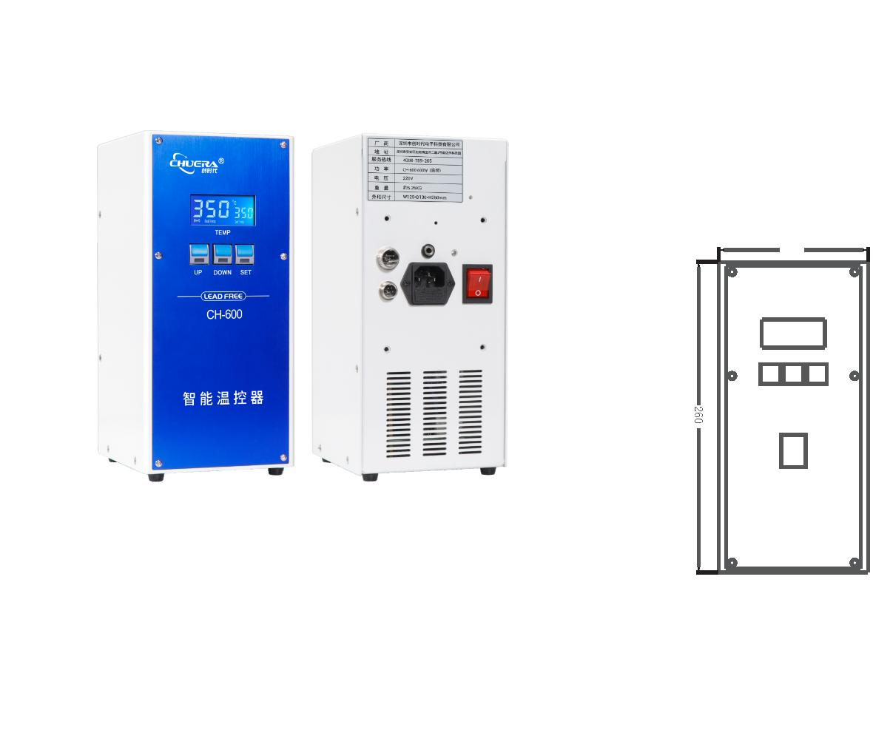

®
Constant temperature controller
CH-150( WiFi)/
00( WiFi)/320( WiFi)
2
High-frequency thermostat
※
With high-frequency eddy current heating, the temperature rise and temperature return speed are fast, and lead-free soldering is
realized;
※
※
※
※
※
Extra-large LCD display, dual digital display of real-time temperature and set temperature;
With microcomputer control, push-button temperature adjustment, digital temperature calibration;
With the password-type temperature locking function, the production process is effectively safeguarded;
With plug-and-play design of heating core, maintenance is more convenient;
With temperature alarm output, the upper and lower temperature alarm ranges can be set by you. If the process range is exceeded,
an alarm is generated and a signal is output.
※The display screen has a Chinese operation interface, making function setting more convenient;
※Network communication is available to enable interaction with the PC. Wired connection is standard and wireless connection is
optional.
Panel color is optional, default is black
2
6

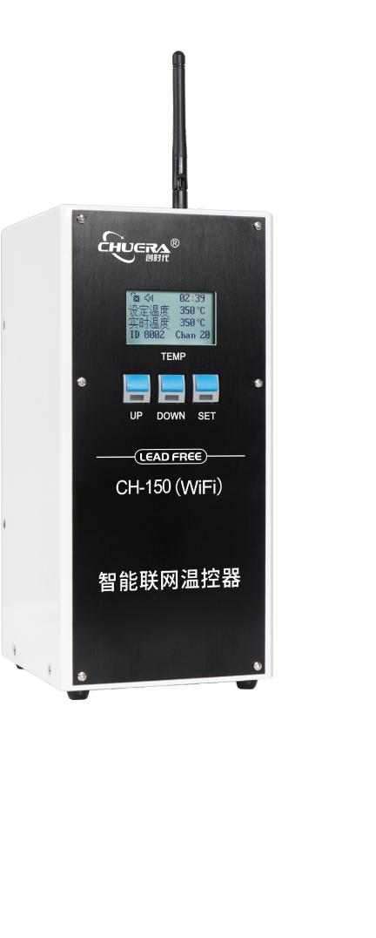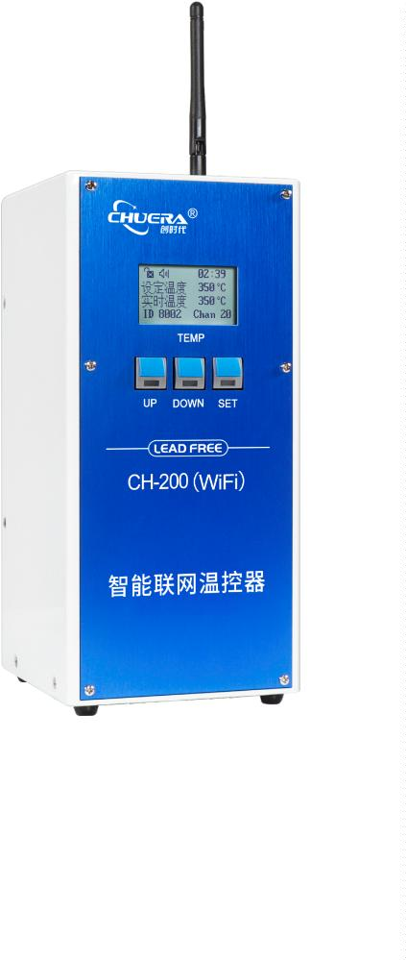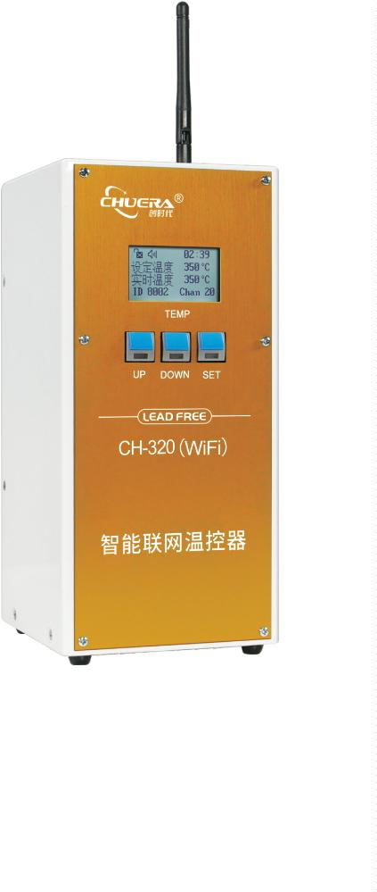

®
Constant temperature controller
Speciﬁcation:
Product model
CH-150(WiFi)
CH-200(WiFi)
CH-320(WiFi)
320W
Operating voltage
AC220V/50HZ AC110V/60HZ
Maximum instantaneous
power
Above earth resistance of
soldering iron
1
50W
200W
﹤ 2Ω
Temperature calibration
method
Digital correction
Temperature range
5
0~550°C
Temperature stability (no
load)
±
2°C
Above earth potential of
soldering iron
﹤2mV
Overall dimensions
Weight
L125*W130*H260mm
About 5.67Kg
_{About}5.9 3Kg
About About 5.9Kg
501G-320W handle
Applicable handle
Applicable heating core
9
11G-150W handle
911G-200W handle
VH200C Heating core
911G Series soldering tip
VH150C Heating core
VH320C Heating core
501G Series soldering tip
Applicable soldering iron
tip
9
11G Series soldering tip
Standard optional
accessories
9
11G-150W handle
911G-200W handle
501G-320W handle
VH150C Heating core
VH200C Heating core
VH320C Heating core
911G Series soldering tip
501G Series soldering tip
CH003/CH003Q/CH004Q handle collet

27
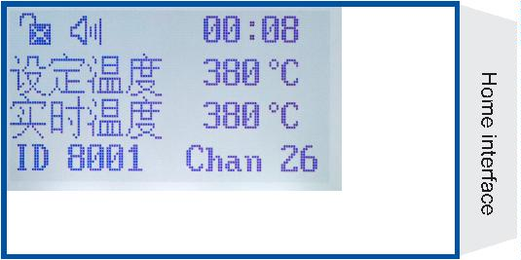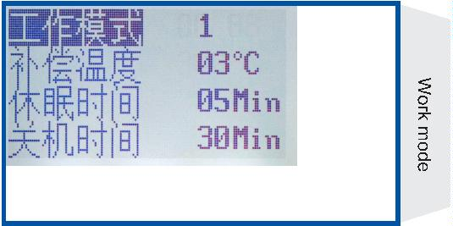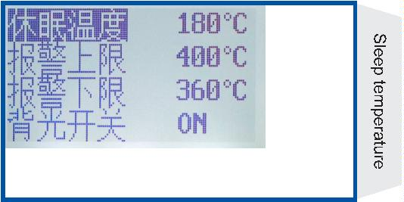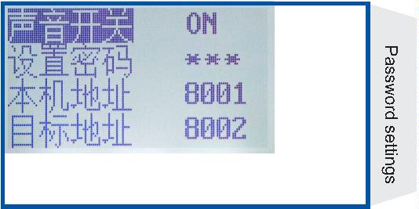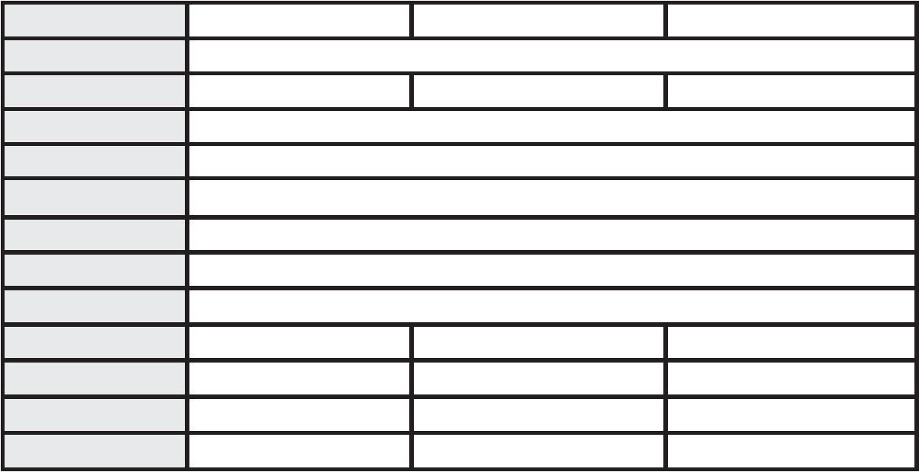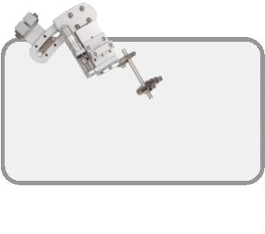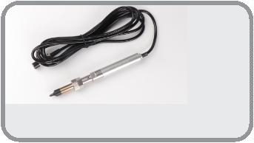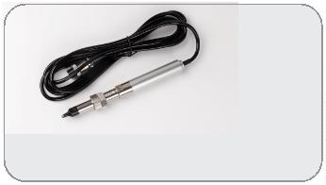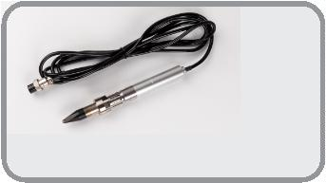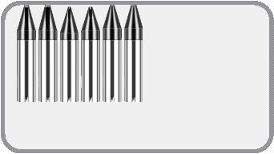

®
Costant temperature controller
CH-2800/4800/6800
High-frequency thermostat
※
With high-frequency eddy current heating, the temperature rise and temperature return speed are fast, and lead-free soldering is
realized;
※
※
※
Color screen 2.4 inch large screen digital display, with the resolution of 320 * 240;
With Chinese operation interface, function settings are more convenient;
With real-time temperature and set temperature double digital display, temperature comparisons are clear at a glance, with the
ability to display temperature curves for more obvious temperature comparisons; With 3 temperature memory modes, for one-
touch switching;
※
※
※
With microcomputer control, push-button temperature adjustment, digital temperature calibration;
With the password-type temperature locking function, the production process is effectively safeguarded;
With plug-and-play design of heating core, maintenance is more convenient; silver alloy thermal conductive material is employed
for long life and fast temperature rise and return;
※
With temperature alarm output, the upper and lower temperature alarm ranges can be set by you. If the process range is exceeded,
an alarm is generated and a signal is output;
※
※
※
※
With network communication function, it can realize interactive communication with PC;
MODBUS RTU standard protocol, 485 interface/2.4GWIFI is adopted to realize multi-machine networking and unified management;
In this series, 280W, 480W, 680W power can be selected, and a variety of soldering iron tip positioning methods are matched;
Separately, they can be matched with: 911G series, 4800 series, 6800 series conventional soldering iron tips.
2
8

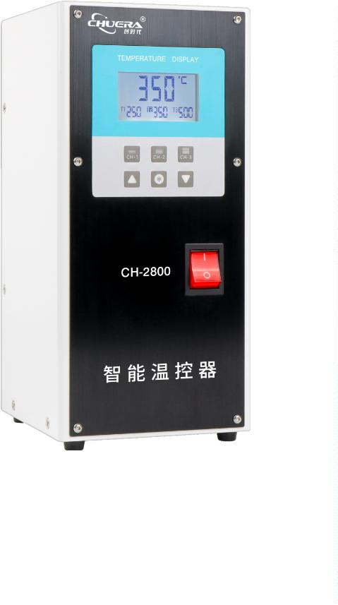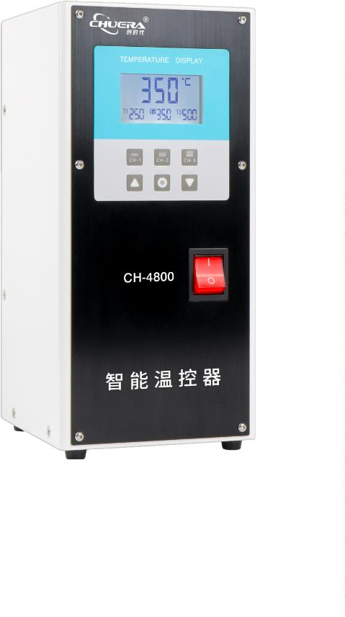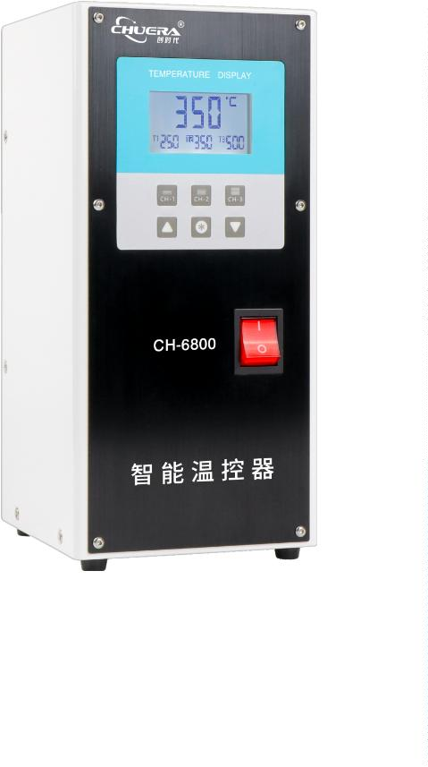

®
Constant temperature controller
Speciﬁcations:
Product model
CH-2800
CH-4800
AC220V/50HZ AC110V/60HZ
480W
CH-6800
680W
Operating voltage
Maximum instantaneous
power
2
80W
Above earth resistance
of soldering iron
Temperature calibration
method
﹤
2Ω
Digital correction
0~550°C
2°C
2mV
Temperature range
5
Temperature stability
(no load)
±
Above earth potential of
soldering iron
﹤
Overall dimensions
L125*W130*H260mm
Temperature memory
mode
T1 T2 T3 three shortcut keys
Temperature alarm
output
Switch closing signal (normally open)
Online communication
Wired connection or 2.4GWIFI wireless (PC side requires wireless receiver)
Weight
About5.6Kg
About
.6Kg
5
About 5.6Kg
Applicable handle
Applicable heating core
2
80W handle
480W handle
480W Heating core
480 Series soldering tip
600W handle
6
80W Heating core
2
80W Heating core
Applicable soldering
iron tip
9
11G Series soldering tip
680 Series soldering tip
Real-time temperature
T1/T2/T3
Temperature memory
Temperature up Conﬁrm key Temperature down

29
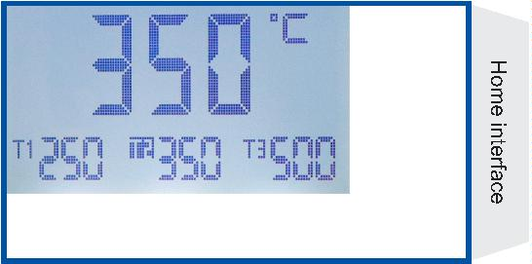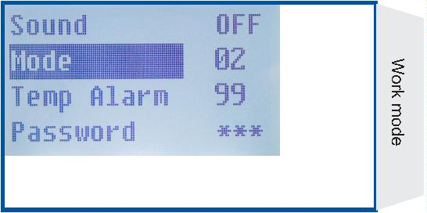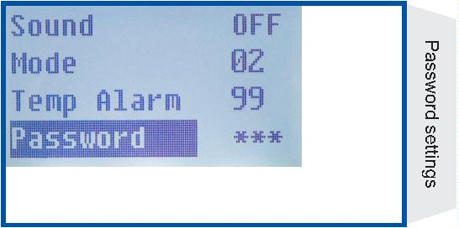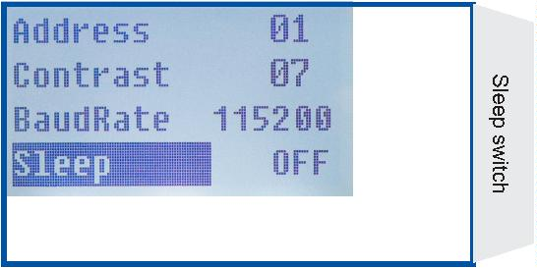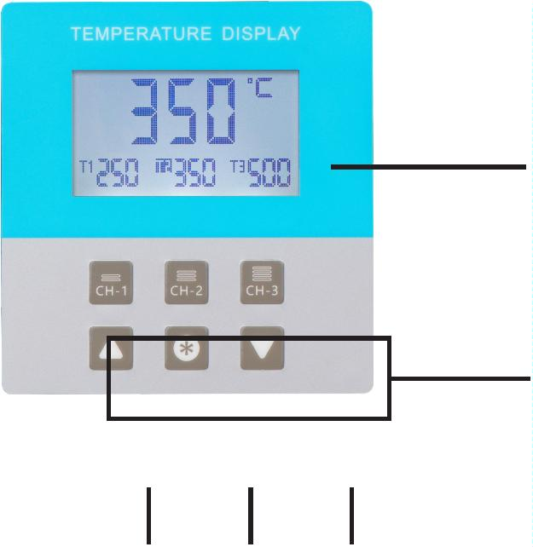

®
Constant temperature controller
CH-01A
Tin soldering machine intelligent thermostat
※
※
※
With 150W high power, to meet the lead-free soldering process;
With digital tube display, push-button temperature adjustment, digital temperature calibration;
With temperature alarm output, upper and lower temperature limits can be set. If the range is exceeded, an alarm is generated and a
signal is output.
※
※
With the password-type temperature locking function, the production process is effectively safeguarded;
Silver alloy thermal conductive material is employed by the heating core, which is heat-conducting, and it has fast temperature rise
and return;
Standard optional
accessories
1
10
WSP150 Heating core
LHT Series soldering tip
Locating nut
Speciﬁcations:
Operating voltage
AC220V/50HZ/AC110V/60HZ
Maximum instantaneous power
Soldering iron resistance to ground
Temperature correction method
Temperature tuowei
150W
2
m Highly ﬂexible cable
﹤ 2Ω
Digital correction
50~550°C
±2°C
Temperature stability (no load)
Soldering iron potential to ground
Dimensions
﹤ 2mV
L125*W110*H300mm
About 5.4Kg
CH001/CH001Q/CH001X
CH002Q handle collet
Weight
3
0

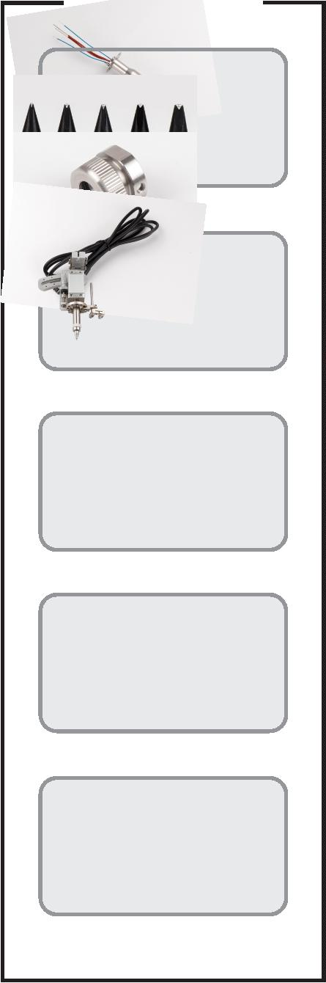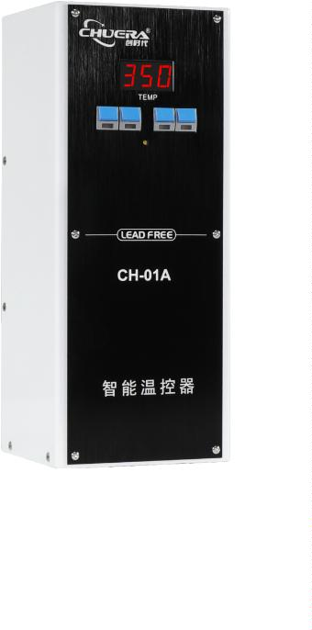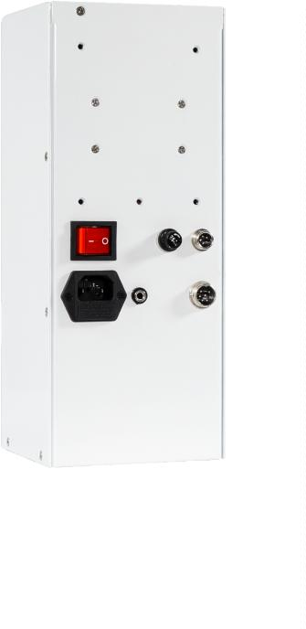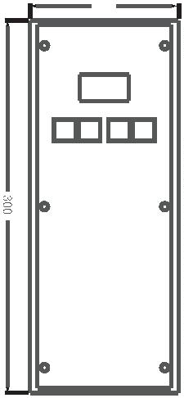

®
Constant temperature controller
CH-01
Tin soldering machine intelligent thermostat
※
※
※
※
With 150W high power, to meet the lead-free soldering process;
With digital tube display, push-button temperature adjustment, digital temperature calibration;
Network communication function can realize interactive communication with PC;
Dual display of real-time temperature and set temperature, upper and lower temperature limits can be set to alarm and output
signals;
※
The heating core is made of silver alloy thermal conductive material, which is heat conduction type and has fast heating and recovery
speed;
※
※
※
Microcomputer control, backlight LCD display, button temperature adjustment, digital temperature calibration;
Adopt MODBUS RTU standard protocol and 485 interface to realize multi-machine networking and unified management;
A network communication version is optional to enable interaction with the PC. Wired connection is standard and wireless
connection can be customized.
Standard optional
accessories
1
10
WSP150 Heating core
LHT Series soldering tip
Locating nut
Speciﬁcations:
Operating voltage
AC220V/50HZ/AC110V/60HZ
Maximum instantaneous power
Soldering iron resistance to ground
Temperature correction method
Temperature tuowei
150W
﹤ 2Ω
2
m Highly ﬂexible cable
Digital correction
50~550°C
±2°C
Temperature stability (no load)
Soldering iron potential to ground
Dimensions
﹤ 2mV
L125*W110*H300mm
CH001/CH001Q/CH001X
Weight
About 5.4Kg
CH002Q handle collet

31
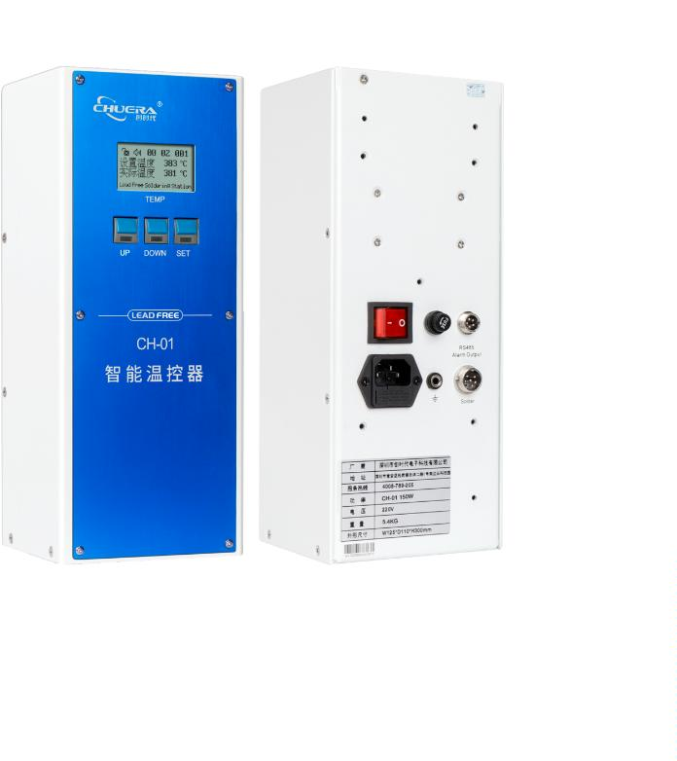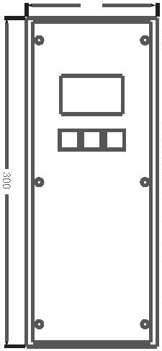

®
Constant temperature controller
CH-02
Tin soldering machine intelligent thermostat
※
※
※
※
With 200W high power, to meet the lead-free soldering process;
With digital tube display, push-button temperature adjustment, digital temperature calibration;
Network communication function can realize interactive communication with PC;
Dual display of real-time temperature and set temperature, upper and lower temperature limits can be set to alarm and output
signals;
※
The heating core is made of silver alloy thermal conductive material, which is heat conduction type and has fast heating and recovery
speed;
※
※
※
Microcomputer control, backlight LCD display, button temperature adjustment, digital temperature calibration;
Adopt MODBUS RTU standard protocol and 485 interface to realize multi-machine networking and unified management;
A network communication version is optional to enable interaction with the PC. Wired connection is standard and wireless
connection can be customized.
1
10
Standard optional
accessories
WXP200 metallic handle
WXP200 Heating core
Speciﬁcations:
Operating voltage
AC220V/50HZ/AC110V/60HZ
Maximum instantaneous power
Soldering iron resistance to ground
Temperature correction method
Temperature tuowei
200W
﹤2Ω
2
m Highly ﬂexible cable
Digital correction
50~550°C
Temperature stability (no load)
Soldering iron potential to ground
Dimensions
±2°C
﹤ 2mV
L125*W110*H300mm
WXP Series soldering tip
Weight
About 6Kg
3
2

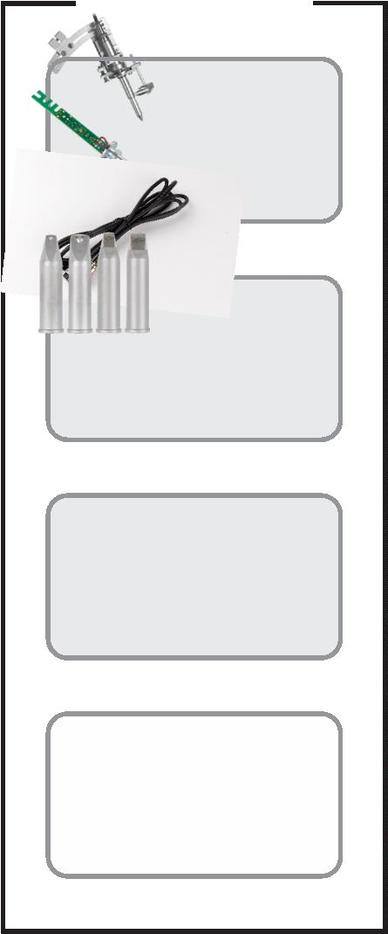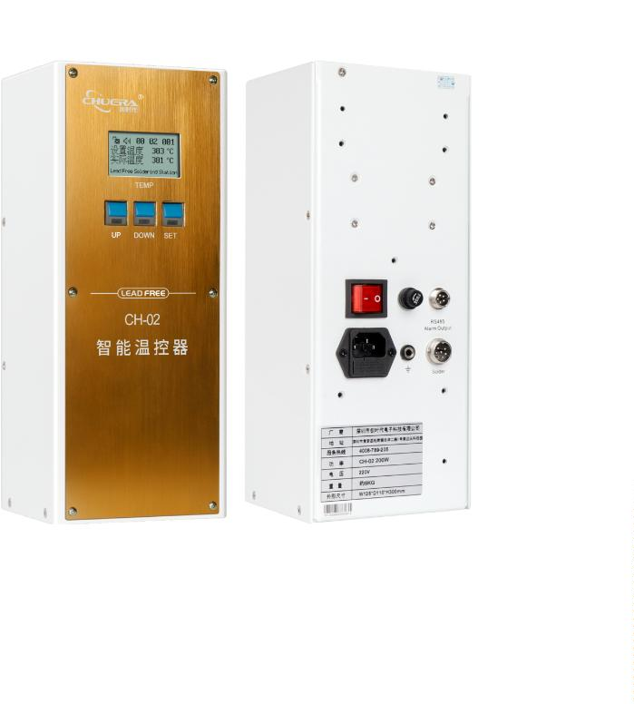

®
Soldering accessories
9
11G-150W/
Product name
9
11G-200W Metal handle
Style
Silver Standard
Standard with VH150C/
VH200C Heating core
Heating core
Standard with
Soldering iron tip
Handle tube diameter
Length
9
11G Series soldering tip
φ17
Total length 198mm
tail pipe 77mm
Product name
911G-150W/
11G-200W Metal handle
9
Right angle short section
Style
Standard with VH150C/
VH200C Heating core
Heating core
Standard with
Soldering iron tip
Handle tube diameter
Length
9
11G Series soldering tip
φ17
Total length 163mm
tail pipe 60mm
9
11-150W/200W
Product name
White/black steel handle
Three-piece handle set optional
Style
Standard with VH150C/
VH200C Heating core
Heating core
Standard with
Soldering iron tip
Handle tube diameter
Length
9
11/911H Series soldering tip
φ17
Total length 150mm
tail pipe 60mm
9
11-150W/200W
Product name
9
11H-150/200W
Metal handle
Style
Three-piece handle set optional
Standard with VH150C/
VH200C Heating core
Heating core
Standard with
Soldering iron tip
Handle tube diameter
Length
9
11/911H Series soldering tip
φ17
Total length 153mm
tail pipe 60mm

33
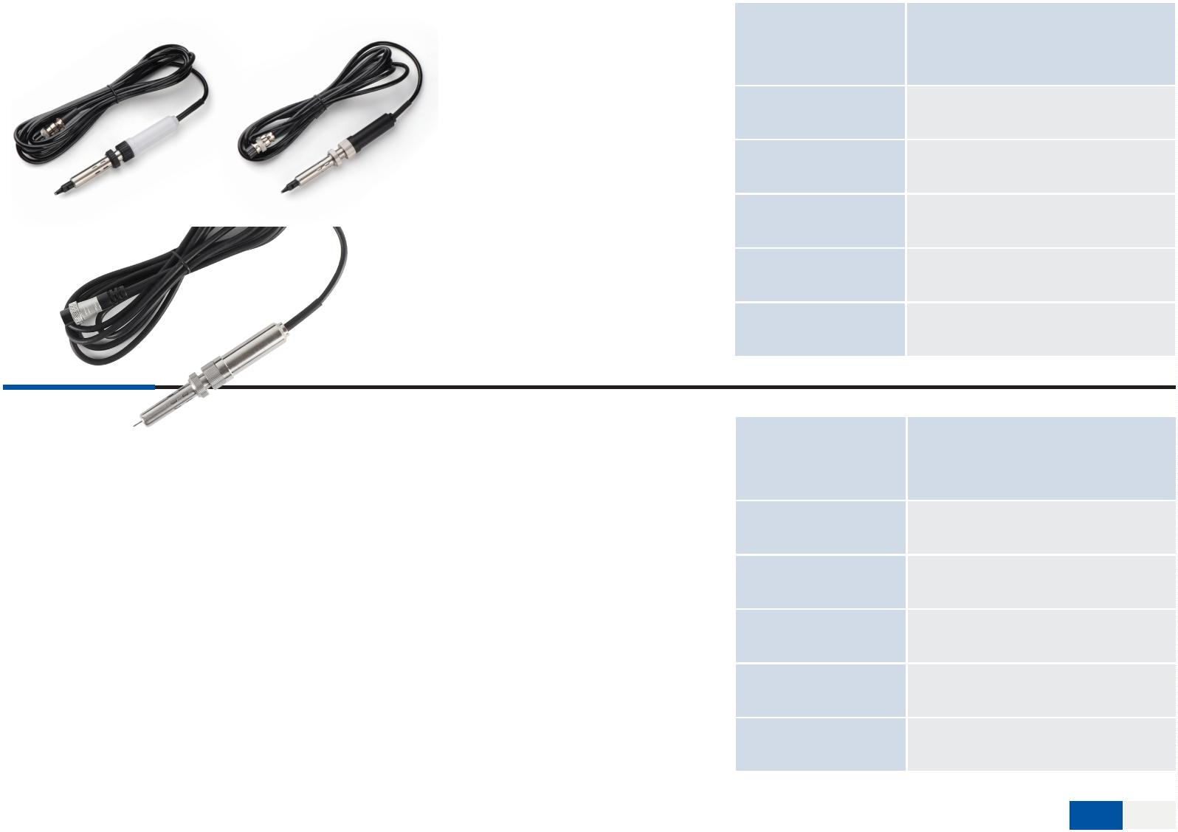

®
Soldering accessories
Product name
Style
5
01G-320W Metal handle
Silver Standard
Standard with VH320C
Heating core
Heating core
Standard with 501G
Soldering iron tip
Handle tube diameter
Length
Series soldering tip
φ20
Total length 187mm
tail pipe 79mm
Product name
Style
600W Metal handle
Silver Standard
Standard with 600W
Heating core
Heating core
Standard with 600
Soldering iron tip
Handle tube diameter
Length
Series soldering tip
φ20
Total length 187mm
tail pipe 79mm
Product name
Style
WXP150 Metal handle
Silver Standard
Standard with WXP150
Heating core
Heating core
Standard with WXP150
Soldering iron tip
Handle tube diameter
Length
Series soldering tip
φ17
Total length 200mm
tail pipe 85mm
Product name
WXP200 Metal handle
Style
Silver short
Standard with WXP200
Heating core
Heating core
Soldering iron tip
Standard with WXP200
Series soldering tip
Handle tube diameter
φ17
Final length 60mm
Length
Plus the aviation plug is 68mm
The total length including the
soldering iron tip is 160mm
3
4

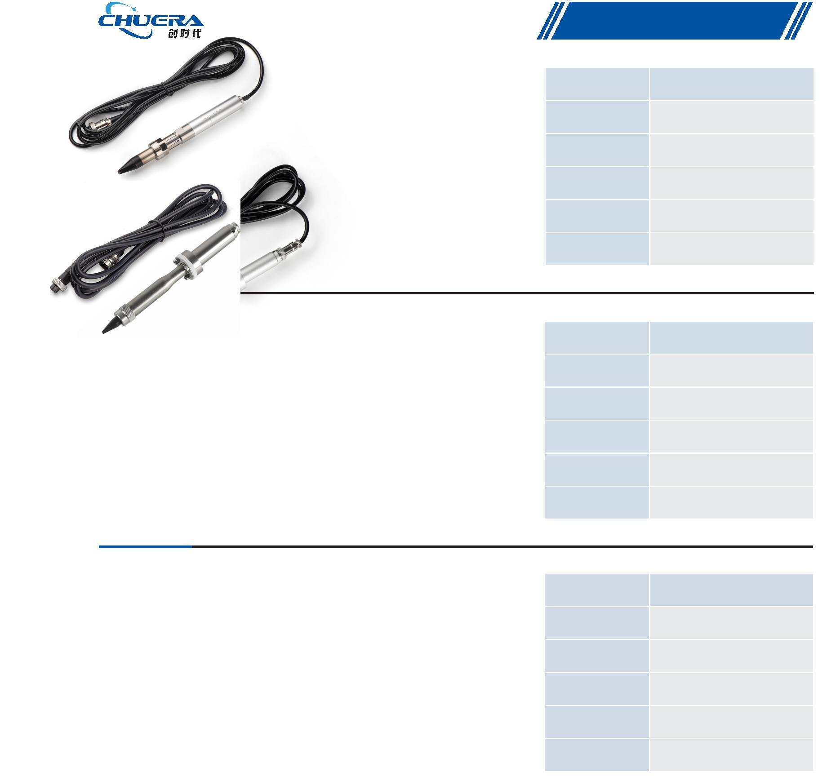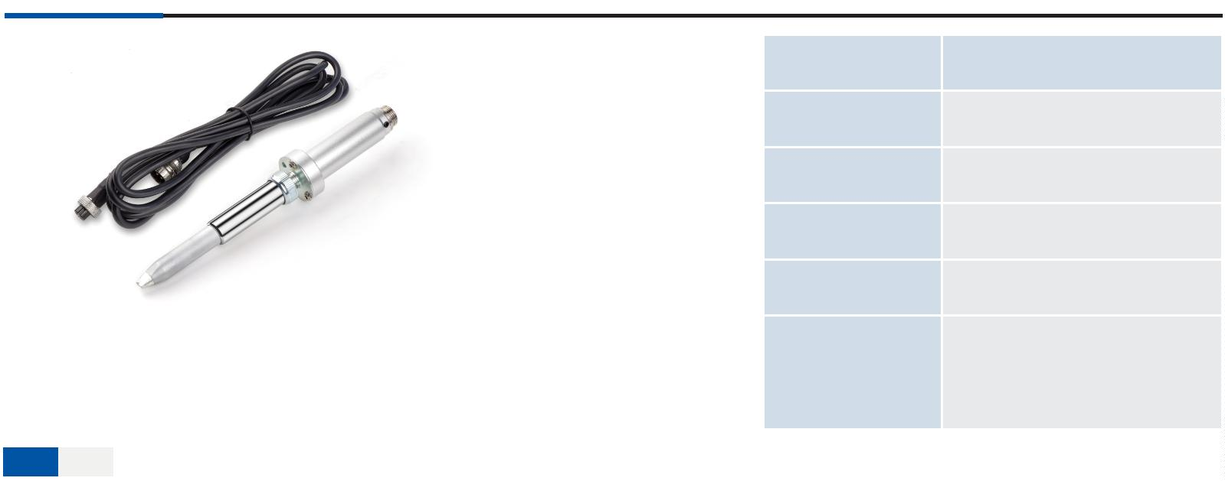

®
Soldering accessories
Product name
Soldering machine chuck
Chuera
Brand
Model
CH001
Material
Weight
Aluminum
0
.5Kg
Suitable for heated
handles
CH01/CH01A
Heating core WSP150
Size
1
30*185
Product name
Soldering machine chuck
Brand
Model
Chuera
CH001Q
Material
Weight
Aluminum
0
.5Kg
Suitable for heated
handles
CH01/CH01A
Heating core WSP150
Size
1
16*215mm
Product name
Soldering machine chuck
Chuera
Brand
Model
CH001X
Material
Weight
Auminum
0
.5Kg
Suitable for heated
handles
CH01/CH01A
Heating core WSP150
Size
1
30*185

35
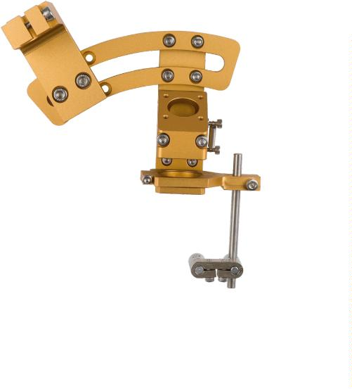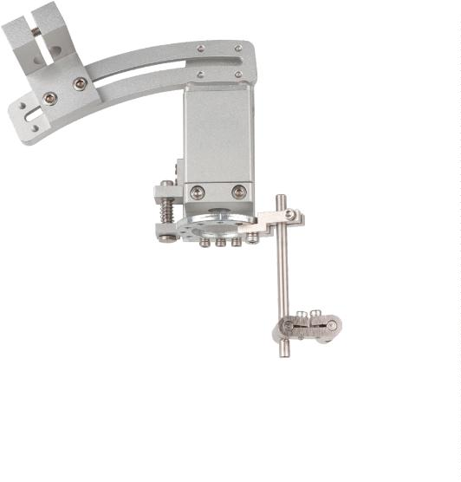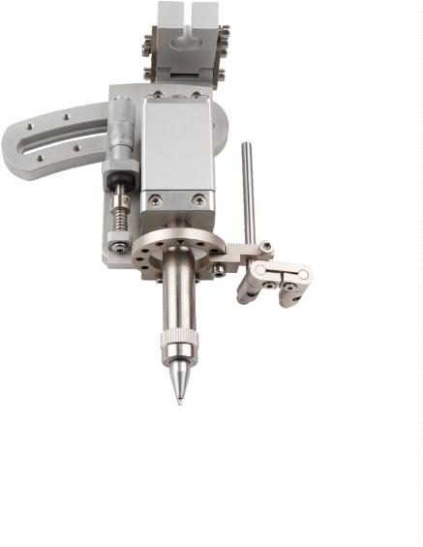

®
Soldering accessories
1
30
Product name
Soldering machine chuck
Brand
Model
Chuera
CH003
Material
Weight
Aluminum
0
.5Kg
Suitable for heated
handles
CH150/CH200/CH320
（
The aperture is φ20mm)/CH02
φ28
Size
1
30*185mm
Product name
Soldering machine chuck
Brand
Model
Chuera
CH003Q
Material
Weight
Aluminum
0.5Kg
CH150/CH200/CH320
Suitable for heated
handles
(The aperture is φ20mm)/CH02
Size
1
15*197mm
Product name
Soldering machine chuck
Brand
Model
Chuera
CH701
Material
Weight
Aluminum
0
.5Kg
Suitable for heated
handles
CH150/CH200/CH320
The aperture is φ20mm)/CH02
（
Size
1
00*89mm
3
6

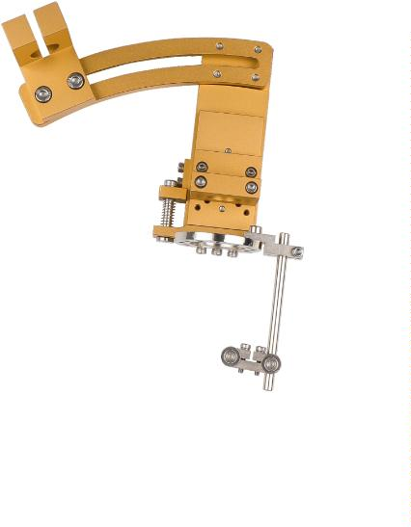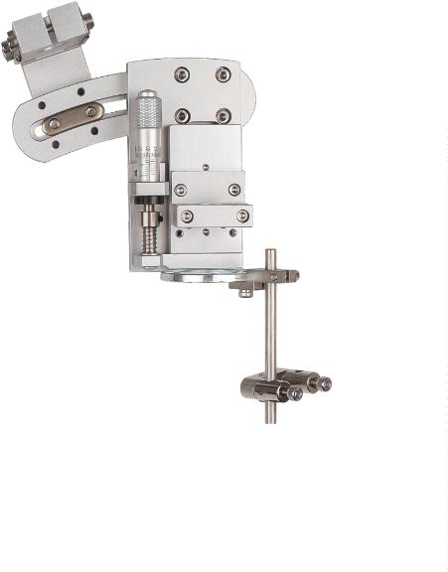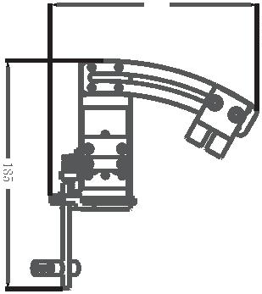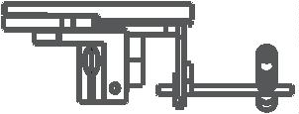

®
Soldering accessories
Product name
Model
Soldering machine chuck
CH002Q
Material
Weight
Made of aluminum
1Kg
Suitable for heated
handles
CH01/CH01A
Heating core WSP150
2
16*131.5mm
Size
Center distance 40mm-165mm
2
16
Product name
Model
Soldering machine chuck
CH004Q
Aluminum
1Kg
Material
Weight
Suitable for heated High frequency thermostat
handles
2
16*165mm
Size
Center distance 40mm-165mm
Product name
Model
Soldering machine chuck
CH004Q-400
Material
Weight
Aluminum
1
.5Kg
Suitable for heated
handles
CH150/CH200/CH320
The aperture is φ20mm）/CH02
（
Size
432*165mm
Product name
Model
Soldering machine chuck
CH005Q
Aluminum
1Kg
Material
Weight
CH150/CH200/CH320
（The aperture is φ20mm）
Suitable for heated
handles
/
CH02/WSP150
216*314mm
Size
Center distance 40mm-235mm

37
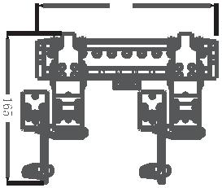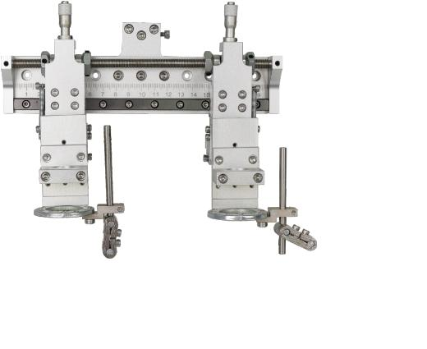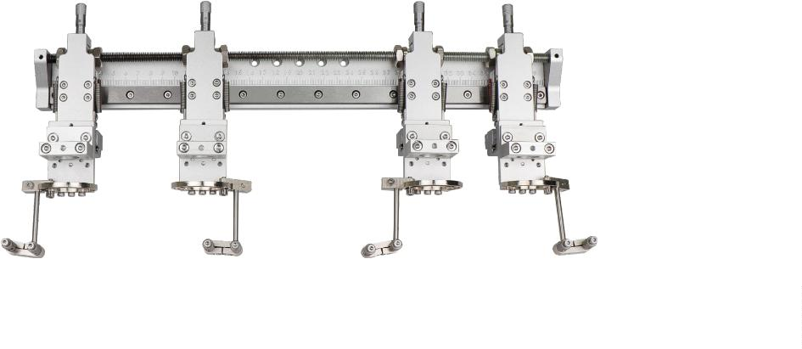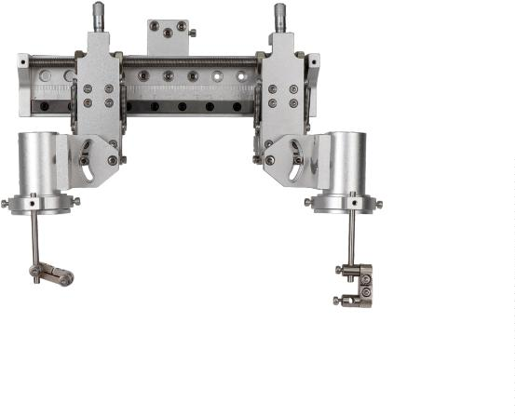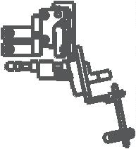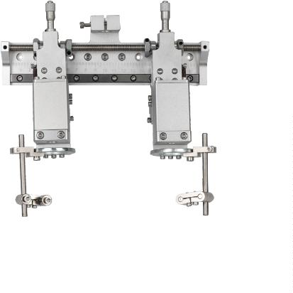

®
Soldering accessories
Features:
※
Using high-precision stepper motors to achieve
precise and stable tin feeding and output
※
※
Imported tungsten steel blade, durable in use
Left and right options available, tin wire
diameter adjustable
CH 201 Tin cutting machine
Features:
※
Using high-precision stepper motors to achieve
precise and stable tin feeding and output
※
※
Specially made tin wheel, durable in use
Left and right options available, tin wire
diameter adjustable
CH 202 Tin feeding machine
Speciﬁcation
Model
CH201
CH202
stepper motor
20W
stepper motor
20W
Motor
Motor power
Scope of application of tin wire
Tin delivery accuracy
Tin return accuracy
Tin tip
0.6-1.6mm
0.4-1.4mm
±0.1mm
±0.1mm
±0.1mm
±0.1mm
0.8/1.0/1.2/1.6/1.8
1Kg
0.6/0.8/1.0/1.2/1.6/1.8
1Kg
Weight
Size
L179mmW80mmH100mm
Tin cutting
L179mmW80mmH100mm
Tin feeding
Tin feeding/Tin cutting
3
8

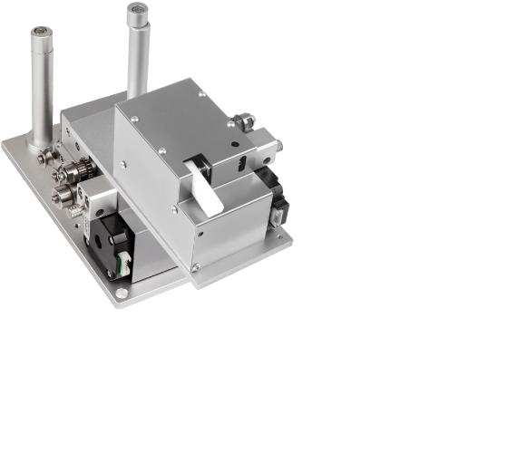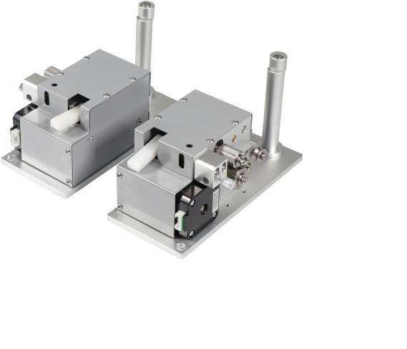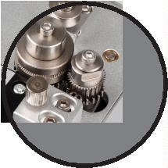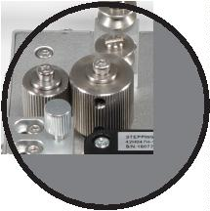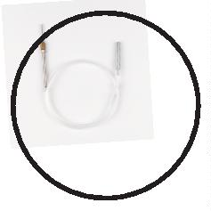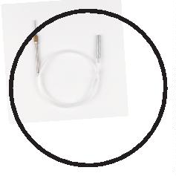

®
Soldering accessories
Features:
Using high-precision stepper motor to
achieve precise tin feeding and accurate and
stable tin output
The center point is precisely positioned and
adjusted to prevent the soldering wire from
shifting.
Clogging tin alarm function
※
※
※
※
※
High-quality stainless steel balls, long
service life
Left and right options available, tin wire
diameter adjustable
No clogging tin alarm function + tin blocking
alarm output
CH 101 Tin feeding machine
/
CH 102 Tin feeding machine（No clogging tin alarm function）
※Specially made tin wheel, durable in use
Features:
Clogging tin alarm function
※
※
Using high-precision stepper motor to
achieve precise tin feeding and accurate and
stable tin output
The center point is precisely positioned and
adjusted to prevent the soldering wire from
shifting.
※
※
※
※
High-quality stainless steel balls, long service
life
Left and right options available, tin wire
diameter adjustable
No clogging tin alarm function + tin blocking
alarm output
Imported tungsten steel toothed blades
punch holes in the tin wire so that the flux
overflows from the holes when heated at high
temperatures, effectively preventing tin
explosions and avoiding tin bead splashes.
CH101T Tin cutting machine
/Ch102Ｔ Tin cutting machine（No clogging tin alarm function）
Speciﬁcation
Model
CH101/102
CH101T/102T
stepper motor
20W
stepper motor
20W
Motor
Motor power
Scope of application of tin wire
Tin delivery accuracy
Tin return accuracy
Tin tip
0.4-1.4mm
0.6-1.4mm
±0.1mm
±0.1mm
±0.1mm
±0.1mm
0.6/0.8/1.0/1.2/1.6/1.8
1Kg
0.8/1.0/1.2/1.6/1.8
1Kg
Weight
Size
L189mmW80mmH100mm
Tin cutting
L189mmW80mmH100mm
Tin feeding
Tin feeding/Tin cutting

39
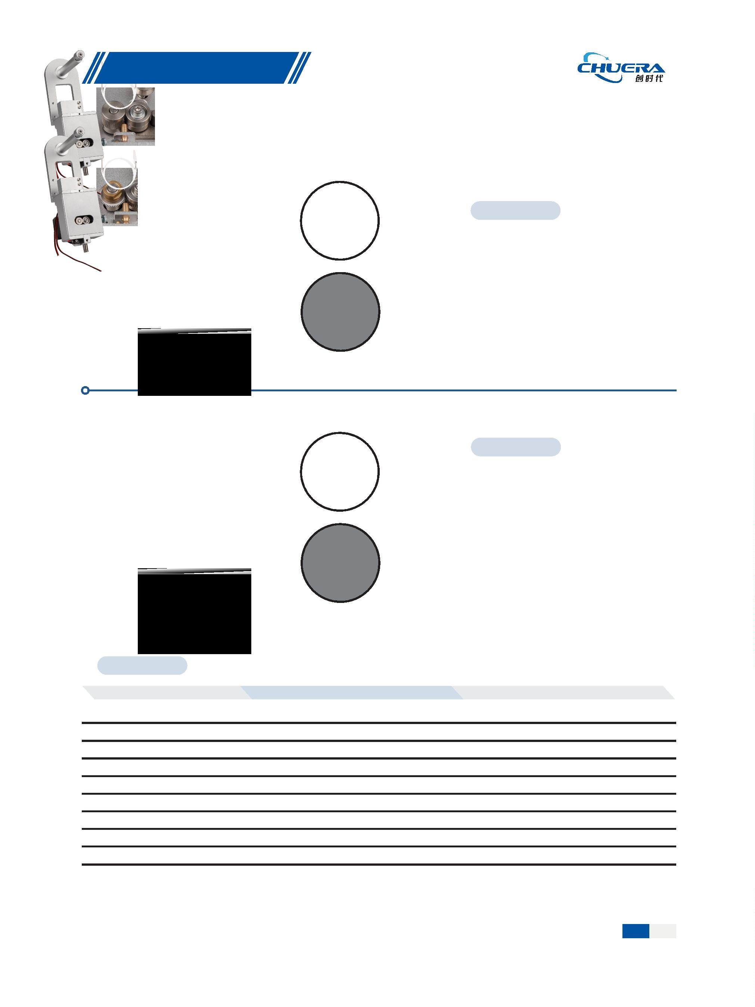

®
Soldering accessories
Features:
※
※
Using high-precision stepper motor to achieve
precise tin feeding and accurate and stable tin
output
The center point is precisely positioned and
adjusted to prevent the soldering wire from shifting.
High-quality stainless steel balls, long service life
Left and right options available, tin wire diameter
adjustable
※
※
※
Imported tungsten steel toothed blades punch holes
in the tin wire so that the flux overflows from the
holes when heated at high temperatures, effectively
preventing tin explosions and avoiding tin bead
splashes.
CH100 Tin cutting machine
Features:
※
※
Using high-precision stepper motor to achieve
precise tin feeding and accurate and stable tin
output
The center point is precisely positioned and
adjusted to prevent the soldering wire from
shifting.
CH101W
※
※
High-quality stainless steel balls, long service life
Imported tungsten steel toothed blades punch
holes in the tin wire so that the flux overflows from
the holes when heated at high temperatures,
effectively preventing tin explosions and avoiding
tin bead splashes.
CH101WT
CH101W Combined double tin feeding
Features:
※
Using high-precision stepper motor to achieve
precise tin feeding and accurate and stable tin
output
※
The center point is precisely positioned and
adjusted to prevent the soldering wire from
shifting.
※
※
High-quality stainless steel balls, long service
life
Imported tungsten steel toothed blade
CH101WT
CH106T Tin feeding machine
Speciﬁcation
Model
CH100
CH101W
CH106T
stepper motor
stepper motor
20W
stepper motor
Motor
Motor power
20W
0.8-1.4mm
±0.15mm
±0.15mm
1.0/1.2/1.6/1.8
1Kg
20W
0.6-1.6mm
±0.1mm
Scope of application of tin wire
Tin delivery accuracy
Tin return accuracy
Tin tip
0.4-1.4mm
±0.1mm
±0.1mm
±0.1mm
0.6/0.8/1.0/1.2/1.6/1.8
2Kg
0.8/1.0/1.2/1.6/1.8
2Kg
Weight
Size
L179mmW80mmH100mm
L189mmW160mmH100mm
L185mmW75mmH50mm
Tin feeding/Tin cutting
Tin cutting
Tin feeding
Tin cutting
4
0

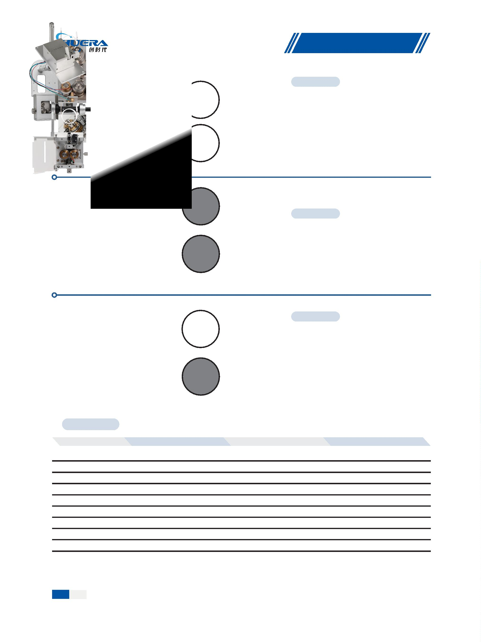

®
Soldering accessories
Features:
※
Air blowing method to clean the soldering
iron tip.
※
※
※
The drawer-type tin slag box is easy to
clean
High quality solenoid valve, long service
life
Beautiful appearance design, high-end
CH 2000 Soldering machine cleaning box
Features:
※
※
Prevent tin slag from splashing when cleaning
Prevent the soldering iron tip from moving
during cleaning
Special hair brush
※
※
※
Can effectively remove oxides from the
welding tip without damaging the welding tip
The tin slag box can be taken out to facilitate
the cleaning of tin slag.
Using 0.08 stainless steel brush to prevent
damage to the welding tip
CH 3000A Soldering machine cleaning box
Features:
※
Prevent tin slag from splashing when
cleaning
※
※
Prevent the soldering iron tip from moving
during cleaning
Can effectively remove oxides from the
welding tip without damaging the welding
tip
Special hair brush
※
The tin slag box can be taken out to
facilitate the cleaning of tin slag.
CH 3000 Soldering machine cleaning box
※Using 0.08 stainless steel brush to prevent
damage to the welding tip
Speciﬁcation
Model
CH2000
.1W
None
CH3000A
CH3000
0
5W
DC24V 50mA
0.6 W
5W
DC24V 50mA
0.6 W
Power
Motor
0
W
Standby power
Dimensions
Weight
L120*W50*H90mm
0.83Kg
L152*W67*H64mm
0.78Kg
L155*W95*H85mm
1.17Kg
Brush speed
None
10000rmp
10000rmp

41
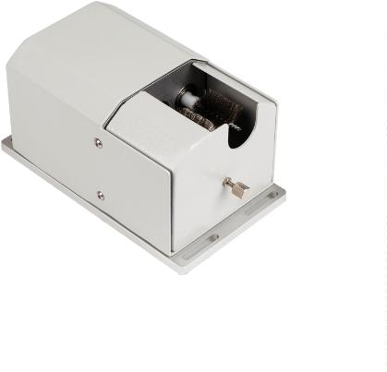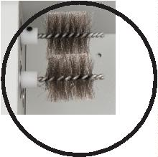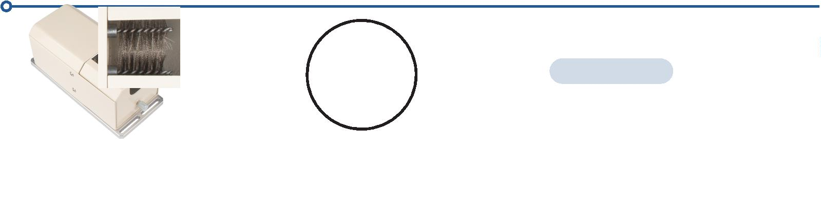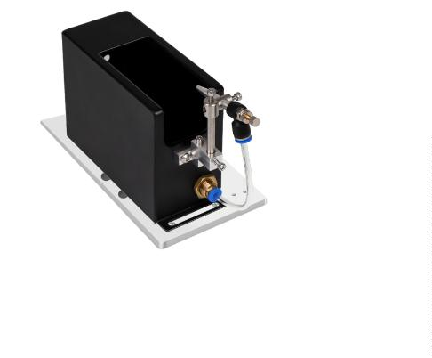

®
Soldering accessories
Model
31R
X-axis（mm) Y1-axis（mm) Y2-axis（mm) Z-axis（mm)
R-axis
360°
360°
360°
Size（mm)
3
300
400
500
300
400
400
/
/
/
100
100
100
H900*L590*W515
H900*L690*W615
H1000*L690*W615
Auto soldering machine
41R
Auto soldering machine
41R
Auto soldering machine
4
5
Model
-axis
Double soldering machine
-axis
Double soldering machine
X1-axis/X2-axis mm Y1-axis/Y2-axis mm Z1-axis/Z2-axis mm R1-axis/R2-axis mm Size（mm)
8
3
3
00
00
300
400
100
100
360°
360°
H880*L590*W1015
H880*L690*W1015
8
Model
441R
X-axis（mm) Y1-axis（mm) Y2-axis（mm) Z-axis（mm)
R-axis
Size（mm)
6
Double soldering machine
600
600
600
400
400
400
400
400
400
100
100
100
360°
H900*L690*W817
6
Double soldering machine
441
/
/
H900*L690*W817
H900*L690*W817
6441
Four-head soldering machine
4
2

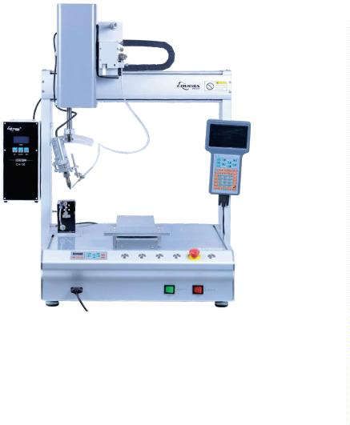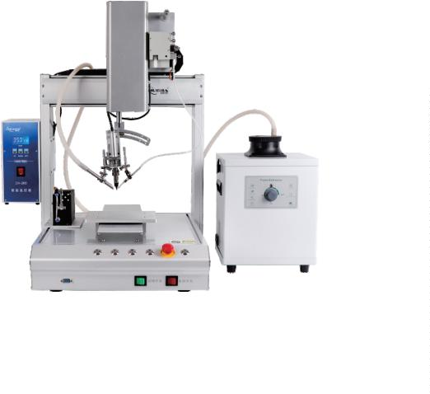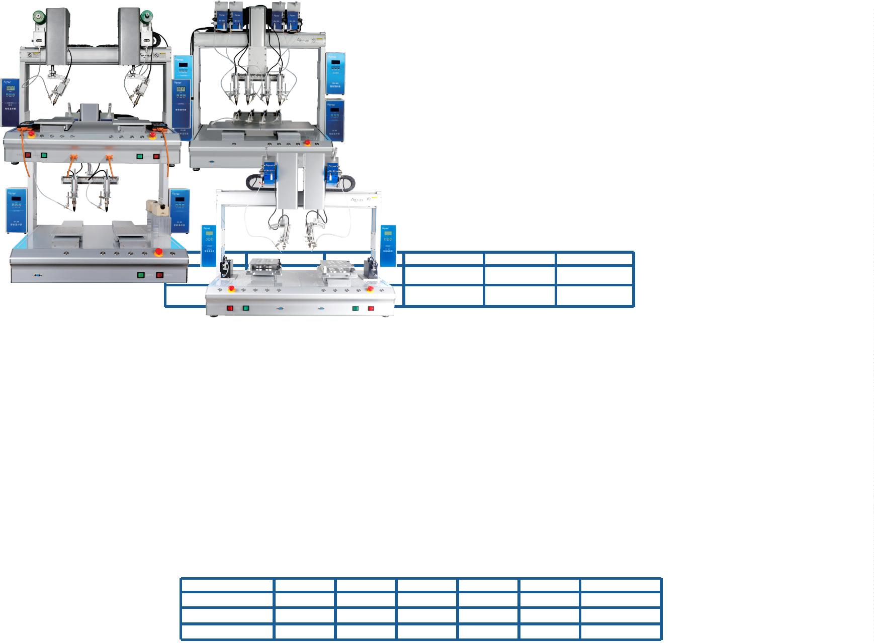

®
Repair welding machine
861D
Intelligent hot air dismantling soldering station
※
With sensor closed loop, microcomputer zero-trigger temperature control, high power, rapid warming, precise and stable temperature.
With LCD liquid crystal screen temperature and air volume dual display, it is more intuitive and convenient;
With three-channel quick temperature setting, it is convenient to set the temperature;
Air flow rate is adjustable, airflow is large and soft, and the temperature is easy to adjust, so it can be used for a variety of purposes;
Automatic cold air function is provided by the system to prolong the life of the heater and protect the hot air gun;
With advanced iron alloy chassis, the body is compact, beautiful and occupies a small area.
※
※
※
※
※
※
Brushless fans are used for extremely long life and low noise.
Standard optional
accessories
LT861D handle
H616A Heating core
3
mm
5mm
8mm
Speciﬁcation
Operating voltage
Maximum instantaneous power
Temperature stable
Airﬂow type
AC220V/50HZ
1000W
±2℃
Heat gun nozzle
Brushless vortex fan
100~500°C
Temperature range
Air volume level
Display method
Noise
Level 1-120
LED digital display (resolution 1°C)
＜40dB
Body weight
About 4Kg

43
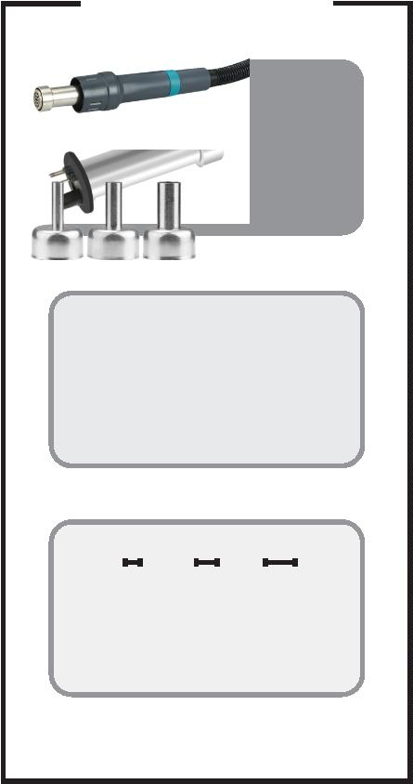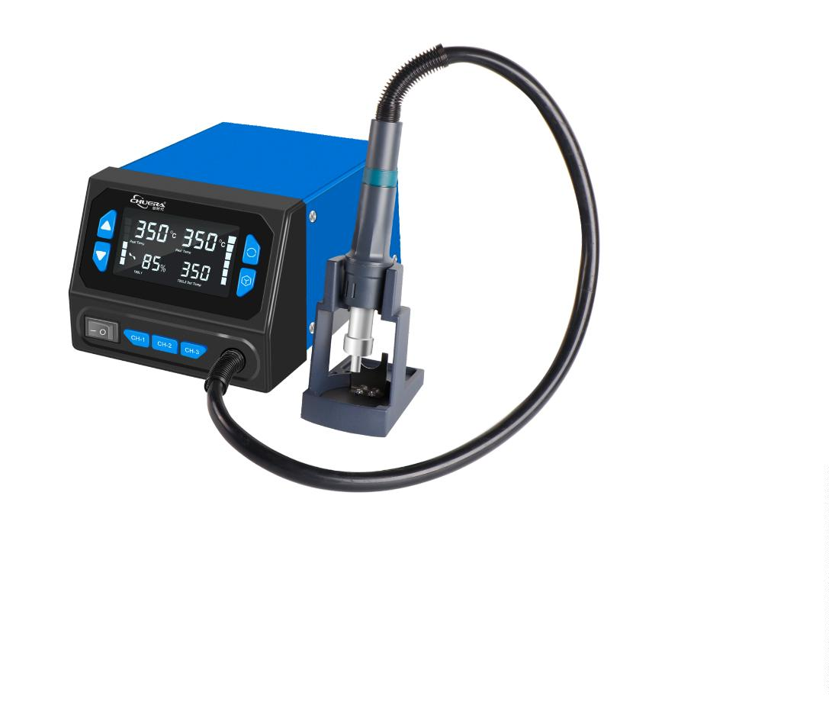

®
Repair welding machine
866D
Intelligent hot air dismantling
soldering station
Features:
※
With sensor closed loop, microcomputer zero-trigger temperature control, high power,
rapid warming, precise and stable temperature.
※
With LCD liquid crystal screen temperature and air volume dual display, it is more intuitive
and convenient;
With three-channel quick temperature setting, it is convenient to set the temperature;
Air flow rate is adjustable, airflow is large and soft, and the temperature is easy to adjust,
so it can be used for a variety of purposes;
※
※
※
Automatic cold air function is provided by the system to prolong the life of the heater and
protect the hot air gun;
※
※
With advanced iron alloy chassis, the body is compact, beautiful and occupies a small area.
Supports Celsius and Fahrenheit switching function.
Speciﬁcation
Operating voltage:
Product size:
AC220V /50Hz
153mm*121mm*98mm
Optional accessories:
Maximum instantaneous power: 700W
3mm
5mm 8mm
Temperature range:
Airﬂow type:
100℃～500℃
Brushless vortex fan
Air ﬂow volume:
120L/min(Max)
Display method: LED digital display (resolution 1°C)
Lt866热风枪手柄
H866热风枪发热丝
热风枪喷ꢍ
Noise:
＜45dB
About 1.4KG
Weight:
866D+
High-eﬃciency 2-in-1 soldering station
Features:
※
※
※
※
※
※
The use of hot air dismantling soldering station and electric soldering station constitutes a multi-
functional integrated dismantling and repair system;
With the perfect 2-in-1 combination, the body is compact, durable, beautiful, and occupies a small
workbench area;
Air gun and soldering iron working temperature and state is in the LCD screen double temperature
display at the same time, which is convenient and desirable to observe;
The hot air temperature and soldering station temperature are continuously adjusted by numerical
control buttons to meet different customer needs;
The power of the hot air gun is large, the heating is rapid, the airflow is soft, and the air volume is large,
which is very suitable for lead-free dismantling work;
Low-voltage power supply is adopted by the heater to supply power, which can effectively protect
sensitive devices and staff safety.
※
※
※
With three-channel quick temperature settings, it is convenient to set the temperature;
Individual switching of air gun and soldering station, and self-diagnostic function for fault detection;
Celsius and Fahrenheit switching function is supported;
Speciﬁcation
Switchboard:
Operating voltage:
AC220V/50HZ
770W
Maximum instantaneous power:
Working environment: 0～40℃ Relative humidity＜80％
Product size:
Heat gun part:
153mm*121mm*98mm
Optional accessories:
Maximum instantaneous power: 700W
3
mm
5mm 8mm
Temperature range:
Temperature stability:
Calibration method:
Soldering station part:
100℃-500℃ Air ﬂow 120L/min (maximum)
±2℃（static）
digital calibration
LT866D+handle
H866D+heating wire Heat gun nozzle
Maximum instantaneous power: 70W
Temperature range:
100℃～450℃
Temperature stability:
±2℃ （static）
digital calibration
Calibration method:
LT866D+ handle Plug-in heating core 900 Series soldering tip
＜
＜
2Ω
2mV
Welding tip impedance to ground:
Welding tip to ground voltage:
4
4

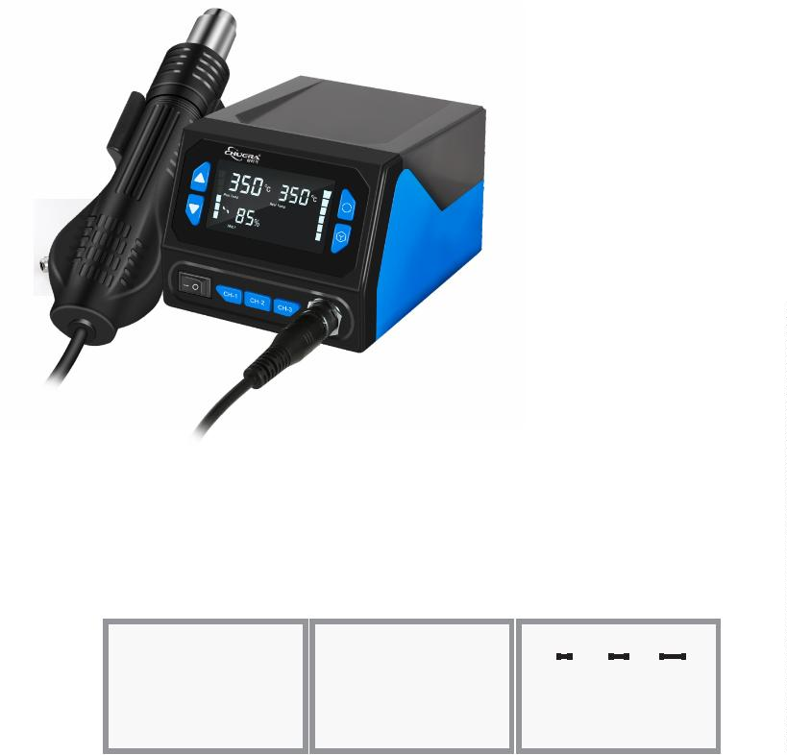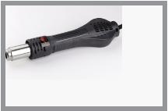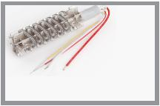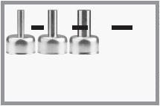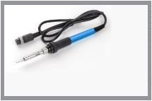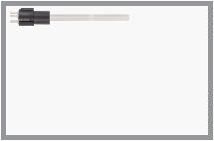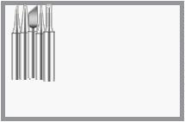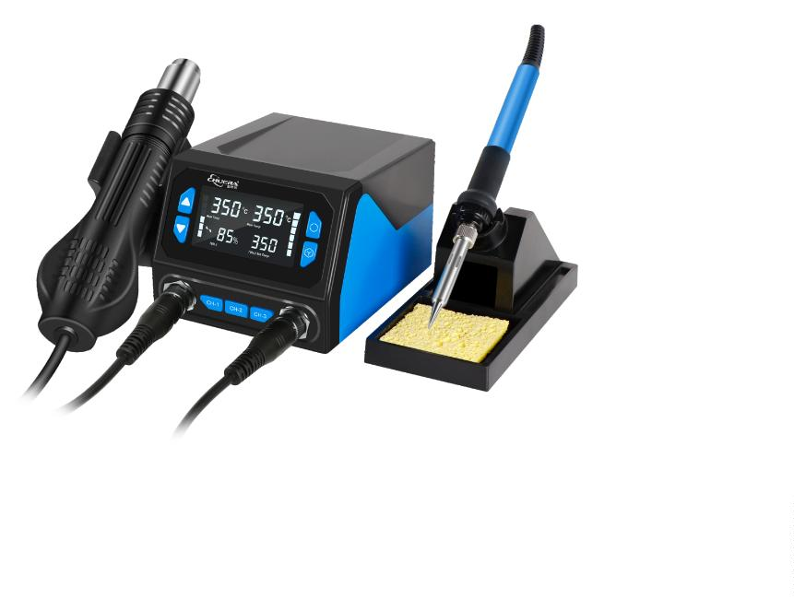

®
Repair welding machine
868D
Intelligent hot air dismantling
soldering station
Features:
※
With sensor closed loop, microcomputer zero-trigger temperature control, high power, rapid
warming, precise and stable temperature.
※
With LCD liquid crystal screen temperature and air volume dual display, it is more intuitive and
convenient;
※
※
※
With three-channel quick temperature setting, it is convenient to set the temperature;
Add a USB charging port to provide USB power supply and charging function;
Air flow rate is adjustable, airflow is large and soft, and the temperature is easy to adjust, so it can
be used for a variety of purposes;
※
Automatic cold air function is provided by the system to prolong the life of the heater and protect
the hot air gun;
※
※
Insulated anti-static casing, compact, beautiful and takes up little area;
Brushless fans are used for extremely long life and low noise.
Speciﬁcation
Operating voltage:
Usb interface:
AC220V /50Hz
5V/2A
Optional accessories:
Maximum instantaneous power: 700W
3
mm
5mm 8mm
Temperature range:
Airﬂow type:
100℃～500℃
Brushless fan soft wind
Air ﬂow volume:
120L/min(Max)
LED digital display (resolution 1°C)
Lt858 handle
H858 heating wire
Heat gun nozzle
Display method:
Noise:
＜45dB
About 1.67KG
Weight:
8586D
High-eﬃciency 2-in-1 soldering station
Features:
※
※
※
※
※
※
The use of hot air dismantling soldering station and electric soldering station constitutes a multi-
functional integrated dismantling and repair system;
With the perfect 2-in-1 combination, the body is compact, durable, beautiful, and occupies a small
workbench area;
Air gun and soldering iron working temperature and state is in the LCD screen double temperature
display at the same time, which is convenient and desirable to observe;
The hot air temperature and soldering station temperature are continuously adjusted by numerical
control buttons to meet different customer needs;
The power of the hot air gun is large, the heating is rapid, the airflow is soft, and the air volume is large,
which is very suitable for lead-free dismantling work;
Low-voltage power supply is adopted by the heater to supply power, which can effectively protect
sensitive devices and staff safety.
※
※
※
Add a USB charging port to provide USB power supply and charging function;
Individual switching of air gun and soldering station, and self-diagnostic function for fault detection;
Celsius and Fahrenheit switching function is supported;
Speciﬁcation
Switchboard:
Operating voltage:
AC220V/50HZ
Maximum instantaneous power: 780W
Working environment: 0～40℃ Relative humidity＜80％
Usb interface:
Heat gun part:
5V/2A
Optional accessories:
Maximum instantaneous power: 700W
3
mm
5mm 8mm
Temperature range: 150℃-500℃ Air ﬂow 120L/min (maximum)
Air ﬂow volume:
±2℃（static）
Calibration method:
Soldering station part:
digital calibration
LT858 handle
H858 heating wire
Heat gun nozzle
Maximum instantaneous power: 80W
Temperature range:
Temperature stability:
Calibration method:
200℃～480℃
±2℃ （static）
digital calibration
LT8586D handle
1324 heating core 900 Series soldering tip
Welding tip impedance to ground: ＜2Ω
Welding tip to ground voltage:
＜2mV

45
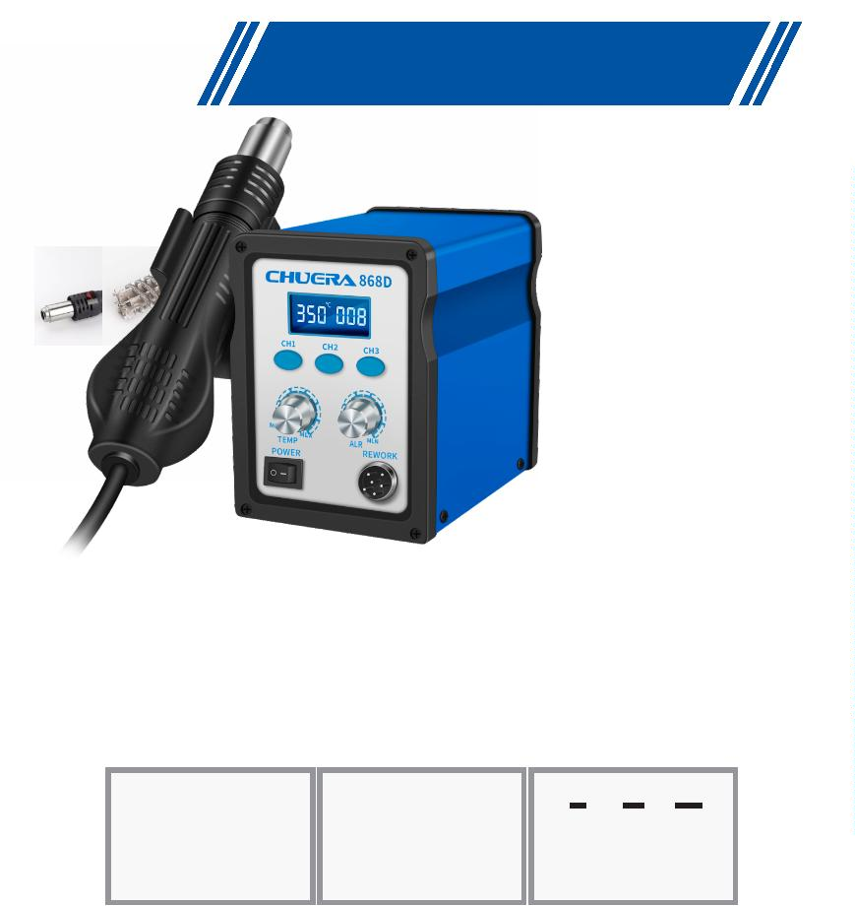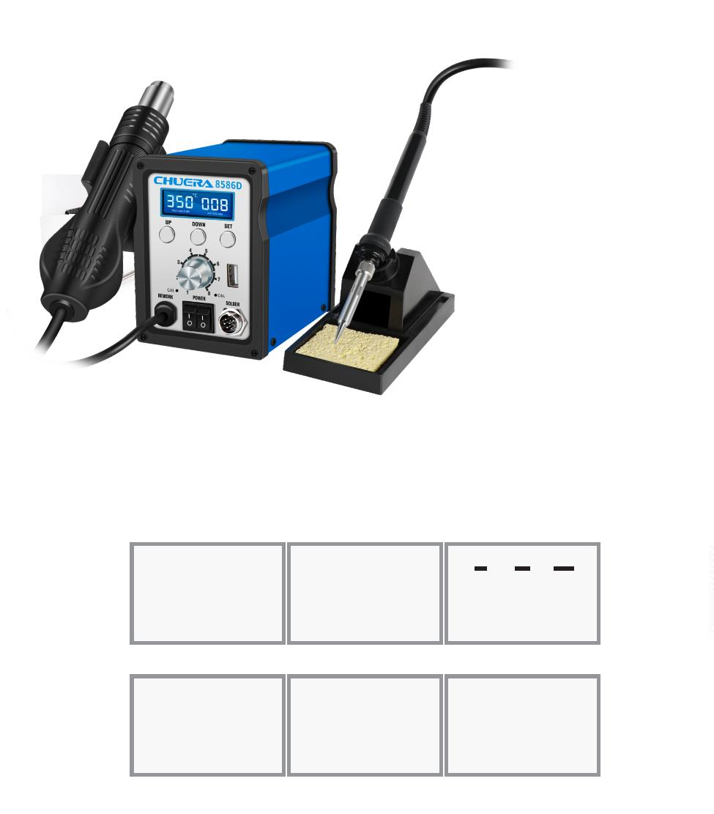

®
Repair welding machine
858D
Intelligent hot air dismantling
soldering station
Features:
※
With sensor closed loop, microcomputer zero-trigger temperature control, high power, rapid
warming, precise and stable temperature.
※
With LCD liquid crystal screen temperature and air volume dual display, it is more intuitive and
convenient;
With three-channel quick temperature setting, it is convenient to set the temperature;
Air flow rate is adjustable, airflow is large and soft, and the temperature is easy to adjust, so it can be
used for a variety of purposes;
※
※
※
Automatic cold air function is provided by the system to prolong the life of the heater and protect the
hot air gun;
※
※
With advanced iron alloy chassis, the body is compact, beautiful and occupies a small area.
Brushless fans are used for extremely long life and low noise.
Speciﬁcation
Operating voltage:
AC220V /50Hz
Maximum instantaneous power: 700W
Temperature range:
Airﬂow type:
100℃～500℃
Brushless fan soft wind
Optional accessories:
Air ﬂow volume:
120L/min(Max)
3
mm
5mm 8mm
LED digital display (resolution 1°C)
Display method:
Noise:
＜45dB
About 1.67KG
Weight:
290×190×155mm
580×485×340mm
10 sets/carton
LT858 handle
H858 heating wire
Heat gun nozzle
Package size:
Carton size:
Packing speciﬁcations:
8586
High-eﬃciency 2-in-1
soldering station
Features:
※
Using hot air desoldering station and electric soldering station to form a multi-functional integrated
desoldering repair system;
※
※
Perfect two-in-one combination, compact, durable, beautiful, and takes up little workbench area;
The dual-temperature LCD display simultaneously displays the working temperature and status of the air
gun and soldering iron, which is convenient and intuitive; ※The numerical control buttons continuously
adjust the hot air temperature and soldering station temperature to meet different desoldering needs;
The hot air gun has high power, rapid heating, soft air output, and large air volume, which is very suitable
for lead-free desoldering operations;
※
※
The heating element of the soldering station is powered by a low-voltage power supply, which can
effectively protect the safety of sensitive components and workers;
※
※
※
Three-channel quick temperature setting, setting temperature is convenient and quick;
Independent switches for air gun and welding station, fault self-detection and indication function;
Supports Celsius and Fahrenheit switching function;
Speciﬁcation
Switchboard:
Operating voltage:
AC220V/50HZ
Maximum instantaneous power: 750W
Working environment:
0～40℃ Relative humidity＜80％
Heat gun part:
Maximum instantaneous power: 700W
Optional accessories:
Temperature range:
Air ﬂow volume:
100℃～500℃
120L/min(Max)
3mm
5mm 8mm
Calibration method:
Soldering station part:
digital calibration
LT858 handle
H858 heating wire
Heat gun nozzle
Maximum instantaneous power: 50W
Temperature range:
200℃～480℃
Temperature stability:
±2℃ （static）
digital calibration
Calibration method:
＜
＜
2Ω
2mV
Welding tip impedance to ground:
Welding tip to ground voltage:
LT907b handle
1323 Metal heating core 900 Series soldering tip
4
6

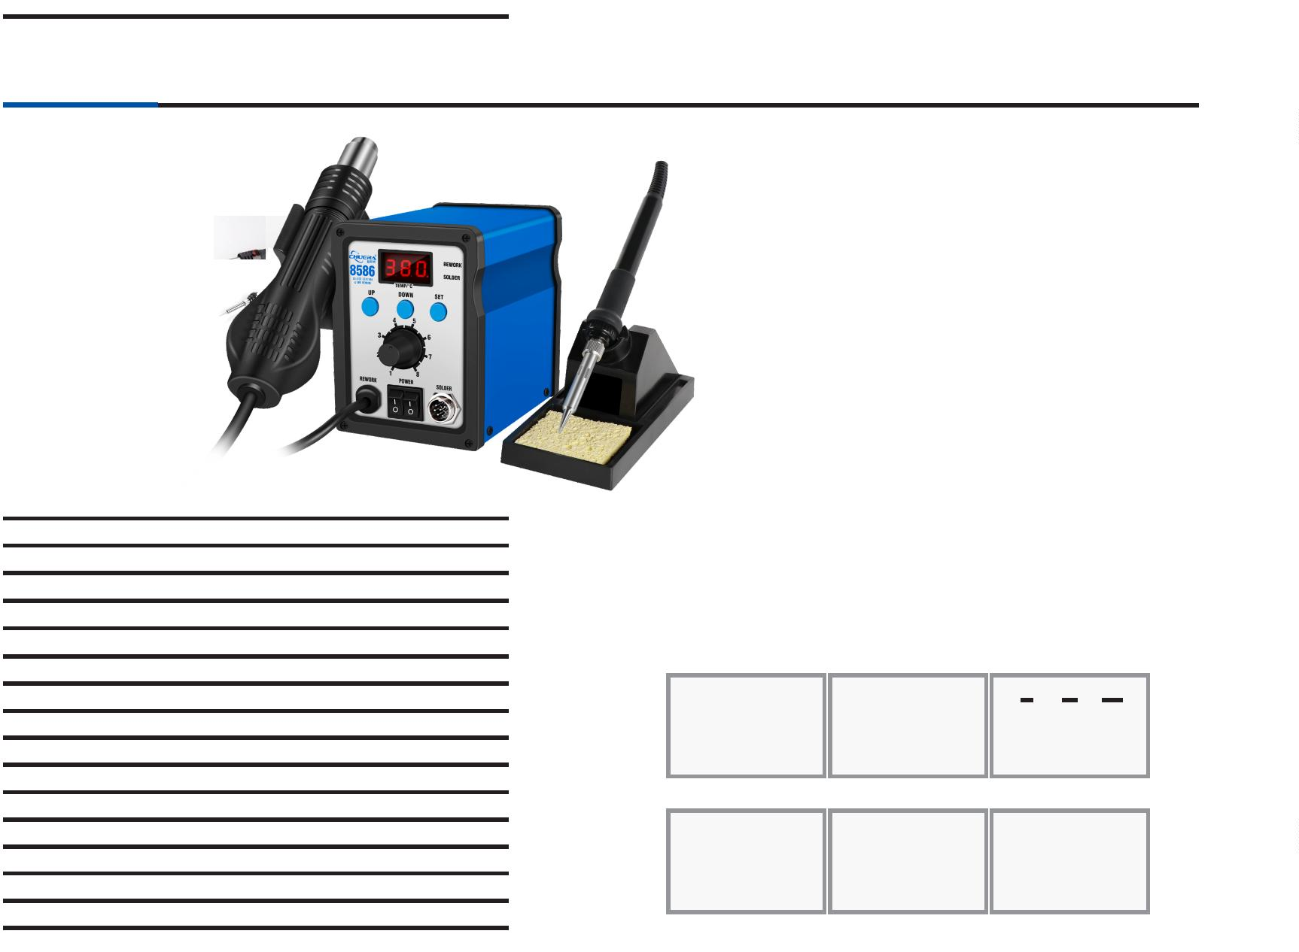

®
Repair welding machine
850B
Intelligent hot air dismantling
soldering station
Features:
※
Using sensor closed loop temperature control, the temperature rises quickly, the
temperature is convenient, and the temperature is accurate and stable;
※
Adopt anti-static design to prevent damage to the PCB board due to static
electricity and leakage;
Using imported heating wire, long service life;
Using original imported air pump, low vibration and noiseless design to keep the
working environment quiet;
※
※
※
Intelligent cooling system, it delays the air supply after shutting down after work,
and automatically cuts off the power when the air temperature is lower than 100℃.
Speciﬁcation
Operating voltage:
AC220V /50Hz
Maximum instantaneous power: 550W
Temperature range:
Airﬂow type:
100℃～480℃
Diaphragm type dedicated pump
24L/min(Max)
Air ﬂow volume:
Noise:
＜40dB
Weight:
About 3.75Kg
Package size:
Carton size:
330×270×195mm
565×345×600mm
6 sets/carton
Optional accessories:
Packing speciﬁcations:
LT-850 Handle
1146B heating core
Heat gun nozzle
852D
Intelligent hot air dismantling
soldering station
Features:
※
Using sensor closed loop temperature control, the temperature rises quickly, the
temperature is convenient, and the temperature is accurate and stable;
※
Adopt anti-static design to prevent damage to the PCB board due to static
electricity and leakage;
Using imported heating wire, long service life;
Using original imported air pump, low vibration and noiseless design to keep the
working environment quiet;
※
※
※
Intelligent cooling system, it delays the air supply after shutting down after work,
and automatically cuts off the power when the air temperature is lower than 100℃.
Speciﬁcation
Operating voltage:
AC220V /50Hz
Maximum instantaneous power: 550W
Temperature range:
Airﬂow type:
Air ﬂow volume:
Air volume level:
Display method:
Noise:
100℃～480℃
Diaphragm type dedicated pump
120L/min(Max)
R25-99
LED digital display (resolution 1°C)
＜45dB
Weight:
About 3.69kg
Optional accessories:
Package size:
Carton size:
Packing speciﬁcations:
330×270×195mm
565×345×600mm
6 sets/carton
LT-850 Handle
1146B heating core
Heat gun nozzle

47
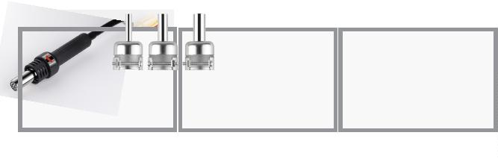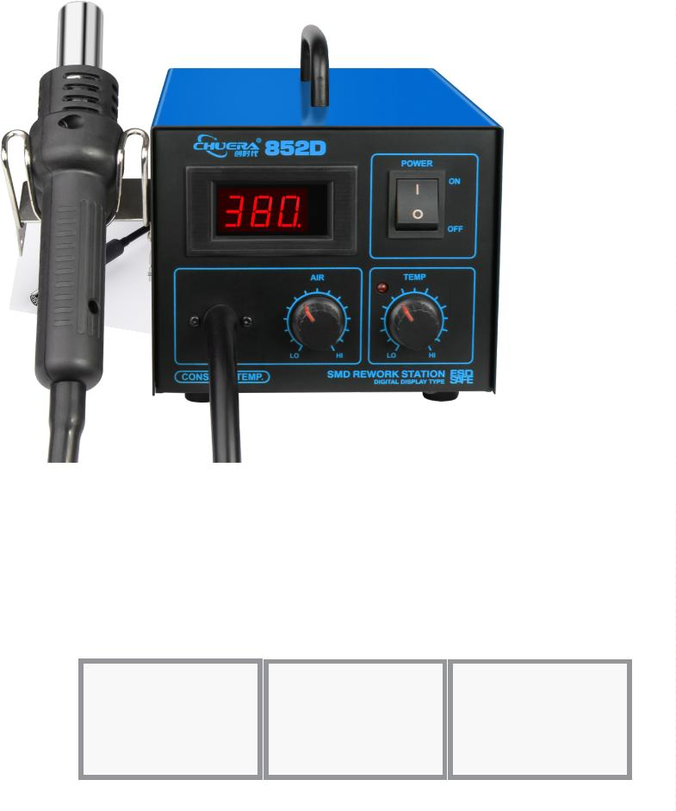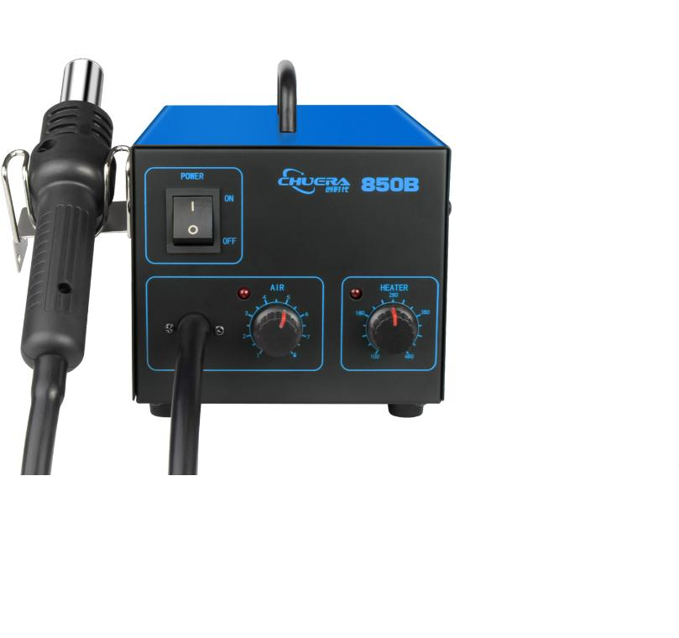

®
Repair welding machine
8502D
Intelligent hot air dismantling
soldering station
Features:
※
※
※
※
Using hot air desoldering station and electric soldering station to form a multi-
functional integrated desoldering repair system;
Dual temperature digital display, real-time display of temperature, making the
temperature clear at a glance;
Using sensor closed loop temperature control and LED display, the temperature rises
quickly, the temperature is convenient, and the temperature is accurate and stable.
Adopt anti-static design to prevent damage to the PCB board due to static electricity
and leakage.
Using imported heating wire, long service life.
※
※
Using original imported air pump, low vibration and noiseless design, keeping the
working environment quiet.
Intelligent cooling system, it delays the air supply after shutting down after work,
※
and automatically cuts off the power when the air temperature is lower than 100℃.
Speciﬁcation
Switchboard:
Operating voltage:
Maximum instantaneous power:
Working environment:
Temperature display:
Dimensions:
AC220V/50HZ
610WW
0～40℃ Relative humidity＜80％
LED
Optional accessories:
330X275X195mm
Heat gun part:
Maximum instantaneous power:
Temperature range:
Temperature stability:
Calibration method:
Air mercury:
550W
100℃～500℃ Air ﬂow 120L/min (maximum)
±2℃（static）
digital calibration
Diaphragm type
≤45dB
LT-850 handle
1146B Heating core Ceramic 1321 heating core
Operating noise:
Soldering station part:
Maximum instantaneous power:
Temperature range:
Temperature stability:
Calibration method:
60W
LT8502D handle
Heat gun nozzle 900 Series Soldering Tips
200℃～480℃
±2℃ （static）
digital calibration
Welding tip impedance to ground: ＜2Ω
Welding tip to ground voltage:
＜2mV
986
Warm-up platform
Features:
※
※
※
Aerospace aluminum hot plate is used, which is heated evenly and conducts heat quickly;
With dual temperature display, real-time temperature and set temperature can be visualized.
Temperature can be adjusted to constant temperature; temperature control is more accurate, with
the panel error of± 2 degrees;
※
※
※
With sunken heater, it has fast heating, high thermal efficiency and low power consumption;
The bottom of the heating surface adopts stainless steel mirror reflection, to reduce heat;
With temperature memory function, it automatically warms up the last temperature after power on;
Speciﬁcation
AC220V/50HZ
Operating voltage:
RT-400℃
Temperature range:
Maximum instantaneous power:
Temperature stability (no load):
Temperature correction method:
Weight:
4
±
00W
2℃
digital calibration
About 2.5Kg
W150*D150*H140mm
Physical dimension:
Packing standard:
1
set/carton
4
8

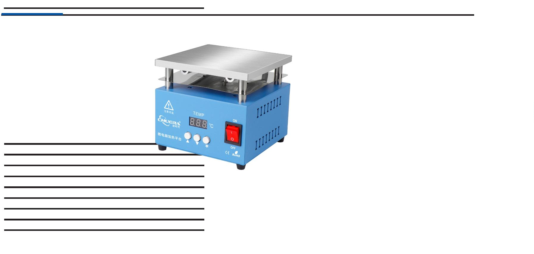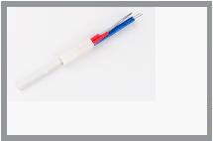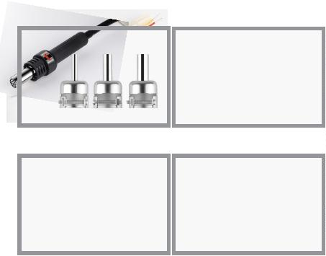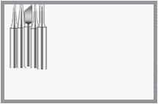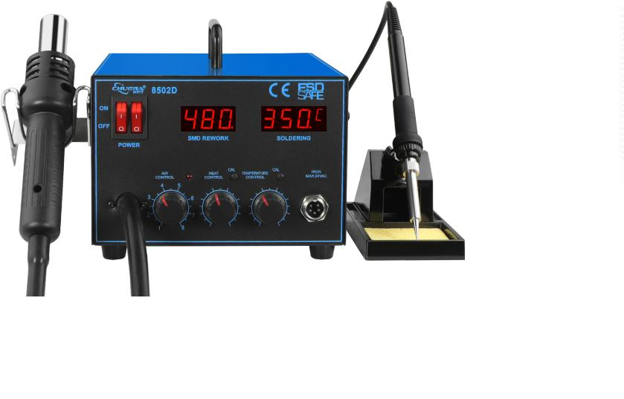

®
Repair welding machine
101
Soldering iron comprehensive tester
Features:
※
※
Tip temperature, leakage voltage and grounding impedance can be measured accurately;
The soldering iron can be managed according to the MIL-HDBK-263B standard when
measuring leakage voltage and ground impedance;
Applicable to lead-free tin soldering;
The [MAX HOLD] function can record and display the maximum value of the test at that
time.
※
※
Speciﬁcation
Temperature measurement:
Decomposition:
Measuring range:
Accuracy:
1℃
0~700℃
±3℃ (between 300~600℃)
K（CA）Thermocouple
Sensor:
Voltage:
Degree of decomposition: 0.1mV
Measuring range:
Accuracy:
0~40mV(AC)
±（5%+1 digit）
Impedance:
Degree of decomposition: 0.1Ω
Optional accessories:
Measuring range:
Accuracy:
0~40Ω
±
（5%+1 digit）
LCD digital display
191-211/191-212
Temperature probe
(Can measure solder and
furnace measurement
welding machine)
Display:
SENSOR
2
W/220V
Power consumption:
Ambient temperature:
Weight:
0
~40℃，20~90%RH
0
.2Kg
L200×W120×H50mm
Dimensions:
191
Soldering iron thermometer
Features:
※
※
※
※
The tip temperature is measured accurately and quickly with a CA sensor;
Clear digital display;
Special alloy coating makes the sensor resistant to corrosion and oxidation.
The sensor can be easily replaced.
Speciﬁcation
Decomposition:
Measuring range:
Accuracy:
1
0
±
℃
~600℃
3℃（between 300~600℃）
Optional accessories:
Sensor:
K（CA）Thermocouple
LCD digital display
DC9V Dry battery
≥150 Hours
Display:
Power supply:
Battery Life:
1
91-211/191-212
SENSOR
Temperature probe
(Can measure solder and
furnace measurement
welding machine)
Environment temperature: 0~40℃，20~80%RH
Weight:
0.26Kg
Dimensions:
L160×W80×H45mm

49
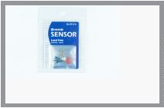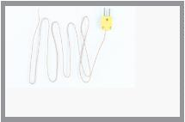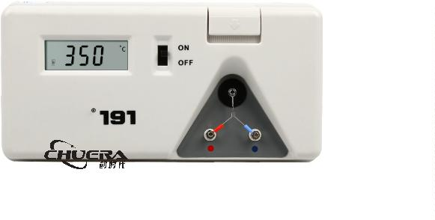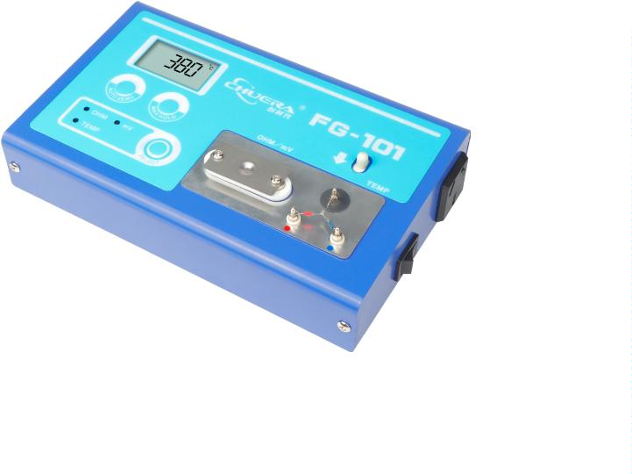

®
Repair welding machine
LT926
Single thermostatic soldering
iron knob model
Features:
※
※
※
The temperature is adjusted by knob, which is convenient;
All-in-one type is easy to carry;
Heating core soldering iron tip is split, which saves consumables.
Speciﬁcation
Power:
60W
Voltage:
220V 50HZ /110V
Temperature range : 200~480℃
Handle cord length: 1.4m
Package size: L270×W100mm（Blister cardboard packaging）
About 0.18Kg
Weight:
Optional accessories:
Heating core
900 Series Soldering Tips
LT927
Single thermostatic soldering
iron digital display model
Features:
※
The temperature can be adjusted by pressing the key on the LED display
to show the temperature accurately;
※
※
All-in-one type is easy to carry;
Heating core soldering iron tip is split, which saves consumables;
Speciﬁcation
Power:
60W
Voltage:
220V 50HZ /110V
Temperature range : 200~480℃
Handle cord length:
Package size:
Weight:
1.4m
L270×W100mm（Carton packing）
About 0.21Kg
Optional accessories:
Heating core
900 Series Soldering Tips
5
0

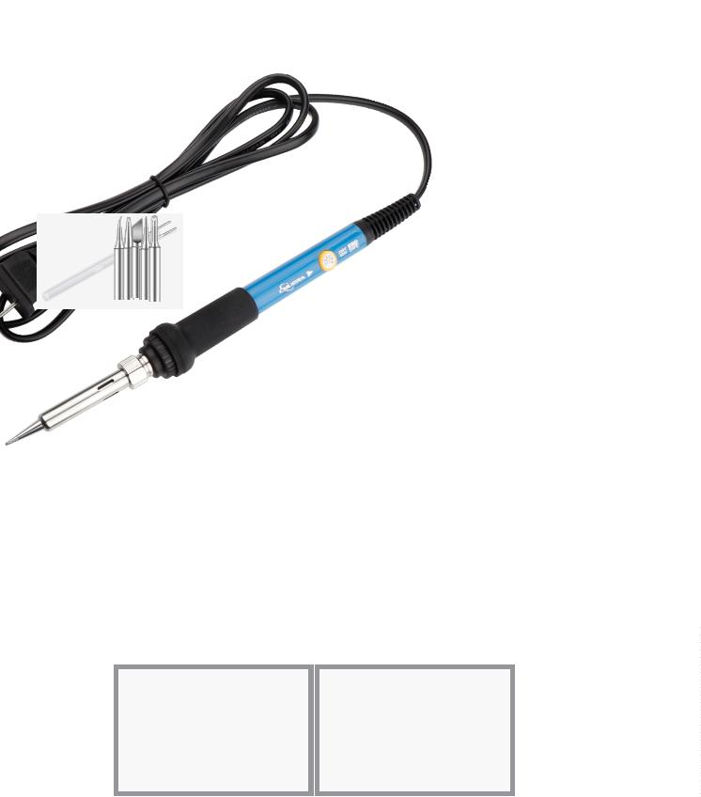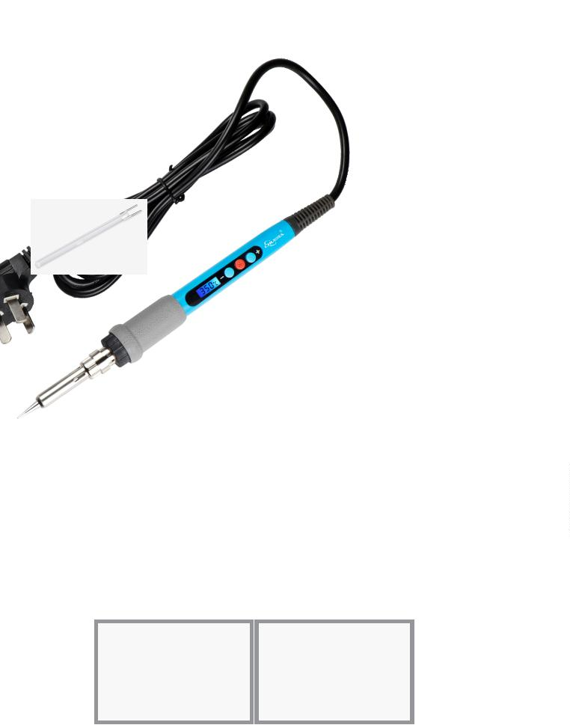

®
Smoke puriﬁer
100XP
Desktop smoke puriﬁer
Features:
※
※
※
※
※
※
With a full metal chassis design, it can resist strong impact and vibration;
Compact machine design, beautiful appearance, occupies little space;
With knob type stepless speed adjustment, simple and convenient operation;
Fatigue-resistant brushless motor, with low noise, high speed and long life;
Customized volute impeller for stable airﬂow and smooth operation;
Multi-stage ﬁltration design ensures thorough ﬁltration of harmful substances and reduces
environmental pollution;
※
※
Smoking pipe can change direction at will, with strong support, simple and convenient installation;
Filter cores should be replaced separately to extend the life of the main ﬁlter cores to improve
eﬃciency and reduce costs;
※
Installation is super easy, and there is no need for a separate pipe.
Speciﬁcation
Operating voltage
Power consumption
Control method
Display
Filter element of layers
Weight
AC220V/AC110V
15W
Knob adjustment
Digital tube display
Level 3
About 1.8Kg (main device)
W185*D185*H88mm
8 sets/carton
Host size
Packing standards
Packing list: main unit, telescopic smoking pipe,
smoking silicone cover, power supply.
The above speciﬁcations and designs are subject to
change without prior notice.
Application areas: manual soldering, laser marking,
immersion tin furnace, soldering robot, scientiﬁc
research experiments, etc.
Complimentary
accessories with
order:
Optional accessories:
High density
primary ﬁlter cotton
HEPA dust
collection ﬁlter
Activated carbon
dust ﬁlter
High-density primary
ﬁlter cotton*1
130XP
Desktop smoke puriﬁer
Features:
※
※
※
※
※
※
With a full metal chassis design, it can resist strong impact and vibration;
Compact machine design, beautiful appearance, occupies little space;
With knob type stepless speed adjustment, simple and convenient operation;
Fatigue-resistant brushless motor, with low noise, high speed and long life;
Customized volute impeller for stable airflow and smooth operation;
Multi-stage filtration design ensures thorough filtration of harmful substances and reduces
environmental pollution;
※
※
※
Smoking pipe can change direction at will, with strong support, simple and convenient
installation;
Filter cores should be replaced separately to extend the life of the main filter cores to improve
efficiency and reduce costs;
Installation is super easy, and there is no need for a separate pipe.
Speciﬁcation
Operating voltage
Power consumption
Control method
Display
Filter element of layers
Weight
AC220V/AC110V
30W
Knob adjustment
Digital tube display
Level 3
About 2.1Kg（main device）
W185*D185*H110mm
8 sets/carton
Host size
Packing standards
Complimentary
accessories with
order:
Packing list: main unit, telescopic smoking pipe,
smoking silicone cover, power supply.
The above speciﬁcations and designs are subject to
change without prior notice.
Application areas: manual soldering, laser marking,
immersion tin furnace, soldering robot, scientiﬁc
research experiments, etc.
Optional accessories:
High density
primary ﬁlter cotton
HEPA dust
collection ﬁlter
Activated carbon
dust ﬁlter
High-density primary
ﬁlter cotton*1

51
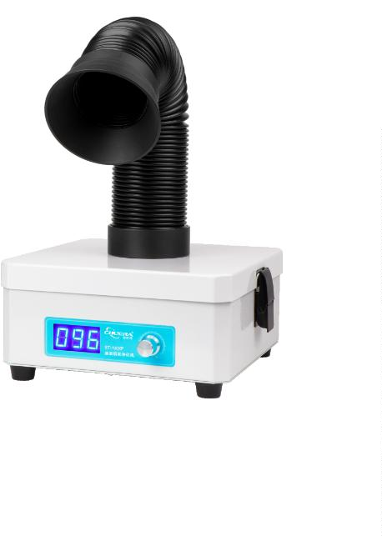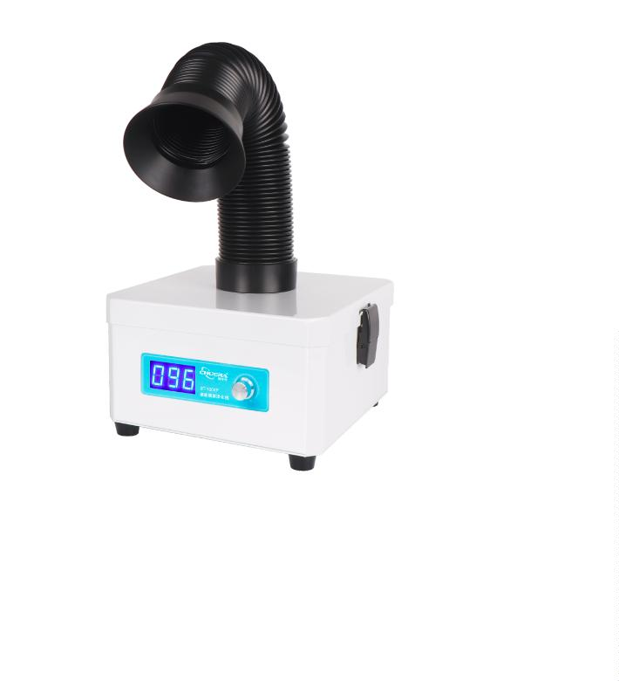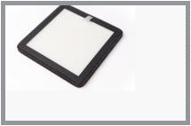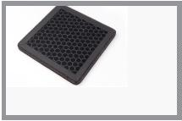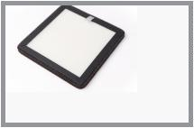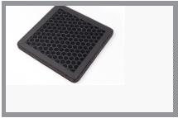

®
Smoke puriﬁer
180XP
200XP-A
Smoke dust puriﬁer
Features:
※
With a full metal chassis design, it can resist strong impact and vibration;
Compact machine design, beautiful appearance, occupies little space;
The air inlet diversion design improves the purification efficiency of the filter core;
Stepless speed adjustment, simple and convenient operation;
Fatigue-resistant brushless motor, with low noise, high speed and long life; .
Aircraft grade aluminum volute impeller for stable airflow and smooth operation;
※
※
※
※
※
※
Multi-stage filtration design ensures thorough filtration of harmful substances and reduces
environmental pollution;
※
※
Smoking pipe can change direction at will, with strong support, simple and convenient installation;
Filter cores should be replaced separately to extend the life of the main filter cores to improve
efficiency and reduce costs;
※
It can be assembled and used in three steps after disassembling the machine, the installation is
super easy, and there is no need for a separate pipe;
Speciﬁcation
Product number
Station
The output voltage
Power consumption
Air inlet interface
System traﬃc
180XP
Single station
AC 110V/220V
100W
φ50/φ75
333m3/h
200XP-A
Single station
AC 110V/220V
150W
φ50/φ75
333m/3h
Number of ﬁlter element layers
Noise
3 layers, customizable
<55dB
3 layers, customizable
<55dB
Pipe length
1.4m(customizable)
>0.3um 9.99%
Knob
280*250*280mm
15Kg
1.4m(customizable)
>0.3um 9.99%
Knob
280*250*280mm
15Kg
Filtering eﬀect
Display method
Host size
Host net weight
Tobacco tube packaging
440*430*190mm
440*430*190mm
Optional accessories:
High density
primary ﬁlter cotton
HEPA dust
collection ﬁlter
Activated carbon
dust ﬁlter
Optional accessories:
Round silicone
smoking hood
Square silicone
smoking hood
Round PC
transparent
smoking hood
Square PC
transparent
smoking hood
Universal bamboo
tube
5
2

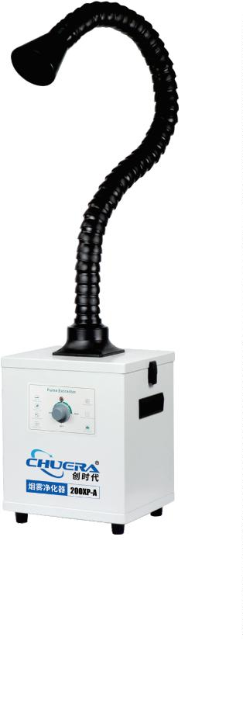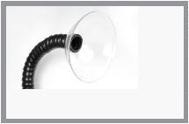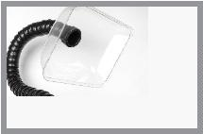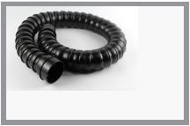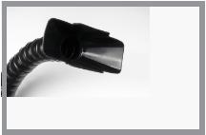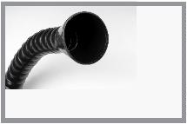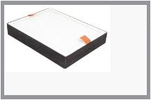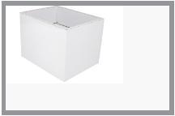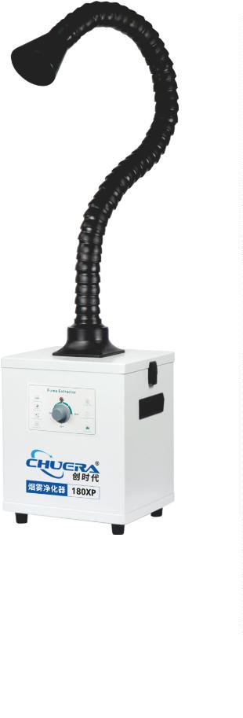

®
Smoke puriﬁer
200XP-1/2
Smoke dust puriﬁer
Features:
※
With a full metal chassis design, it can resist strong impact and vibration;
Compact machine design, beautiful appearance, occupies little space;
The air inlet diversion design improves the purification efficiency of the filter core;
Stepless speed adjustment, simple and convenient operation;
Fatigue-resistant brushless motor, with low noise, high speed and long life; .
Aircraft grade aluminum volute impeller for stable airflow and smooth operation;
※
※
※
※
※
※
Multi-stage filtration design ensures thorough filtration of harmful substances and
reduces environmental pollution;
※
※
※
※
※
Smoking pipe can change direction at will, with strong support, simple and convenient
installation;
Filter cores should be replaced separately to extend the life of the main filter cores to
improve efficiency and reduce costs;
The bottom of the machine is equipped with silent PU wheels, which is convenient to move
and saves energy and more worry;
It can be assembled and used in three steps after disassembling the machine, the
installation is super easy, and there is no need for a separate pipe;
The indoor circulation filtration method avoids exhausting indoor cold air (warm air) to
the outdoors and keeps the indoor air empty.
Speciﬁcation
Product number
Station
The output voltage
Power consumption
Air inlet interface
System traﬃc
200XP-1
Single station
AC 110V/220V
220W
200XP-2
Double station
AC 110V/220V
220W
φ75
φ75
333m/³
h
333m/³
h
Number of ﬁlter element layers
Noise
3 layers, customizable
<55dB
3 layers, customizable
<55dB
Pipe length
1.4m(customizable)
>0.3um 9.99%
Knob
425*250*410mm
15Kg
440*430*190mm
1.4m(customizable)
>0.3um 9.99%
Knob
425*250*410mm
15Kg
440*430*190mm
Filtering eﬀect
Display method
Host size
Host net weight
Tobacco tube packaging
Optional accessories:
High density
primary ﬁlter cotton
HEPA dust
collection ﬁlter
Activated carbon
dust ﬁlter
Optional accessories:
Round silicone
smoking hood
Square silicone
smoking hood
Round PC
transparent
smoking hood
Square PC
transparent
smoking hood
Universal bamboo
tube

53
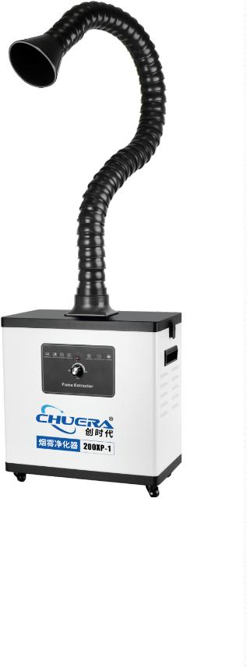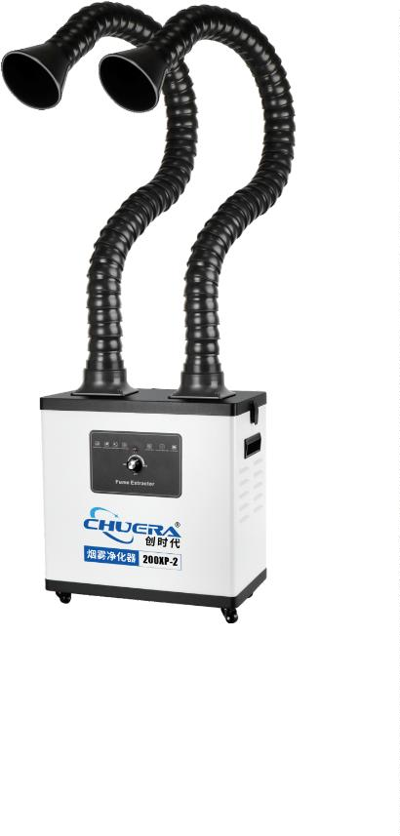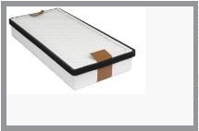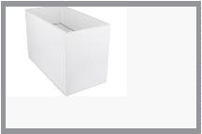

moke puriﬁer
400XP-1/2
Smoke dust puriﬁer
Features:
※
With a full metal chassis design, it can resist strong impact and vibration;
Compact machine design, beautiful appearance, occupies little space;
The air inlet diversion design improves the purification efficiency of the filter core;
Stepless speed adjustment, simple and convenient operation;
Fatigue-resistant brushless motor, with low noise, high speed and long life; .
Aircraft grade aluminum volute impeller for stable airflow and smooth operation;
※
※
※
※
※
※
Multi-stage filtration design ensures thorough filtration of harmful substances and
reduces environmental pollution;
※
※
※
※
※
Smoking pipe can change direction at will, with strong support, simple and convenient
installation;
Filter cores should be replaced separately to extend the life of the main filter cores to
improve efficiency and reduce costs;
The bottom of the machine is equipped with silent PU wheels, which is convenient to move
and saves energy and more worry;
It can be assembled and used in three steps after disassembling the machine, the
installation is super easy, and there is no need for a separate pipe;
The indoor circulation filtration method avoids exhausting indoor cold air (warm air) to
the outdoors and keeps the indoor air empty.
Speciﬁcation
Product number
Station
The output voltage
Power consumption
Air inlet interface
System traﬃc
400XP-1
Single station
AC 110V/220V
220W
400XP-2
Double station
AC 110V/220V
220W
φ75
φ75
333m3
/h
333m/h
3
Number of ﬁlter element layers
Noise
3 layers, customizable
<55dB
3 layers, customizable
<55dB
Pipe length
1.4m(customizable)
>0.3um 9.99%
Knob
1.4m(customizable)
>0.3um 9.99%
Knob
425*250*410mm
15Kg
440*430*190mm
Filtering eﬀect
Display method
Host size
Host net weight
Tobacco tube packaging
4
25*250*410mm
5Kg
40*430*190mm
1
4
Optional accessories:
High density
primary ﬁlter cotton
HEPA dust
collection ﬁlter
Activated carbon
dust ﬁlter
Optional accessories:
Round silicone
smoking hood
Square silicone
smoking hood
Round PC
transparent
smoking hood
Square PC
transparent
smoking hood
Universal bamboo
tube
5
4

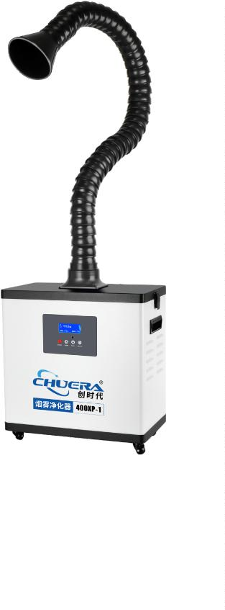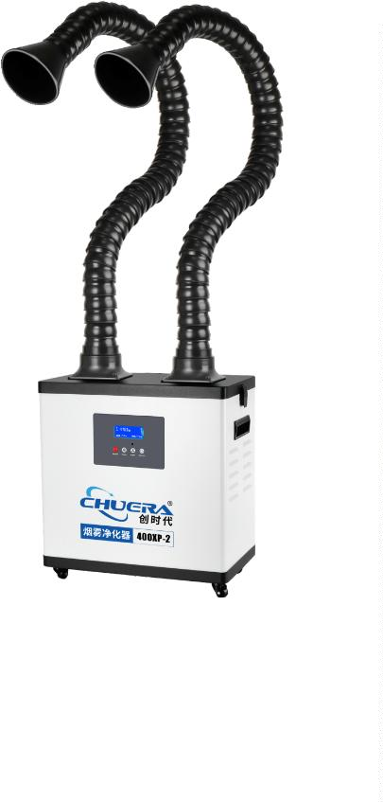

®
Smoke puriﬁer
300X/300X2
Component foot sucker
※
※
※
※
※
※
※
※
※
※
With a full metal chassis design, it can resist strong impact and vibration;
Compact machine design, beautiful appearance, occupies little space;
The air inlet diversion design improves the purification efficiency of the filter core;
Stepless speed adjustment, simple and convenient operation;
Fatigue-resistant brushless motor, with low noise, high speed and long life;
Aircraft grade aluminum volute impeller for stable airflow and smooth operation;
Audio-visual alarm control system is available, thus avoiding filter core failure to reduce efficiency;
The silicone material of the suction tube can be changed direction at will, with simple and convenient installation;
The bottom of the machine is equipped with silent PU wheels, which is convenient to move and saves energy and more worry;
The collection box has a large volume, can be assembled and used in three steps after disassembling the machine, the installation is
super easy, and it is very convenient to clean the component feet;
※
Imported clippers are used, with long life and good materials. Pliers are interchangeable and regular sizes are optional.
Specification
Product number
Product name
The output voltage
Power
300X
300X2
Single head double cutting pliers
AC 110V / 220V
Double-headed four-pair pliers
AC 110V / 220V
260W
260W
Air inlet interface
System traffic
Filter element method
Noise
Flange + silicone tube φ8/10
460m/h
Flange + silicone tube φ8/10
2*230m/h
Cartridge filtration
<65dB
Cartridge filtration
<65dB
Silicone tube length
Display method
Host size
1.5-2M(Max 3M)
LCD digital display/remote control possible
495*301*270mm
28kg
1.5-2M(Max 3M)
LCD digital display/remote control possible
425*250*410mm
28.5kg
Host net weight

55
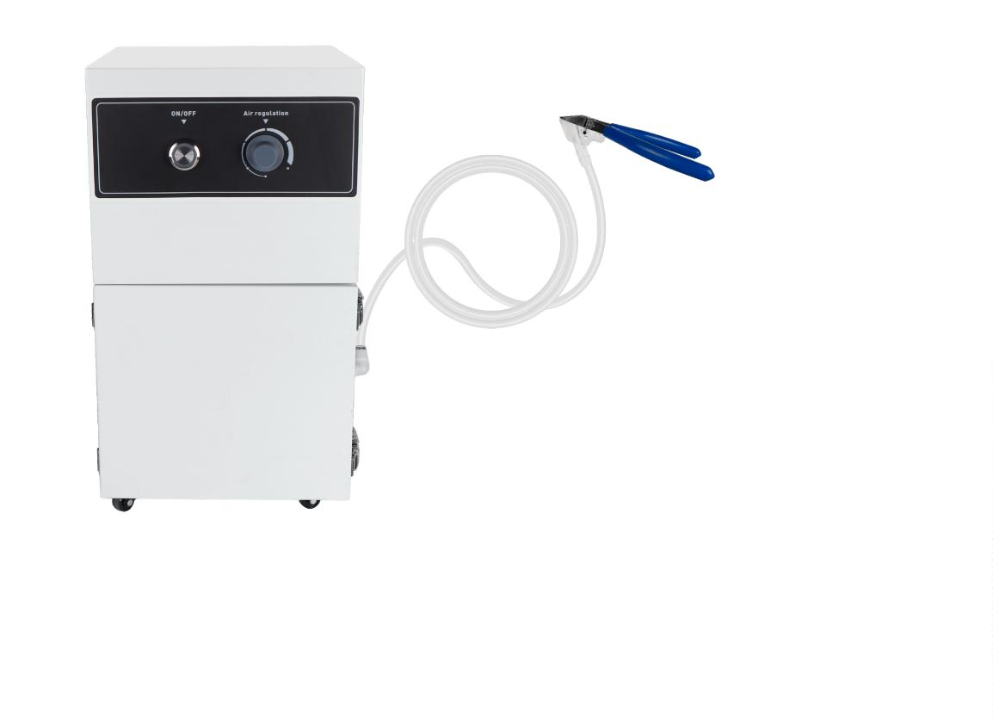

®
Anti-static electricity series
419D
Intelligent DC ion fan
※
※
※
※
※
Digital display of ion balance voltage and automatic adjustment of ion balance voltage;
With plasma high-pressure abnormal alarm, sound and light alarm, users and management personnel can be prompted;
With air supply system detection, the ionizing needle is cleared automatically, manually and on a timer;
The back cover of the ion fan can be removed directly, saving time for cleaning and maintenance and making it more convenient;
The network communication connection is wireless, the system integration is data-driven, and the fan operation can be reflected to the
computer in real time.
Snap-on front/rear wind windows
Plug-in ion wind needle
Snap-on front windshield
Snap-on rear window with cleaning belt
Power
Display
Test Conditions
Humidity: ≤60% Test voltage: 1KV-100V Environment temperature: 22℃
Distance
300mm
1.1s
.3s
600mm
1.5s
1.7s
900mm
2.0s
2.3s
+
-
Back key
Neutralizing time
1
+
-
Residual voltage
≤±10v
*
The test instrument uses CPM374 electrostatic comprehensive tester. The test
results shall prevail.
Tested according to IEC-61340-5-1 A-6.
Up and down filter keys
*
*
Test data will vary due to changes in surrounding temperature and humidity.
Main menu key
Features:
2
.4-inch color display, real-time display of data
Automatic cleaning of ion emission needle
Display high voltage value in real time
Intelligent adjustment of wind speed from 1 to 7 levels
Fan abnormality can alarm
No high pressure or low pressure can alarm
Real-time display of ion balance
Alarm when out of range
Wireless networking
Manage and monitor data online via software
Plug-in ion needle
High-frequency AC discharge,
Eliminating static electricity quickly
Modular front and rear windshields make maintenance more convenient
5
6

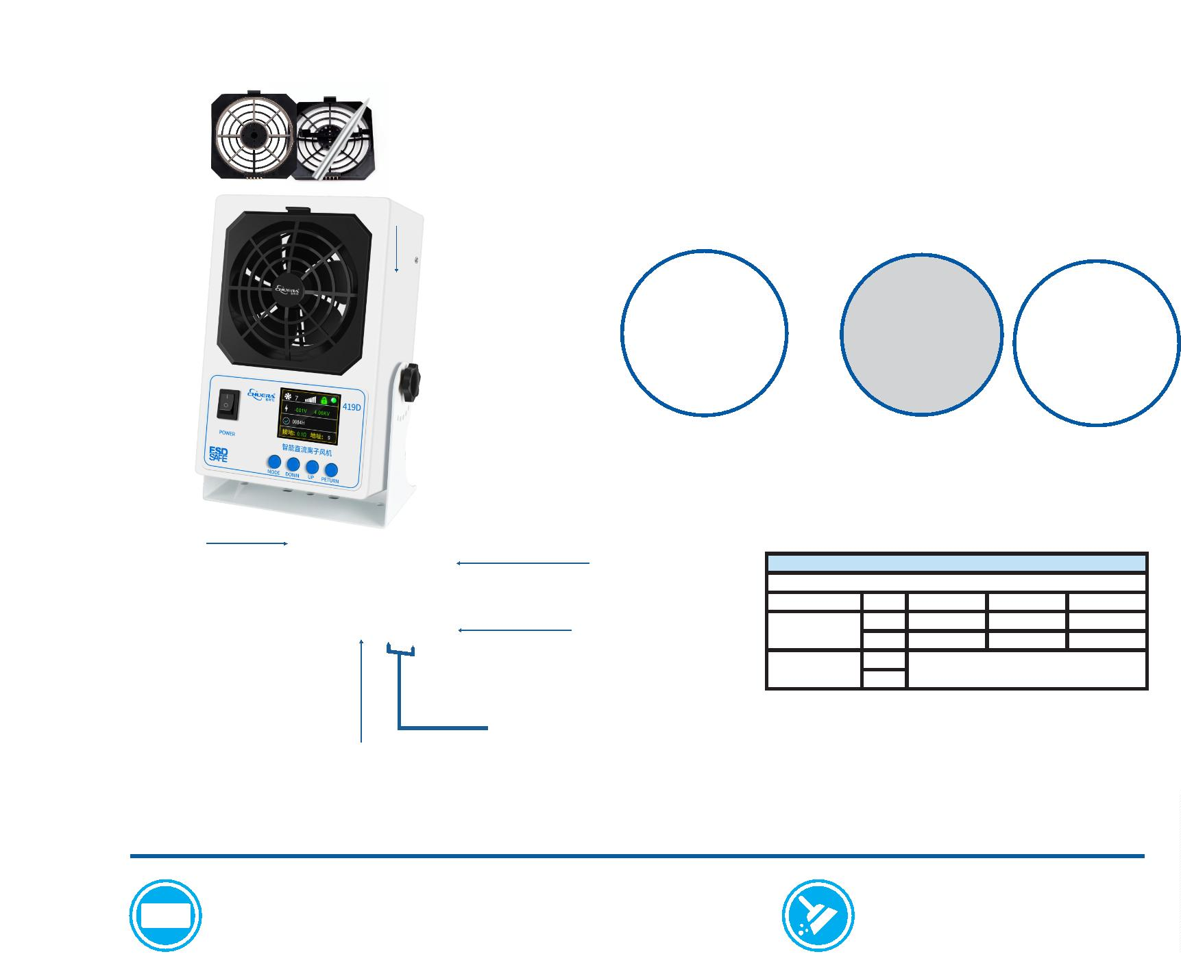

®
静电ꢉ列
Anti-static electricity
429D
Intelligent DC ion fan
Features:
※
※
※
※
Digital display of ion balance voltage and automatic adjustment of ion
balance voltage;
With plasma high-pressure abnormal alarm, sound and light alarm, users
and management personnel can be prompted;
With air supply system detection, the ionizing needle is cleared
automatically, manually and on a timer;
The back cover of the ion fan can be removed directly, saving time for
cleaning and maintenance and making it more convenient;
The network communication connection is wireless, the system integration
is data-driven, and the fan operation can be reflected to the computer in
real time.
※
Speciﬁcation
Input voltage
Power
DC24V（The power adapter adopts wide voltage 110V-220V）
20W
Power consumption time
Air volume
≤2S（300mm from the test center in front of the fan）
2.56-4.07m³/min（Stand-alone）
Ozone concentration
Dimensions
Cleaning settings
Display screen
≤ 0.01ppm （150mm from the front center of the air outlet）
W590*H190*D110mm
Can be set within the range of 0-999 hours
Fan operating status, high pressure status, cleaning time setting,
ID setting, sound and light setting, on/oﬀ cleaning setting, etc.
The output voltage
Ion balance
AC 5.6KV
≤|±10V|（300mm from the test center in front of the fan）
Eﬀective range
Operating temperature
Operating humidity
Noise
400X800mm
-20℃-70℃
≤90%
40-55dB
About 5.4Kg
Gross Weight
439D
Intelligent DC ion fan
Features:
※
※
※
※
※
Digital display of ion balance voltage and automatic adjustment of ion balance voltage;
With plasma high-pressure abnormal alarm, sound and light alarm, users and management personnel can be prompted;
With air supply system detection, the ionizing needle is cleared automatically, manually and on a timer;
The back cover of the ion fan can be removed directly, saving time for cleaning and maintenance and making it more convenient;
The network communication connection is wireless, the system integration is data-driven, and the fan operation can be reﬂected to the
computer in real time.
Speciﬁcation
Input voltage
Power
DC24V（The power adapter adopts wide voltage 110V-220V）
20W
Power consumption time ≤2S（300mm from the test center in front of the fan）
Air volume
2.56-4.07m³/min（Stand-alone）
Ozone concentration
Dimensions
≤ 0.02 ppm （150mm from the front center of the air outlet）
W900*H190*D110mm
Cleaning settings
Display screen
Can be set within the range of 0-999 hours
Fan operating status, high pressure status, cleaning time
setting, ID setting, sound and light setting, on/oﬀ cleaning
setting, etc.
The output voltage
Ion balance
AC 5.6KV
≤|±10V|（300mm from the test center in front of the fan）
Eﬀective range
Operating temperature
Working humidity
Noise
400X1200mm
-20℃-70℃
≤90%
40-55dB
Gross Weight
About 7.8Kg

57
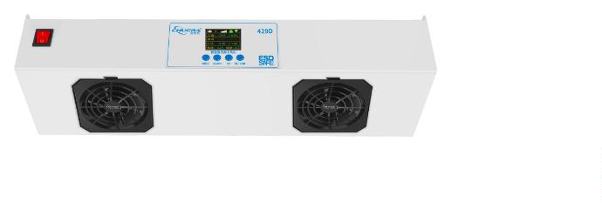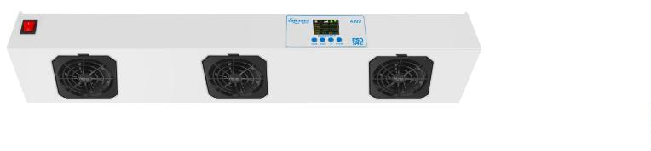

®
Anti-static electricity series
2200A
Intelligent high-frequency ion air gun
Features:
Test Results:
Test Conditions
Humidity: ≤60% Test voltage: 1KV-100V Environment temperature: 22℃
※
※
※
Rapid elimination of static electricity;
Small size, light weight, portable design, angle adjustable;
Distance
300mm
.1s
.3s
600mm
1.5s
1.7s
900mm
2.0s
2.3s
The automatic cleaning of the discharge needle function is provided by this product, which
reduces the frequency of daily manual cleaning and maintenance;
Wireless network monitoring function is added to this product, to realize real-time
monitoring by wireless receiver and transmitter (optional function);
According to the workshop environment, you can arbitrarily set the automatic cleaning time
of the ion-emitting electric needle, and you can display the set time through the LED
display;
+
-
+
-
1
Neutralizing time
1
※
※
Residual voltage
≤±10v
*
The test instrument uses CPM374 electrostatic comprehensive tester.
The test results shall prevail.
* Tested according to IEC-61340-5-1 A-6.
*Test data will vary due to changes in surrounding temperature and
humidity.
※
※
The whole machine has a locking function (refer to the description of key functions);
The fan is well protected by grounding.
Speciﬁcation
Input voltage
Power
Power consumption time
Air volume
DC24V（The power adapter adopts wide voltage 110V-220V）
20W
≤2S（300mm from the test center in front of the fan）
4
5-110CFM
Ozone concentration
Dimensions
Cleaning settings
Display screen
≤ 0.01 ppm （150mm from the front center of the air outlet）
L192xW180xH72mm
Can be set within the range of 0-999 hours
Fan operating status, high pressure status, cleaning
time setting, ID setting, sound and light setting, on/oﬀ
cleaning setting, etc.
The output voltage
Ion balance
High frequency AC ±2.2KV
≤|±10V|（300mm from the test center in front of the fan）
Eﬀective range
Operating temperature
Operating humidity
Noise
400X600mm
0℃-60℃
≤90%
40-55dB
Gross Weight
About 1.5Kg
2200B
Intelligent high-frequency ion air gun
Features:
※
※
※
Rapid elimination of static electricity;
Test Results:
Small size, light weight, portable design, angle adjustable;
The automatic cleaning of the discharge needle function is provided by this
product, which reduces the frequency of daily manual cleaning and
maintenance;
Wireless network monitoring function is added to this product, to realize real-
time monitoring by wireless receiver and transmitter (optional function);
According to the workshop environment, you can arbitrarily set the automatic
cleaning time of the ion-emitting electric needle, and you can display the set
time through the LED display;
Test Conditions
Humidity: ≤60% Test voltage: 1KV-100V Environment temperature: 22℃
Distance
300mm
.1s
.3s
600mm
1.5s
900mm
2.0s
※
※
+
-
+
-
1
Neutralizing time
1
1.7s
2.3s
Residual voltage
≤±10v
*
The test instrument uses CPM374 electrostatic comprehensive tester.
The test results shall prevail.
* Tested according to IEC-61340-5-1 A-6.
※
※
The whole machine has a locking function (refer to the description of key
functions);
The fan is well protected by grounding.
*
Test data will vary due to changes in surrounding temperature and
humidity.
Speciﬁcation
Input voltage
Power
DC24V（The power adapter adopts wide voltage 110V-220V）
20W
Power consumption time
Air volume
≤2S（300mm from the test center in front of the fan）
2.56-4.07m³/min (Single interface)
Ozone concentration
Dimensions
Cleaning settings
Display screen
≤ 0.02 ppm （150mm from the front center of the air outlet）
L500xW150xH82mm
Can be set within the range of 0-999 hours
Fan operating status, high pressure status, cleaning
time setting, ID setting, sound and light setting, on/oﬀ
cleaning setting, etc.
The output voltage
Ion balance
High frequency AC ±2.2KV
≤|±10V|（300mm from the test center in front of the fan）
Eﬀective range
Operating temperature
Operating humidity
Noise
400X800mm
0℃-60℃
≤90%
40-55dB
About 1.5Kg
Gross Weight
5
8

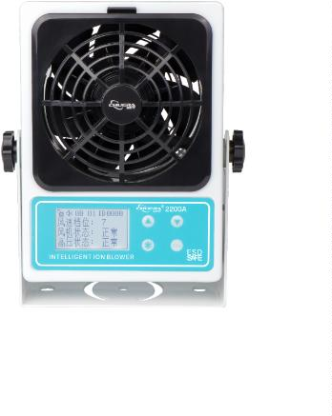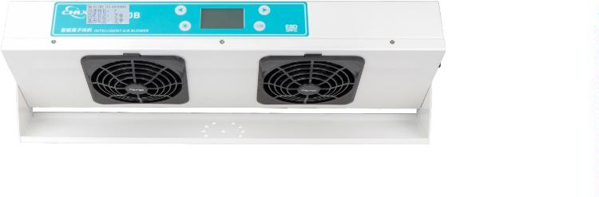

®
Anti-static electricity series
2200C
Intelligent high-frequency ion fan
Features:
※
※
※
Rapid elimination of static electricity;
Small size, light weight, portable design, angle adjustable;
Test Results:
The automatic cleaning of the discharge needle function is provided by this product, which
reduces the frequency of daily manual cleaning and maintenance;
Wireless network monitoring function is added to this product, to realize real-time
monitoring by wireless receiver and transmitter (optional function);
According to the workshop environment, you can arbitrarily set the automatic cleaning
time of the ion-emitting electric needle, and you can display the set time through the LED
display;
Test Conditions
※
※
Humidity: ≤60% Test voltage: 1KV-100V Environment temperature: 22℃
Distance
300mm
1.1s
600mm
1.5s
900mm
2.0s
+
-
+
-
Neutralizing time
1.3s
1.7s
2.3s
※
※
The whole machine has a locking function (refer to the description of key functions);
The fan is well protected by grounding.
Residual voltage
≤±10v
Speciﬁcation
* The test instrument uses CPM374 electrostatic comprehensive tester. The test
results shall prevail.
Tested according to IEC-61340-5-1 A-6.
* Test data will vary due to changes in surrounding temperature and humidity.
*
Input voltage
Power
DC24V（The power adapter adopts wide voltage 110V-220V）
40W
Power consumption time ≤2S（300mm from the test center in front of the fan）
Air volume
2.56-4.07m³/min（Stand-alone）
Ozone concentration
Dimensions
≤ 0.02ppm （150mm from the front center of the air outlet）
L700xW150xH82mm
Cleaning settings
Display screen
Can be set within the range of 0-999 hours
Fan operating status, high pressure status, cleaning
time setting, ID setting, sound and light setting, on/oﬀ
cleaning setting, etc.
The output voltage
Ion balance
High frequency AC ±2.2KV
≤|±10V|（300mm from the test center in front of the fan）
Eﬀective range
Operating temperature
Operating humidity
Noise
400X1200mm
0℃-60℃
≤90%
40-55dB
Gross Weight
About 5.2Kg
2200D
Intelligent high-frequency ion fan
Features:
※
※
※
Rapid elimination of static electricity;
Small size, light weight, portable design, angle adjustable;
The automatic cleaning of the discharge needle function is provided by this product, which reduces the frequency of daily manual cleaning and
maintenance;
※
※
Wireless network monitoring function is added to this product, to realize real-time monitoring by wireless receiver and transmitter (optional function);
According to the workshop environment, you can arbitrarily set the automatic cleaning time of the ion-emitting electric needle, and you can display the
set time through the LED display;
※
※
The whole machine has a locking function (refer to the description of key functions);
The fan is well protected by grounding.
Speciﬁcation
Input voltage
Power
DC24V（The power adapter adopts wide voltage 110V-220V）
40W
Power consumption time ≤2S（300mm from the test center in front of the fan）
Air volume
2.56-4.07m³/min（Stand-alone）
Ozone concentration
Dimensions
≤ 0.02ppm （150mm from the front center of the air outlet）
L900xW150xH82mm
Cleaning settings
The output voltage
Ion balance
Can be set within the range of 0-999 hours
High frequency AC ±2.2KV
≤|±10V|（300mm from the test center in front of the fan）
Eﬀective range
Operating temperature
Operating humidity
Noise
400X1600mm
0℃-60℃
≤90%
40-55dB
Gross Weight
About 8.2Kg
Display screen
Fan operating status, high pressure status, cleaning
time setting, ID setting, sound and light setting, on/oﬀ
cleaning setting, etc.

59
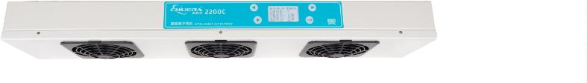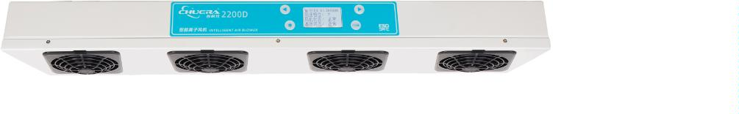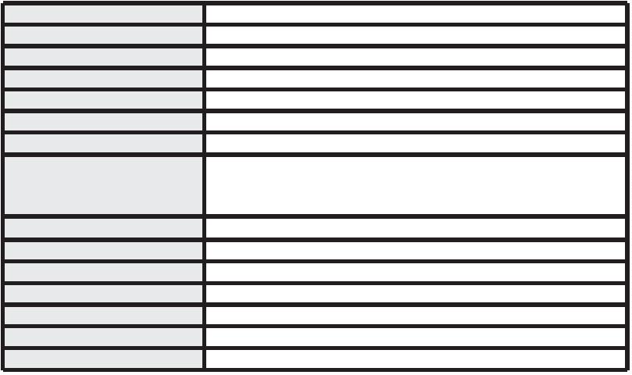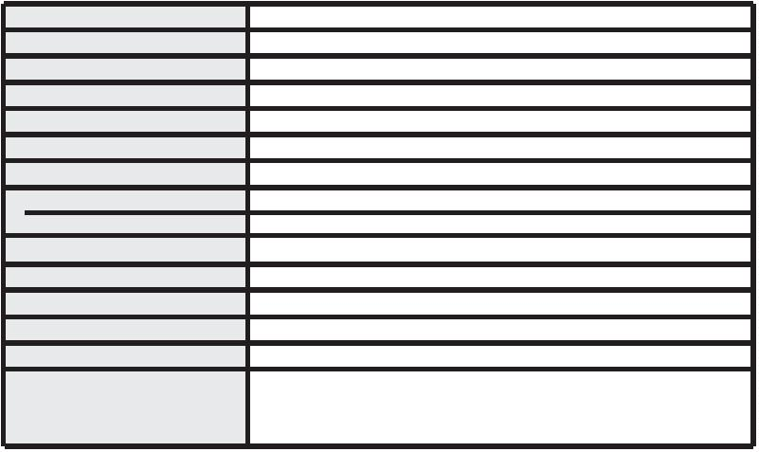
®
Anti-static electricity series
ST001
Desktop ion fan
Features:
Test Results:
※
※
※
Quickly eliminate static electricity;
Ion balance indicator light;
There are special ion emitter needle cleaners equipped with over-fillers for
customers to choose;
Small size, light weight, portable design, adjustable angle;
If necessary, a cold air heating device can be installed;
The fan has good grounding protection function.
Test Conditions
Humidity: ≤60% Test voltage: 1KV-100V Environment temperature: 22℃
Distance
300mm
600mm
1.0s
1.3s
+
-
0.7s
.9s
Neutralizing time
0
※
※
※
+
-
+8v
-7v
+10v
-10v
Residual voltage
* The test instrument uses CPM374 electrostatic comprehensive
tester. The test results shall prevail.
Tested according to IEC-61340-5-1 A-6.
Test data will vary due to changes in surrounding temperature and
humidity.
*
*
Speciﬁcation
Input voltage
Power
220V/50Hz or 110V/60Hz
40W
Power consumption time
Air volume
Ozone concentration
Dimensions
≤2S （300mm from the front center of the air outlet）
45-110CFM
≤ 0.03ppm （150mm from the front center of the air outlet）
L190xW85xH240mm (including bracket)
L140xW85xH220mm(including bracket)
The output voltage
ion balance
AC 5.6KV
≤|±10V| (300mm from the test center in front of the fan)
Operating humidity
Noise
Gross Weight
Surface
＜75%
45-55dB
About 2.8Kg
Electrostatic spray painting
ST002
Desktop ion fan
Features:
※
※
※
※
※
※
※
Quickly eliminate static electricity;
The ion air flow covers a large area;
With ionization indicator;
Test Results:
There is a special ion emission needle cleaner;
If necessary, a cold air heating device can be installed;
Suspension installation can save space;
The fan has good grounding protection function.
Test Conditions
Humidity: ≤60% Test voltage: 1KV-100V Environment temperature: 22℃
Distance
300mm
1.0s
600mm
+
-
+
-
Speciﬁcation
1.4s
1.5s
+10v
-9v
Neutralizing time
1.0s
Input voltage
220V/50Hz or 110V/60Hz
50W
+6v
-7v
Residual voltage
Power
Power consumption time ≤2S （300mm from the front center of the air outlet）
Air volume
Ozone concentration
Dimensions
The output voltage
ion balance
Operating humidity
Operating temperature
Noise
Gross Weight
Surface
*
The test instrument uses CPM374 electrostatic comprehensive
tester. The test results shall prevail.
* Tested according to IEC-61340-5-1 A-6.
80-110CFM
≤ 0.03ppm （150mm from the front center of the air outlet）
L600xW170xH125mm
AC 5.6KV
≤|±10V| (300mm from the test center in front of the fan)
＜75%
0℃-50℃
49-55dB
About6Kg
Electrostatic spray painting
*
Test data will vary due to changes in surrounding temperature and
humidity.
6
0

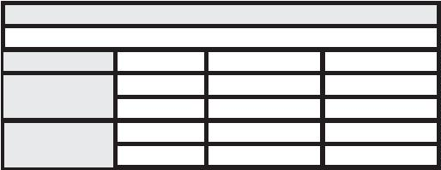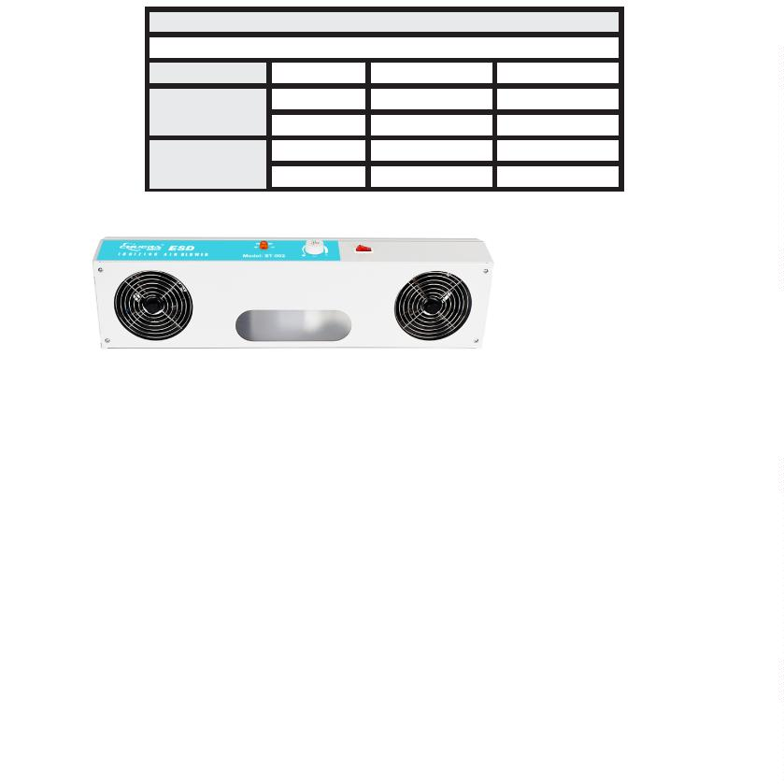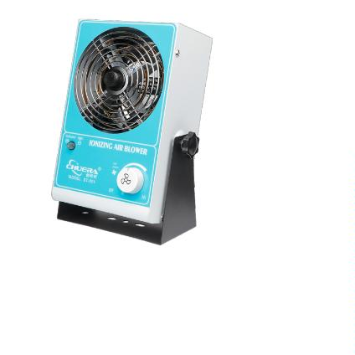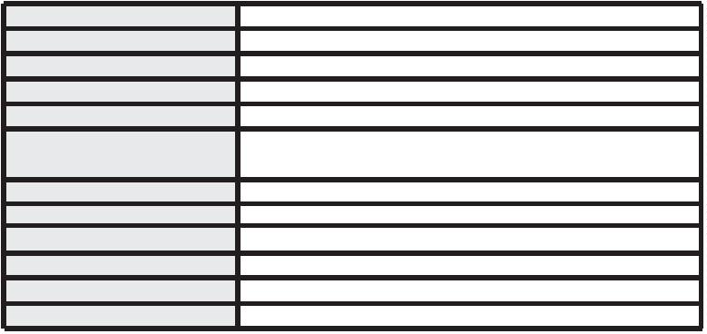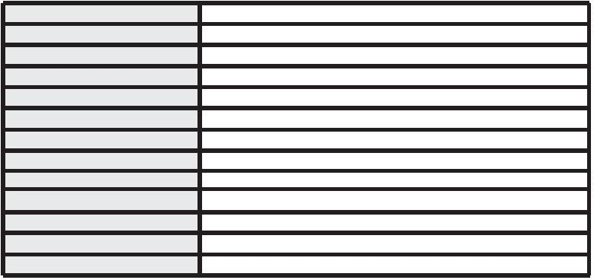

®
Anti-static electricity series
ST003
Hanging three-head ion fan
Features:
※
※
※
※
※
※
Rapid elimination of static electricity;
There is an ionization indicator;
Suspension mounted sickle should be adopted to save space;
The ionized airflow covers a large area;
Specialized ion launching needle cleaner is available;
The fan is well protected by grounding.
Test Results:
Test Conditions
Humidity: ≤60% Test voltage: 1KV-100V Environment temperature: 22℃
Distance
300mm
.0s
.1s
600mm
1.8s
1.8s
+
-
1
Neutralizing time
1
+
-
+
6v
+10v
-9v
Residual voltage
-
7v
*
The test instrument uses CPM374 electrostatic comprehensive
tester. The test results shall prevail.
Tested according to IEC-61340-5-1 A-6.
Test data will vary due to changes in surrounding temperature and
humidity.
*
*
Speciﬁcation
Input voltage
220V/50Hz or 110V/60Hz
Power
Power consumption time
Air volume
Ozone concentration
Dimensions
50W
≤
2S （300mm from the front center of the air outlet）
120-330CFM
≤ 0.03ppm（150mm from the front center of the air outlet）
L1100xW170xH125mm
Surface
The output voltage
Ion balance
Electrostatic spray painting
AC 5.6KV
≤|±10V| (300mm from the test center in front of the fan)
Eﬀective range
Operating humidity
Operating temperature
Noise
400x1200mm
0℃-50℃
＜75%
49-55dB
Gross Weight
About8.7Kg
ST004
Suspended four-head ion blower
Features:
Test Results:
Test Conditions
Humidity: ≤60% Test voltage: 1KV-100V Environment temperature: 22℃
※
※
※
※
※
※
Rapid elimination of static electricity;
There is an ionization indicator;
Suspension mounted sickle should be adopted to save space;
The ionized airflow covers a large area;
Specialized ion launching needle cleaner is available;
The fan is well protected by grounding.
Distance
300mm
.0s
1.1s
6v
7v
600mm
1.8s
1.8s
+10v
-9v
+
-
+
-
1
Neutralizing time
+
-
Residual voltage
*
The test instrument uses CPM374 electrostatic comprehensive
tester. The test results shall prevail.
Tested according to IEC-61340-5-1 A-6.
Test data will vary due to changes in surrounding temperature and
humidity.
*
*
Speciﬁcation
Input voltage
220V/50Hz or 110V/60Hz
Power
50W
Ion balance
Air volume
≤|±10V| (300mm from the test center in front of the fan)
120-330CFM
≤2S （300mm from the front center of the air outlet）
400x1600mm
AC 5.6KV
Power consumption time
Eﬀective range
The output voltage
Operating temperature
Operating humidity
Ozone concentration
Dimensions
0℃-50℃
＜75%
≤ 0.03ppm （150mm from the front center of the air outlet）
L1600xW170xH125mm
Surface
Noise
Electrostatic spray painting
40-55dB
Gross weight
About 10.2Kg

61
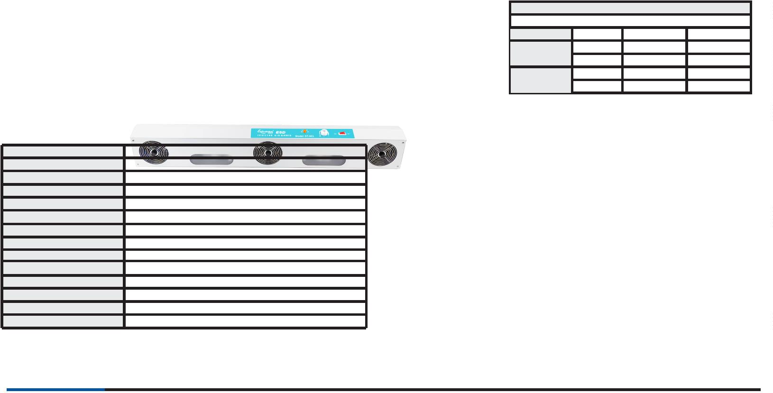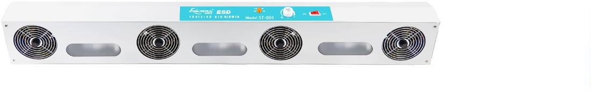

®
Anti-static electricity series
6004B
Horizontal ion fan
Features:
※
※
※
※
※
※
※
Quickly eliminate static electricity.
The ion air flow covers a large area.
With ionization indicator.
There is a special window launcher cleaner.
The angle is adjustable.
The fan has good grounding protection function.
If necessary, a cold air heating device can be installed.
Speciﬁcation
Use voltage
Power
220V/50Hz or 110V/60Hz
50W (no heating) 250W (heating)
Power consumption time
Operating temperature
Air volume
Ozone concentration
Dimensions
Snake length
The output voltage
Ion balance
≤2S （300mm from the front center of the air outlet）
0℃-50℃
70-120CFM
≤ 0.03ppm （150mm from the front center of the air outlet）
L450xW210xH190mm (including bracket)
L390xW210x115mm (without bracket)
AC 5.6KV
≤|±10V| (300mm from the test center in front of the fan)
Eﬀective range
Operating humidity
Noise
Gross Weight
Air velocity
600×1200mm
＜75%
50-65dB
About 7.3kg
3-10m/S
Electrostatic spray painting
Test Results:
Test Conditions
Humidity: ≤60% Test voltage: 1KV-100V Environment temperature: 22℃
Surface
Distance
300mm
.0s
.8s
+7v
-7v
600mm
1.9s
+
-
+
-
1
0
Neutralizing time
1.8s
+9v
-9v
Residual voltage
*
The test instrument uses CPM374 electrostatic comprehensive
tester. The test results shall prevail.
Tested according to IEC-61340-5-1 A-6.
Test data will vary due to changes in surrounding temperature and
humidity.
*
*
6107
ESD ionized air curtain machine
Features:
※
Roller blades provide wind power and neutralize static
electricity quickly.
※
※
※
The ionized airflow covers a large area;
Built-in static electricity elimination;
Good grounding protection is provided by the ionized air
curtain machine.
※
※
The body is made of aluminum alloy and high-precision ABS combination, and it is not easy to iron, the whole machine is lightweight with
extraordinary design, 40% lighter than the weight of ordinary air curtains, suitable for installation on the top of glass doors and marble doors;
The unequally spaced cross-flow ultra-quiet wind turbine has been adopted to avoid the area of maximum noise, resulting in strong wind power and
calm operation;
※
※
The air deflector design is unique; the wind direction can be adjusted at will, suitable for a variety of use of the environment.
The whole machine adopts arc shape design, which is easy to install, clean and maintain. The air deflector design is unique; the wind direction can be
adjusted at will, suitable for a variety of use of the environment.
※
Optimized air-conditioning motor is used, which is more reliable, for continuous operation of 5,000 hours without failures; the effective installation
height is 3.5 to 4 meters.
Speciﬁcation
Model
Size
Rated frequency Rated voltage Input frequency Air volume HILO Wind speed HILO Noise Weight
6
00
00
L600*W180*H215mm
L600*W180*H215mm
L900*W180*H215mm
L1500*W180*H215mm
L1800*W180*H215mm
50/60
50/60
50/60
50/60
50/60
220-240
220-240
220-240
220-240
220-240
140
160
200
230
300
840/680
1400/1100
1900/1500
2500/2000
3200/2600
11/9
11/9
11/9
11/9
11/9
<60 8.5KG
<60 11.5KG
<60 13.5KG
<60 15.0KG
<60 20.0KG
9
1
1
1
200
500
800
Test Results:
Test Conditions
Humidity: ≤60% Test voltage: 1KV-100V Environment temperature: 22℃
Distance
600mm
.5S
.3S
1000mm
2.0S
2000mm
3.0S
+
-
1
Neutralizing time
1
2.2S
3.1S
*
*
*
The test instrument uses CPM374 electrostatic comprehensive tester. The test results shall prevail.
Tested according to IEC-61340-5-1 A-6.
Test data will vary due to changes in surrounding temperature and humidity.
6
2

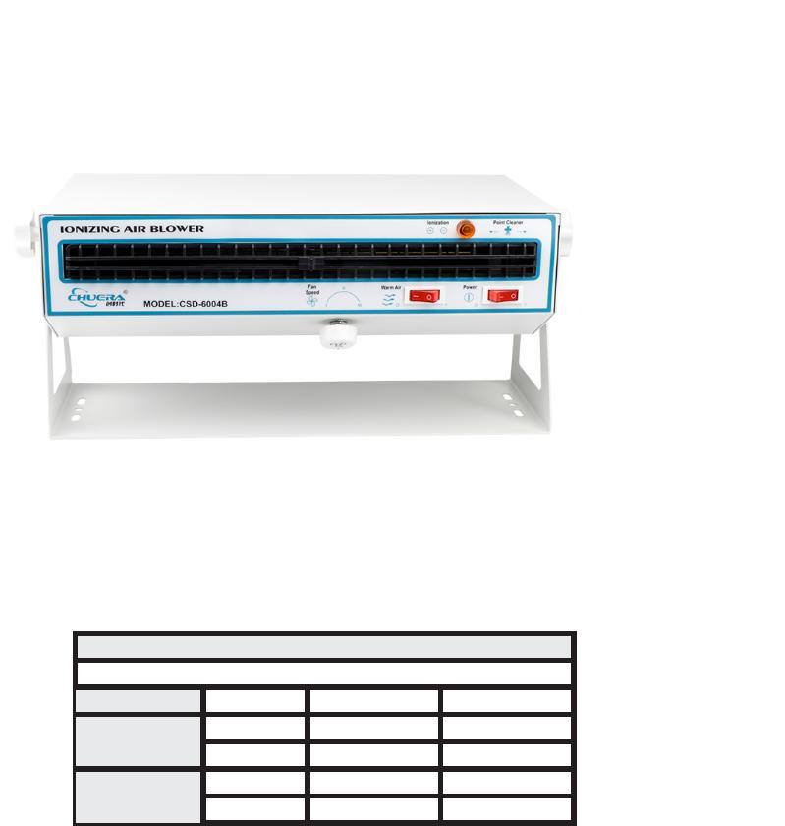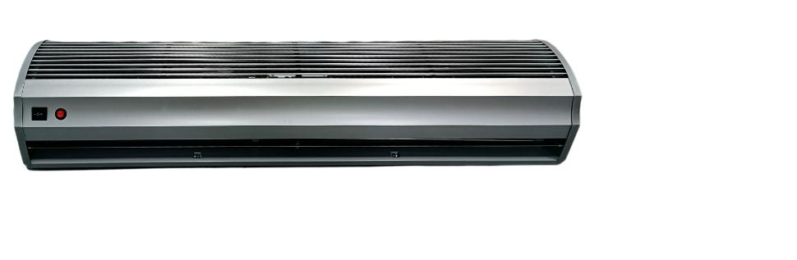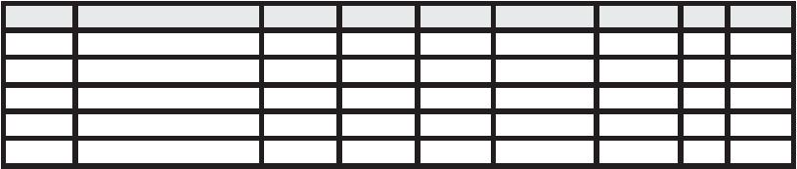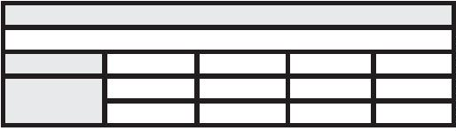

®
Anti-static electricity series
2812A
Intelligent high-frequency ion air gun
Features:
※
High-frequency electric chamber discharge method is adopted,
eliminating static electricity rapidly and stabilizing the ionic balance.
※
※
※
※
The wind is strong and the noise is low;
Plastic lightweight gun body is easy to hand-held operations;
Compact size, light weight and easy to operate;
The power supply voltage indicator and high voltage abnormality
indicator are equipped;
※
DC24/1A external power supply is used, which is safe and reliable.
Speciﬁcation
DC24V
00－400mm
≤2S
＜70%
about 0.4kg
Output voltage
ion balance
AC2.2KV
≤|±35V|
Use voltage
1
Work distance
0
℃-50℃
Discharge time
Operating temperature
Noise
Operating humidity
＜70dB
3M
0.3~0.7Mpa
Net weight
High voltage cable length
Working air pressure
clean compressed air
about 5m³/H(0.5MPA)
Use medium
Air consumption
Test Results:
Test Conditions
Test voltage: +1000V~100V -1000V~100V Environmental temperature: 5ꢀ~25ꢀ
Environmental humidity: ꢀ60%RH
Distance
150mm
≤1.0s
≤1.0s
+
-
Neutralizing time
+
-
≤±15V
≤±15V
Residual voltage
*
The test instrument uses CPM374 electrostatic comprehensive
tester. The test results shall prevail.
Tested according to IEC-61340-5-1 A-6.
Test data will vary due to changes in surrounding temperature and
humidity.
*
*
Horizontal Ion
Features:
※
※
※
Static electricity is quickly eliminated and dust removal is effective;
Built-in customized high air volume air duct;
One for two power supply, which can be equipped with two air
guns;
※
Ergonomic design for comfortable hand feeling.
Detailed view of the gun head of the 6202C
Speciﬁcation
Operating voltage
Current consumption
Operating temperature
High voltage cable length
Operating air pressure
Ion balance
4600v
200uA
0~50°C
3mꢀcustomizableꢀ
40-70 psi
0v±35 v
Operating airﬂow speed >10m/sec
Test Results:
Test Conditions
Humidity: ≤60% Test voltage: 1KV-100V Environment temperature: 22℃
Distance
150mm
0.8s
+
Neutralizing time
Residual voltage
±30v
*
*
The test data is based on the results of ME286A electrostatic
tester.
Test data will vary due to changes in surrounding temperature and
humidity.

63
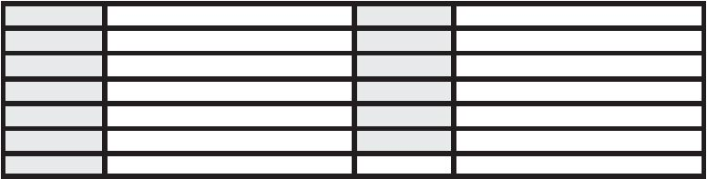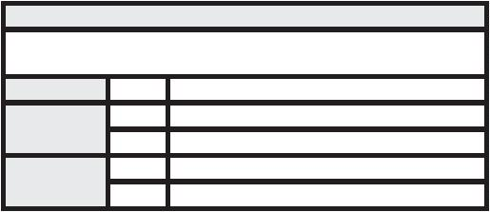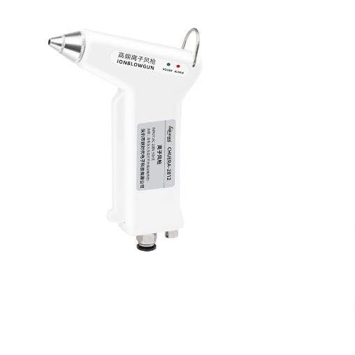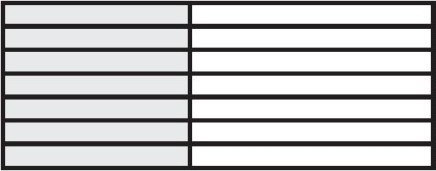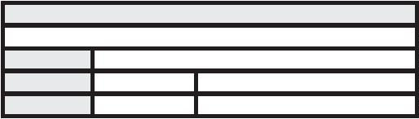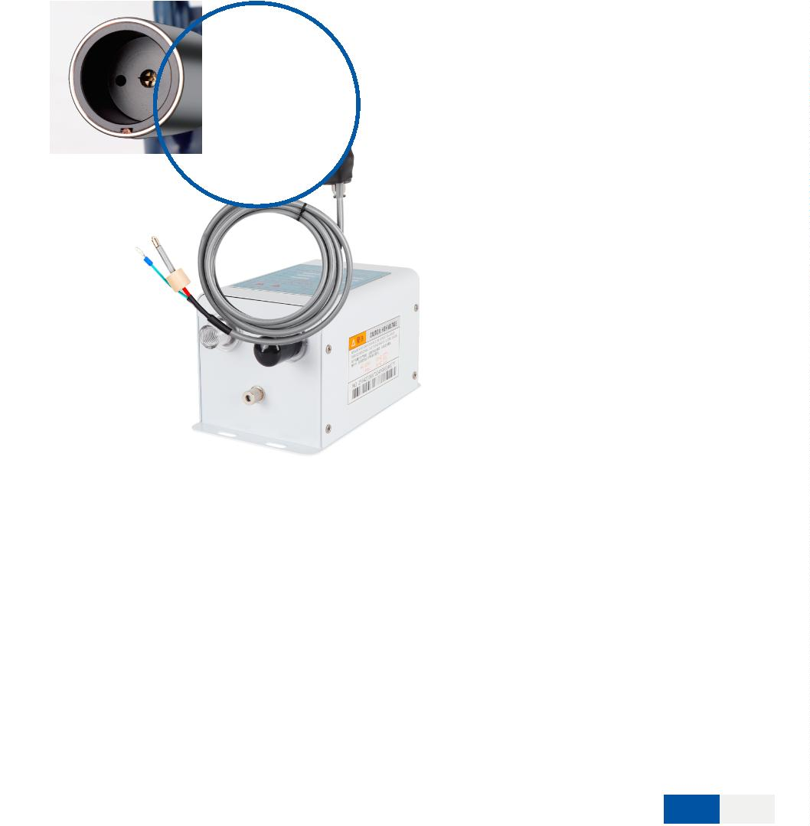

®
Anti-static electricity series
6302BF
Ion Wind Serpent
Features:
※
※
※
※
Quickly eliminate static electricity;
Small size, space saving;
A regulator can be added to adjust the airflow at will;
Infrared photoelectric sensor switch can be optionally installed to avoid manual operation for customers
to choose;
※
The wind snake can rotate to make the air nozzle point to the target position, allowing the ion airflow to
blow directly to the target surface without manual operation;
※
SpTehceiﬁwcaintidonsnake has good grounding protection function.
U
s
e
v
o
l
t
a
g
e
220V/50Hz or 110V/60Hz AC 4.6KV
O
u
t
p
u
t
v
o
l
t
a
g
e
26W
Power working distance
100－300mm
≤2S
＜70%
Ion balance
≤|±40V|
0℃-50℃
＜70dB
Power consumption time
Operating humidity
Weight
Operating temperature
Noise
about 3.5kg
Ф8mm（customizable）
3-10m/S
Use medium
clean compressed air
0.3-0.8Mpa
525mm
Air source connector
Air velocity
Compression air pressure
Snake length
Power cable length
1.8m
Test Results:
Test Conditions
Humidity: ≤60% Test voltage: 1KV-100V Environment temperature: 22℃
Distance
300mm
0.8s
0.9s
+
-
Neutralizing time
Residual voltage
≤±40V
*
*
*
The test instrument uses CPM374 electrostatic comprehensive tester. The test results shall prevail.
Tested according to IEC-61340-5-1 A-6.
Test data will vary due to changes in surrounding temperature and humidity.
6302DF
Ion Wind Serpent
Features:
※
※
※
※
※
Quickly eliminate static electricity;
Small size, space saving;
A regulator can be added to adjust the airflow at will;
Wind and electricity isolation makes the ion needle last longer;
Infrared photoelectric sensor switch can be optionally installed to avoid manual operation for
customers to choose;
※
The wind snake can rotate to make the air nozzle point to the target position, allowing the ion airflow to
blow directly to the target surface without manual operation;
※
The wind snake has good grounding protection function.
Speciﬁcation
Use voltage
Output voltage
220V/50Hz or 110V/60Hz
26W
AC 4.6KV
Power
working distance
Power consumption time
Operating humidity
Weight
100－300mm
≤2S
Ion balance
≤|±40V|
Operating temperature
Noise
0℃-50℃
＜70%
＜70dB
About 3.5kg
Ф8mm（customizable）
Use medium
clean compressed air
0.3-0.8Mpa
525mm
Air source connector
Air velocity
Compression air pressure
Snake length
3-10m/S
1.8m
Power cable length
Test Results:
Test Conditions
Humidity: ≤60% Test voltage: 1KV-100V Environment temperature: 22℃
Distance
300mm
.8s
0.9s
≤±40V
+
-
0
Neutralizing time
Residual voltage
*
*
*
The test instrument uses CPM374 electrostatic comprehensive tester. The test results shall prevail.
Tested according to IEC-61340-5-1 A-6.
Test data will vary due to changes in surrounding temperature and humidity.
6
4

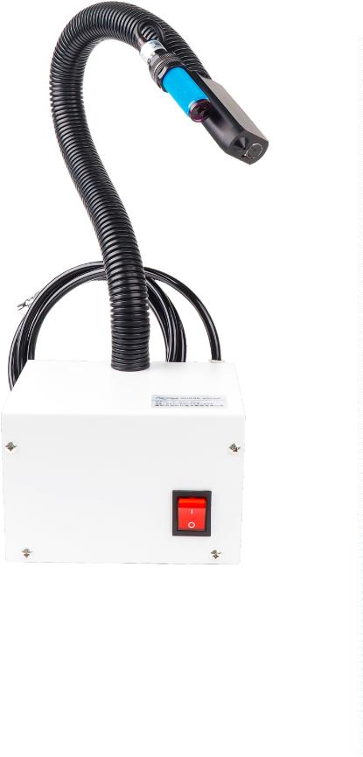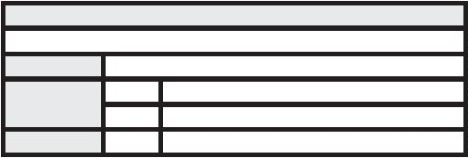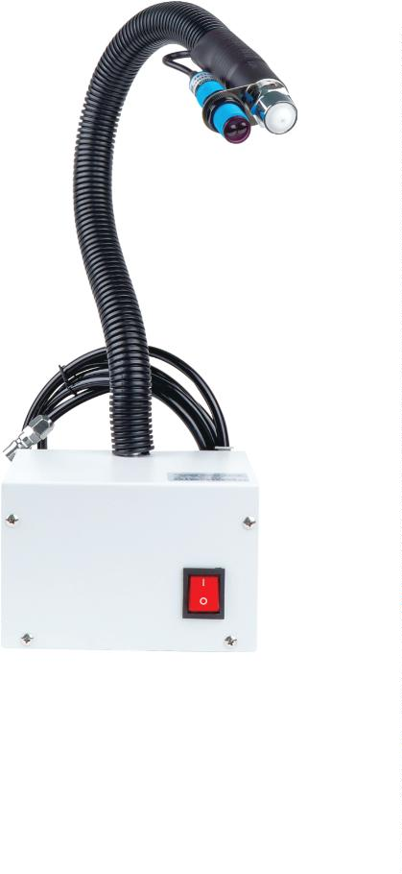

®
Anti-static electricity series
2800D
Intelligent ion air stick
※
※
Pulsed ionizing air rods are adjustable according to the balance of different distances;
Aluminum steel ionic needles have a long life and plug-and-play design, which are easy to maintain and clean, and single independent
replacement is supported;
※
※
Display is available for intelligent adjustment and failure alarm function;
The networked version is capable of communication and networking, and needs to be equipped with supporting accessories such as
networking software and receivers;
※
※
※
The casing is made of plastic injection molding, with good insulation effect and exquisite appearance;
The fully sealed glue filling structure is not easy to be contaminated and damaged, and has a longer service life;
It is easy to install in a narrow space with easy installation, and the bar body has a special bar-shaped groove, and the installation bolts
are movable and convenient;
※
※
Anti-electric shock function is available to avoid accidental human touch resulting in injury;
The customized high air volume air duct is equipped and the fan is well protected by grounding.
Plug-in tungsten steel
ion wind needle
Specification
Panel function description:
Input voltage
DC24V±10%
LED
High pressure
Mood
selection
Discharge voltage
Power
±5.6Kv(5%)
shut-oﬀ button display window
22W
Ion balance
≤±10V（Adjustable）
Operating temperature
Noise
0℃-50℃
＜65dB
Use medium
clean compressed air
Network
port
Power
port
Alarm indicator
light receiver
Up and down
adjustment
buttons
Compression air pressure
Operating distance
Power consumption time
Working humidity
Air source connector
Flow
0-0.5Mpa（Usually less than 0.3MPa）
00－300mm
Can be connected when network communication is required.
DC24V DC socket entrance (please choose our company's
special connecting cable).
≤2S
35～80%RH（No condensation）
Ф6mm（customizable）
2L/min（±10%）[Lower than 0.1MPa]
corona discharge
When cleaning the high voltage click pin, please turn oﬀ the
high voltage or unplug the power supply.
When the high voltage is abnormal, the alarm light lights up
and the LED display window displays Error.
When the button is not locked, adjust the UP/DOWN button to
adjust the ion balance voltage.
How electric ions are generated
Voltage output mode
Output frequency
Discharge needle replacement
When the button is not locked, press this button to adjust the
frequency, IP and other functions.
High frequency AC
10-50Hz（Select different frequencies for different test distances）
Replaceable
6
6

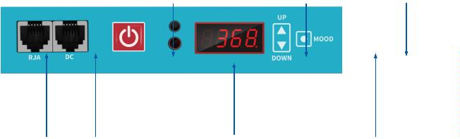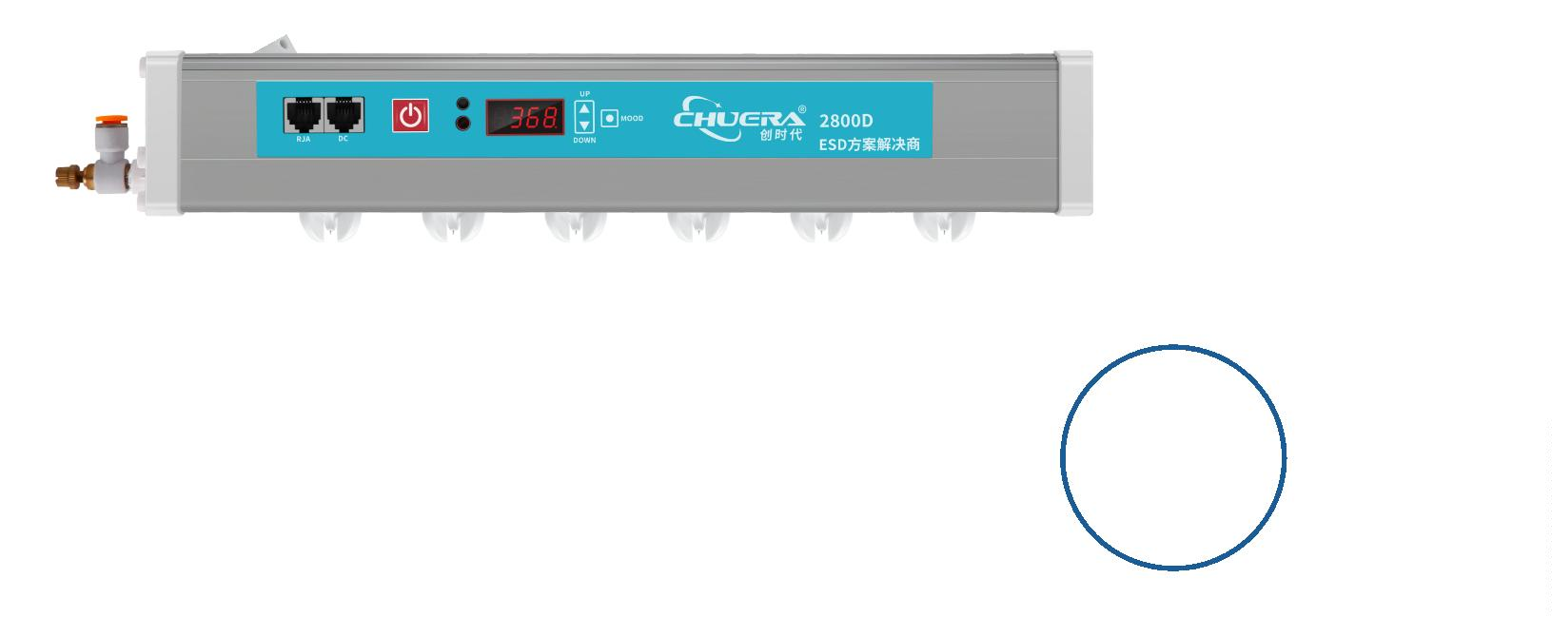

®
Anti-static electricity series
6505A
Ion air stick
Features:
※
※
Excellent appearance and durability;
Static electricity is quickly eliminated and dust removal is
effective;
※
※
Compact and flexible, φ 30mm in diameter;
Aluminum alloy rod body should be adopted, with induction
electrode-free design and high safety performance.
※
The bar body has a special bar-shaped groove, and the
installation bolts are movable and convenient;
※
※
Built-in customized high air volume air duct;
The fan is well protected by grounding.
Speciﬁcation
Input voltage
220V/50Hz or 110V/60Hz
Output voltage
Ion balance
AC 7KV
≤|±10V| (300mm from the test center in front of the fan)
Power consumption time ≤2S (300mm from the test center in front of the fan)
Applicable medium
Operating humidity
Air connection
clean compressed air
＜70%
Operating temperature 0℃-50℃
Operating distance 100-300mm
Φ6mm
Cross-sectional area W15xH35.5mmx any length
Voltage cables
Length 3M
Shell material
aluminum material
Test Results:
Test Conditions
Test voltage: ±1KV~±100V Operating voltage: 110V/220V Environmental temperature: 22℃ Environmental humidity: ≤65%RH
Distance
300mm
.6s
.7s
-28v
30v
400mm
1.1s
500mm
2.5s
600mm
5.3s
+
-
+
-
0
Neutralizing time
0
1.3s
0.7s
5.6s
-20v
-18v
-17v
Residual voltage
-
-25v
-20v
-18v
*
The test instrument uses CPM374 electrostatic comprehensive tester. The test
results shall prevail.
Tested according to IEC-61340-5-1 A-6.
Test data will vary due to changes in surrounding temperature and humidity.
*
*
6509A
Ion air stick
Features:
※
※
※
Excellent appearance and durability;
Static electricity is quickly eliminated and dust removal is effective;
Compact and flexible, with a thickness of only 15mm and a width of 35.5mm, it can be used in
small spaces and the length can be customized;
※
※
Aluminum alloy rod body should be adopted, with induction electrode-free design and high
safety performance.
The bar body has a special bar-shaped groove, and the installation bolts are movable and
convenient;
※
※
Built-in customized high air volume air duct;
The fan is well protected by grounding.
Speciﬁcation
Input voltage
220V/50Hz or 110V/60Hz
Output voltage
Ion balance
AC 7KV
≤|±10V| (300mm from the test center in front of the fan)
Power consumption time ≤2S (300mm from the test center in front of the fan)
Applicable medium
Operating humidity
Air connection
clean compressed air
Operating temperature 0℃-50℃
＜70%
Operating distance 100-300mm
Φ6mm
Cross-sectional area W15xH35.5mmx any length
Voltage cables
Length 3M
Shell material
aluminum material
Test Results:
Test Conditions
Test voltage: ±1KV~±100V Operating voltage: 110V/220V Environmental temperature: 22℃ Environmental humidity: ≤65%RH
Distance
300mm
1.6s
.7s
+30v
-30v
400mm
2.1s
500mm
3.5s
600mm
5.3s
+
-
+
-
Neutralizing time
1
2.3s
3.7s
5.6s
+30v
-30v
+30v
-30v
+30v
-30v
Residual voltage
*
The test instrument uses CPM374 electrostatic comprehensive tester. The test
results shall prevail.
Tested according to IEC-61340-5-1 A-6.
*
*
Test data will vary due to changes in surrounding temperature and humidity.

65
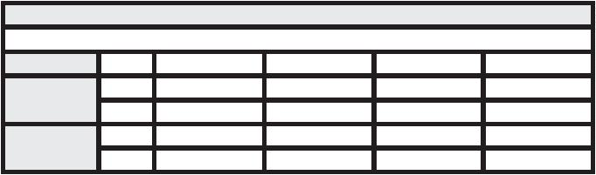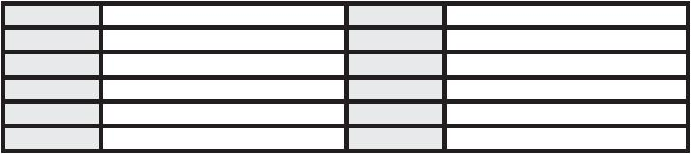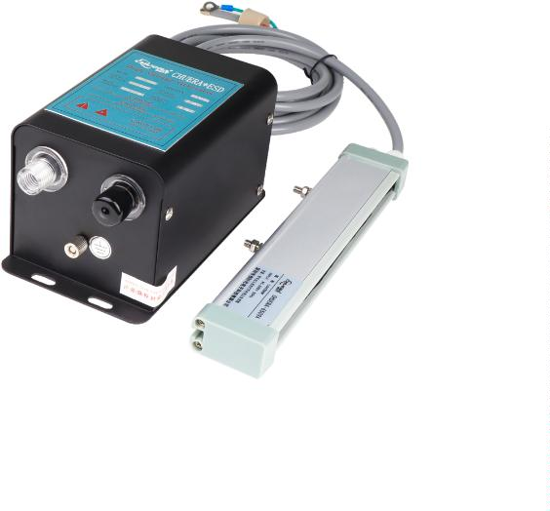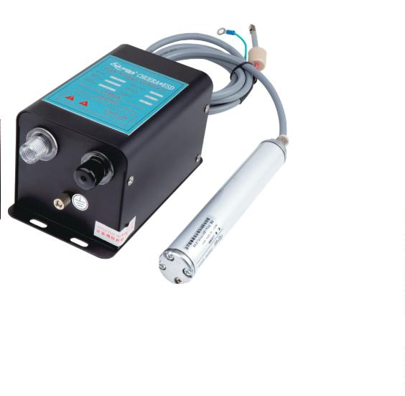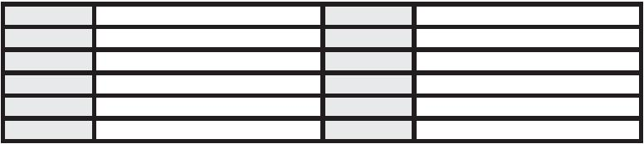

®
Anti-static electricity series
492-1
Wristband monitor
Features:
※
※
※
※
The operator's electrostatic wristband is monitored in real time and an
automatic alarm is activated in the event of an abnormal condition;
It is compact and lightweight, convenient and easy to use, 9V voltage is safe
and reliable;
With microcomputer chip control, it has strong anti-interference ability and
free of debugging;
Monitoring resistance value can be customized according to the design needs,
generally set to 750 KΩ -30M (±5%), in line with international norms, but the
monitoring parameters can be also set according to customer requirements;
※
It has affordable price and is cost saving to ensure the quality of products in
production;
※
※
This instrument fits any kind of wristband with a banana plug;
With a separate switch, it can be turned off when not in use. duct is equipped
and the fan is well protected by grounding.
Optional accessories:
Speciﬁcation
Name
Wristband monitor
1 person
3W
Monitor quantity
Maximum power
Input voltage
9VDC
single line wrist strap
Wristband monitoring
Resistance (Ω)
7
50KΩ-30MΩ（Factory settings）
Operating environment Anti-static workshop, -10-50℃
Indicator light
Appearance volume
Host weight
OK-green; H-red;
L60×W60×H29mm
0.1Kg
492-2
Wristband monitor
Features:
※
※
※
※
The operator's electrostatic wristband is monitored in real time and an automatic alarm
is activated in the event of an abnormal condition;
It is compact and lightweight, convenient and easy to use, 9V voltage is safe and
reliable;
With microcomputer chip control, it has strong anti-interference ability and free of
debugging;
Monitoring resistance value can be customized according to the design needs,
generally set to 750 KΩ -30M (±5%), in line with international norms, but the
monitoring parameters can be also set according to customer requirements;
※
※
※
It has affordable price and is cost saving to ensure the quality of products in production;
This instrument fits any kind of wristband with a banana plug;
With a separate switch, it can be turned off when not in use. duct is equipped and the fan
is well protected by grounding.
Optional accessories:
Speciﬁcation
Name
Wristband monitor
2 person
3W
Monitor quantity
Maximum power
Input voltage
9VDC
single line wrist strap
Wristband monitoring
Resistance (Ω)
7
50KΩ-30MΩ（Factory settings）
Operating environment Anti-static workshop, -10-50℃
Indicator light
Appearance volume
Host weight
OK-green; H-red;
L110×W60×H29mm
0.11 Kg

67
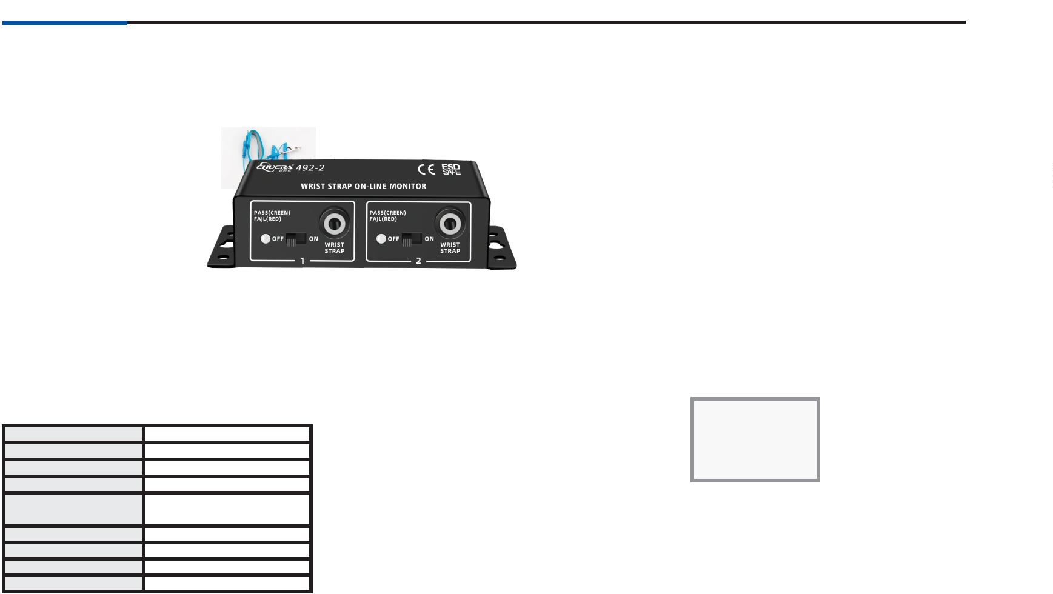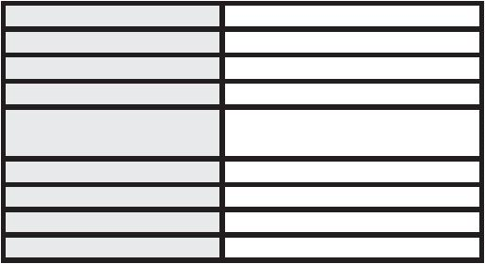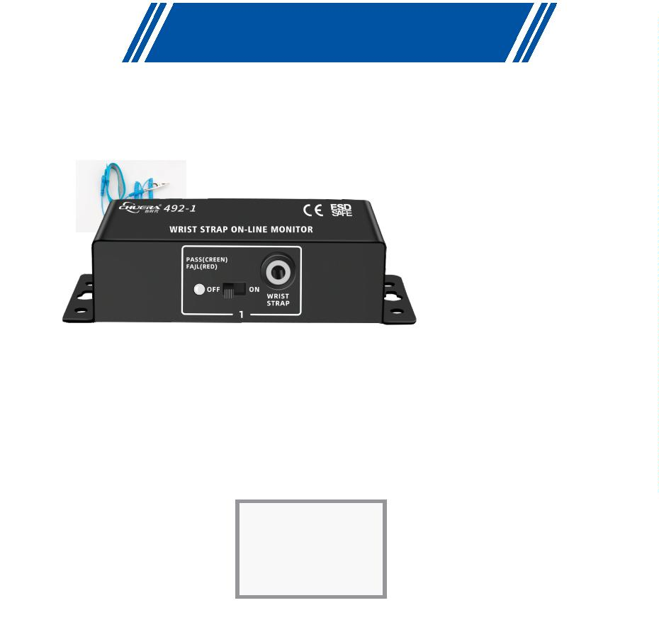

®
Anti-static electricity series
495-1
Wristband monitor
Features:
※
Real-time monitoring of the operator's electrostatic wrist strap wearing status
and the ground connection of the monitor's ground wire will automatically alarm
if any abnormal conditions occur.
※
The monitor and the ground wire are connected in two ways. If any one or both
connections are abnormal, an alarm can be issued. The contact situation
between the ground wire on the ground and the ground wire on the monitor can
be correctly determined to ensure real-time conduction effect.
※
※
Small and lightweight, convenient and easy to use, 9V voltage is safe and reliable.
Microcomputer chip control, strong anti-interference ability, no need for
debugging, plug and play, no switch required.
※
※
Monitoring resistance value can be customized according to the design needs,
generally set to 750 KΩ -30M (±5%), in line with international norms, but the
monitoring parameters can be also set according to customer requirements;
This monitor requires a dual-circuit wrist strap, which ensures more reliable
grounding.
Optional accessories:
Dual circuit wrist strap
Speciﬁcation
Name
Wristband monitor
1 person
3W
Monitor quantity
Maximum power
Input voltage
Wristband monitoring
Resistance (Ω)
9VDC
7
50KΩ-30MΩ（Factory settings）
Operating environment Anti-static workshop, -10-50℃
Indicator light
Appearance volume
Host weight
OK-green; H-red;L-Blue
67(L)×67(W)×31(H)mm
0.2 Kg
495-2
Wristband monitor
Tail port:
Features:
※
※
Real-time monitoring of the operator's electrostatic wrist strap wearing status and
the ground connection of the monitor's ground wire will automatically alarm if any
abnormal conditions occur.
The monitor and the ground wire are connected in two ways. If any one or both
connections are abnormal, an alarm can be issued. The contact situation between
the ground wire on the ground and the ground wire on the monitor can be correctly
determined to ensure real-time conduction effect.
※
※
Small and lightweight, convenient and easy to use, 9V voltage is safe and reliable.
Microcomputer chip control, strong anti-interference ability, no need for debugging,
plug and play, no switch required.
※
※
Monitoring resistance value can be customized according to the design needs,
generally set to 750 KΩ -30M (±5%), in line with international norms, but the
monitoring parameters can be also set according to customer requirements;
This monitor requires a dual-circuit wrist strap, which ensures more reliable
grounding.
Optional accessories:
Dual circuit wrist strap
Speciﬁcation
Wristband monitor
2 person
Name
Monitor quantity
Maximum power
Input voltage
Wristband monitoring
Resistance (Ω)
3
W
9
VDC
7
50KΩ-30MΩ（Factory settings）
Operating environment Anti-static workshop, -10-50℃
Indicator light
Appearance volume
Host weight
OK-green; H-red;L-Blue
L121×W67×H31mm
0.232Kg
6
8

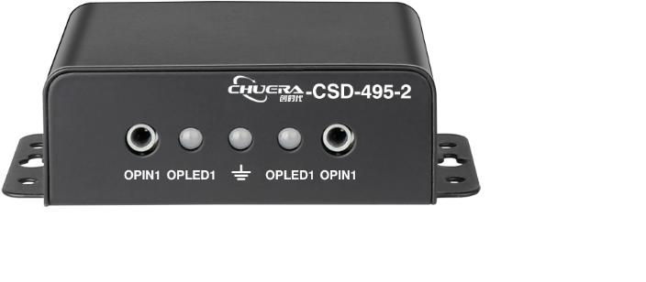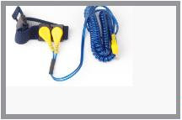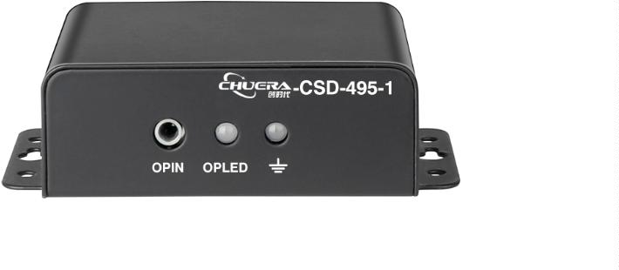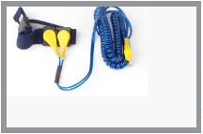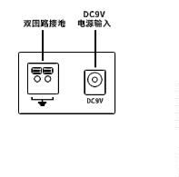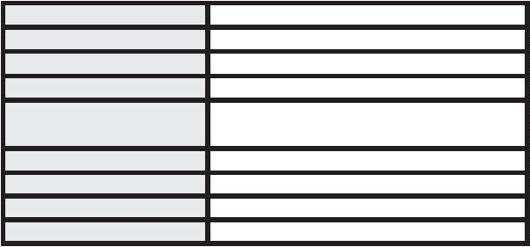

®
Anti-static electricity series
496-1
Wristband monitor
Features:
※
※
Real-time monitoring of the operator's electrostatic wrist strap wearing status and the
ground connection of the monitor's ground wire will automatically alarm if any
abnormal conditions occur.
The monitor and the ground wire are connected in two ways. If any one or both
connections are abnormal, an alarm can be issued. The contact situation between the
ground wire on the ground and the ground wire on the monitor can be correctly
determined to ensure real-time conduction effect.
※
※
Small and lightweight, convenient and easy to use, 9V voltage is safe and reliable.
Microcomputer chip control, strong anti-interference ability, no need for debugging,
plug and play, no switch required.
※
Monitoring resistance value can be customized according to the design needs,
generally set to 750 KΩ -30M (±5%), in line with international norms, but the
monitoring parameters can be also set according to customer requirements;
※
※
※
This monitor requires a dual-circuit wrist strap, which ensures more reliable grounding.
You can connect external alarm lights and sound and light alarm prompts.
With optional infrared sensor, it automatically turns off when people are walking and
turns on when people are around.
Optional accessories:
Speciﬁcation
Name
Wristband monitor
1 person
3W
Monitor quantity
Maximum power
Input voltage
Dual circuit wrist strap
Wristband adapter Photoelectric sensor (optional)
9VDC
Wristband monitoring
Resistance (Ω)
7
50KΩ-30MΩ（Factory settings）
Operating environment Anti-static workshop, -10-50℃
Indicator light
Appearance volume
Host weight
OK-green; H-red;L-Blue
67(L)×67(W)×31(H)mm
0.18Kg
496-2
Wristband monitor
Features:
Tail port:
※
※
Real-time monitoring of the operator's electrostatic wrist strap wearing status and the
ground connection of the monitor's ground wire will automatically alarm if any
abnormal conditions occur.
The monitor and the ground wire are connected in two ways. If any one or both
connections are abnormal, an alarm can be issued. The contact situation between the
ground wire on the ground and the ground wire on the monitor can be correctly
determined to ensure real-time conduction effect.
※
※
Small and lightweight, convenient and easy to use, 9V voltage is safe and reliable.
Microcomputer chip control, strong anti-interference ability, no need for debugging,
plug and play, no switch required.
※
Monitoring resistance value can be customized according to the design needs,
generally set to 750 KΩ -30M (±5%), in line with international norms, but the
monitoring parameters can be also set according to customer requirements;
※
※
※
This monitor requires a dual-circuit wrist strap, which ensures more reliable grounding.
You can connect external alarm lights and sound and light alarm prompts.
With optional infrared sensor, it automatically turns off when people are walking and
turns on when people are around.
Speciﬁcation
Wristband monitor
2 person
Name
Monitor quantity
Maximum power
Input voltage
Wristband monitoring
Resistance (Ω)
Optional accessories:
Dual circuit wrist strap
3
W
9
VDC
7
50KΩ-30MΩ（Factory settings）
Operating environment Anti-static workshop, -10-50℃
Indicator light
Appearance volume
Host weight
OK-green; H-red;L-Blue
L67×W67×H31mm
0.18Kg
Wristband adapter x 2 Photoelectric sensor (optional)

69
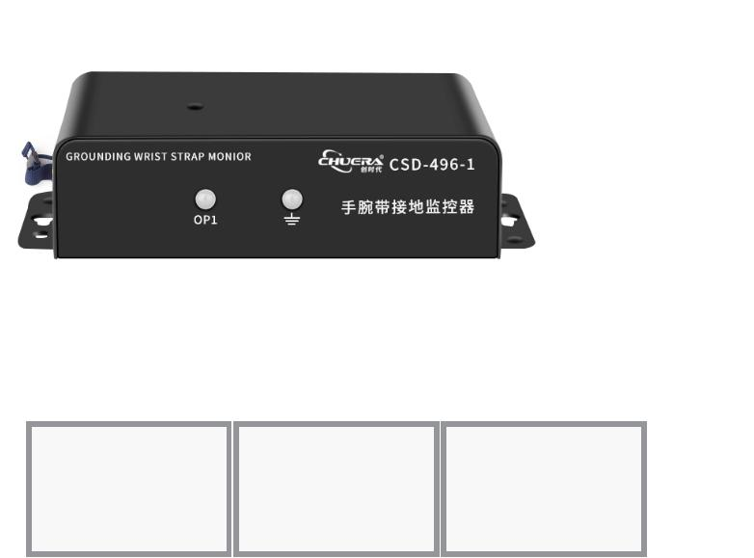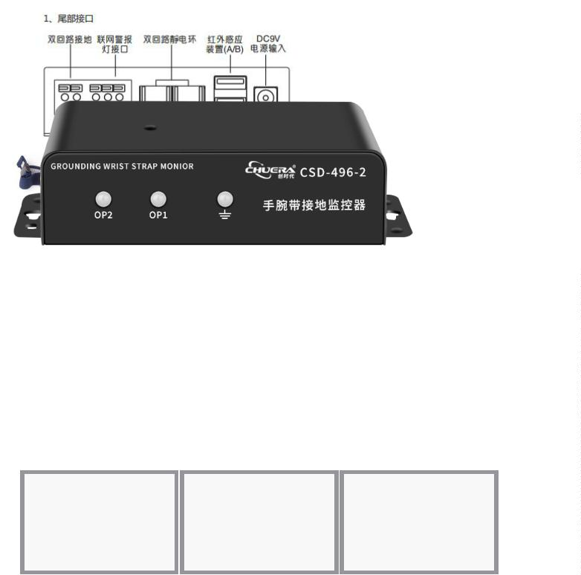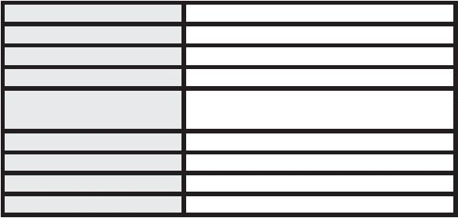

®
Anti-static electricity series
4804D
Intelligent IOT ESD grounding
monitor
Features:
Speciﬁcation
※
Four-way devices or four-way wristbands or four-way cushions can be monitored by one
device;
Name
Static electricity wrist
750K——35M±10%
≤1.55V
≤100ms
Table mat
Device
≤4Ω±10%
≤1.55V
※
※
※
※
One device can be combined with wristbands or cushions at will;
Wireless transmission, flexible installation and easy debugging;
With 2.4-inch intelligent serial LCD module screen, online upgrade is supported;
Resistance range
Open circuit voltage
Scanning frequency
≤10M±10%
≤1.55 V
≤100 ms
≤100ms
For intelligent infrared sensing, there should be an alarm to prevent leakage of insertion and Maximum adjustment range of resistance 10K——100M±10%
wearing;
≤20Ω±10%
10K——100M±10%
※
※
Intelligent detection of outlet cord leakage or disconnection alarm;
Three-color light is used by the monitoring device to indicate the monitoring state: (Fail: red and
alarm, Qualified: green; Low: yellow and alarm)
※
Monitoring resistance should be visualized and dynamically displayed by the monitoring equipment,
and the monitoring state icon should be dynamically displayed. (Fail: red, Qualified: Green; Low:
Yellow; Unused: gray);
※
※
※
※
※
※
Wristband, cushion grounding, and equipment grounding should be intelligently recognized by the
monitoring equipment;
Monitoring equipment has an automatic data storage function, and the machine can automatically
save 1,000 pieces of data in case of communication abnormality;
Recorded data is automatically transferred to the PC after communication is restored to normal. Data
recording time range (10 seconds to 3,600 seconds) is self-adjustable;
With wireless communication signal dynamic display, the monitoring device supports online upgrade
and the management software intelligently locks the IP;
The management software is divided into an administrator account and an ordinary management
account, and system privileges can be independently divided into ordinary management account;
The monitoring software can be displayed in map mode, so that when an abnormality occurs, the
information about the abnormal station can be confirmed by simulating the graphic of the
production line, and the site of the production abnormality can be found accurately;
※
The resistance value should be monitored by the monitoring system in real time, and the management
software should set the parameters of the equipment (e.g.: the monitoring resistance value of the
wristband and cushion can be adjusted in the range of 10K-100M, and the grounding of the
equipment can be adjusted in the range of 0Ω-≤20Ω.);
※
※
※
Data record query can be filtered and queried according to different time, date, type and state, and
can output reports, graphs and curves and support downloading;
The monitoring software supports to send the report of the previous day's monitoring record to the
specified e-mail address at regular intervals;
The system management mode is divided into PC management mode and mobile phone APP
management mode, which can realize remote query remote management.
4804S
ESD wired grounding monitor
Features:
※
Four-way devices or four-way wristbands or four-way cushions can be
monitored by one device;
One device can be combined with wristbands or cushions at will;
With 2.4-inch intelligent serial LCD module screen, online upgrade is
supported;
For intelligent infrared sensing, there should be an alarm to prevent leakage
of insertion and wearing;
Intelligent detection of outlet cord leakage or disconnection alarm;
Three-color light is used by the monitoring device to indicate the
monitoring state: (Fail: red and alarm, Qualified: green; Low: yellow and
alarm);
Speciﬁcation
※
※
Name
Static electricity wrist
750K——35M±10%
≤1.55V
≤100ms
Table mat
Device
≤4Ω±10%
≤1.55V
Resistance range
Open circuit voltage
Scanning frequency
≤10M±10%
≤1.55 V
※
≤100 ms
≤100ms
※
※
Maximum adjustment range of resistance 10K——100M±10%
10K——100M±10%
≤20Ω±10%
※
Monitoring resistance should be visualized and dynamically displayed by
the monitoring equipment, and the monitoring state icon should be
dynamically displayed. (Fail: red; Qualified: green; Low: yellow; Unused:
gray);
※
※
Wristband, cushion grounding, and equipment grounding should be
intelligently recognized by the monitoring equipment;
The resistance value should be monitored by the monitoring system in real
time, and the management software should set the parameters of the
equipment (e.g.: the monitoring resistance value of the wristband and
cushion can be adjusted in the range of 10K-100M, and the grounding of
the equipment can be adjusted in the range of 0Ω-≤20Ω..);
7
0

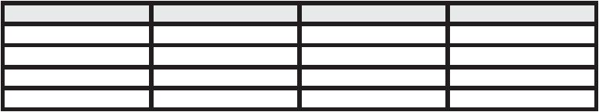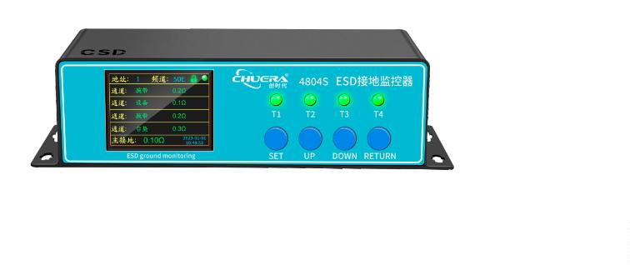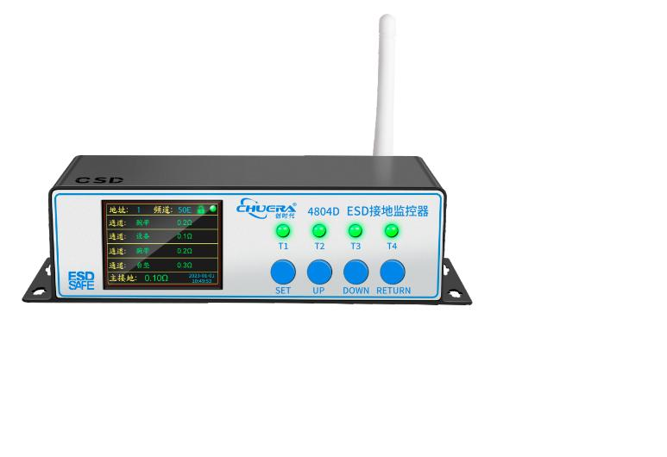

®
Anti-static electricity series
Speciﬁcation
4108A
Terminal power supply: DC9V~DC30V POE power supply: 48V
Temperature: -20 ~ 80℃ Humidity: 0 ~ 100% rh
Intelligent IOT temperature and
Rated voltage
Measuring range
Measurement precision Temperature: ±0.3℃ Resolution: 0.1℃ Humidity: ±3% rh resolution 0.1r
humidity meter
Output Interface
Address
Rj45
1-247
Work mode
Optional TCP Server TCP Client UDP
Data collection frequency 10~500ms (Note: Scanning time is for stand-alone scanning. Unit: milliseconds)
Power consumption
Switching output
Data record
＜2W
Features:
Optional 1 to 2 switching outputs, none by default
Optional temperature and humidity data recording and event recording, none by default
10-20m 2/only
※
※
※
Wireless transmission, flexible installation and easy debugging;
With 3.5-inch intelligent LCD color screen, online upgrade is supported;
Two-color light is used by the monitoring device to indicate the monitoring state: (Fail:
red and alarm, Qualified: green);
Eﬀective working area
Installation method
Indoor wall installation, ceiling installation
※
Temperature and humidity values should be visualized and dynamically displayed by the
monitoring equipment, and the monitoring state icon should be dynamically displayed.
(Fail: red, Qualified: green);
※
※
Monitoring equipment has an automatic data storage function, and the machine can
automatically save 1,000 pieces of data in case of communication abnormality;
Recorded data is automatically transferred to the PC after communication is restored to
normal. Data recording time range is self-adjustable;
Wireless communication signal dynamic display and signal intensity;
※
※
The monitoring device supports online upgrade and the management software
intelligently locks the IP;
※
※
Monitoring resistance value and anti-dulling function can be set freely by the
administrator;
The management software is divided into an administrator account and an ordinary
management account, and system privileges can be independently divided into ordinary
management account;
※
The monitoring software can be displayed in map mode, so that when an abnormality
occurs, the information about the abnormal station can be confirmed by simulating the
graphic of the production line, and the site of the production abnormality can be found
accurately;
※
※
Temperature and humidity values should be monitored by the monitoring system in real
time, and the management software should set the parameters of the equipment (e.g.
temperature and humidity correction value, alarm value);
Data record query can be filtered and queried according to different time, date, type and
state, and can output reports, graphs and curves and support downloading;
The monitoring software supports e-mail, WeChat and SMS function;
※
※
The system management mode is divided into PC management mode and mobile phone
APP management mode, which can realize remote query remote management.
4121D
Intelligent IOT dust particle monitor
Speciﬁcation
Rated voltage
Terminal power supply: DC9V~DC30V POE power supply: 48V
Particulate matter detection range 0.3~10nm
Particle size 0.3,0.5,1.0,3.0, 5.0,10pim
Particle number output range Less than or equal to 2,000,000 pieces/L
Features:
※
With wireless communication signal dynamic display and signal intensity, the
monitoring device supports online upgrade and the management software
intelligently locks the IP;
Flow
1 liter/minute (2.83L=1L*2.83)
Counting eﬃciency
Concentration resolution
Cleanliness standards
PM2.5 output range
PM2.5 detection accuracy
Operating temperature
Operating humidity
1pg/m3
10~500ms (Note: Scanning time is for stand-alone scanning. Unit: milliseconds)
※
※
※
※
The detection value is dynamically displayed on 3.5-inch LCD color screen and online
upgrade is supported;
The alarm range can be set, if it exceeds the range, the buzzer alarm two-color light
alarm is triggered: (Fail: red and alarm, Qualified: green);
The size of dust particles per unit volume can be visualized and dynamically displayed
by the monitoring equipment.
The number of 0.3um, 0.5um, 1.0um, 2.5um, 5.0um and 10um particles within the area
can be simultaneously detected by the monitor;
The 3-channel version is optional and supports 3 sensors for 1 host;
Complies with ISO 14644-11S05 level -lS09 level
0~1000ljg/m3
0~100Hg/m3:+10ng/m3 100~1000ng/m3+10%
-10~+50C
0-95% (eye view)
※
※
The monitoring device supports online upgrade and the management software
intelligently locks the IP;
※
※
Monitoring resistance value and anti-dulling function can be set freely by the
administrator;
The management software is divided into an administrator account and an ordinary
management account, and system privileges can be independently divided into
ordinary management account;
※
※
Local storage function: With serial flash memory, cyclic data storage is performed,
guaranteeing data storage locally in case of poor communication;
Temperature and humidity values should be monitored by the monitoring system in
real time, and the management software should set the parameters of the equipment
(e.g. temperature and humidity correction value, alarm value);
※
Data record query can be filtered and queried according to different time, date, type
and state, and can output reports, graphs and curves and support downloading;
The monitoring software supports e-mail, WeChat and SMS function;
The system management mode is divided into PC management mode and mobile
phone APP management mode, which can realize remote query remote management.
※
※

71
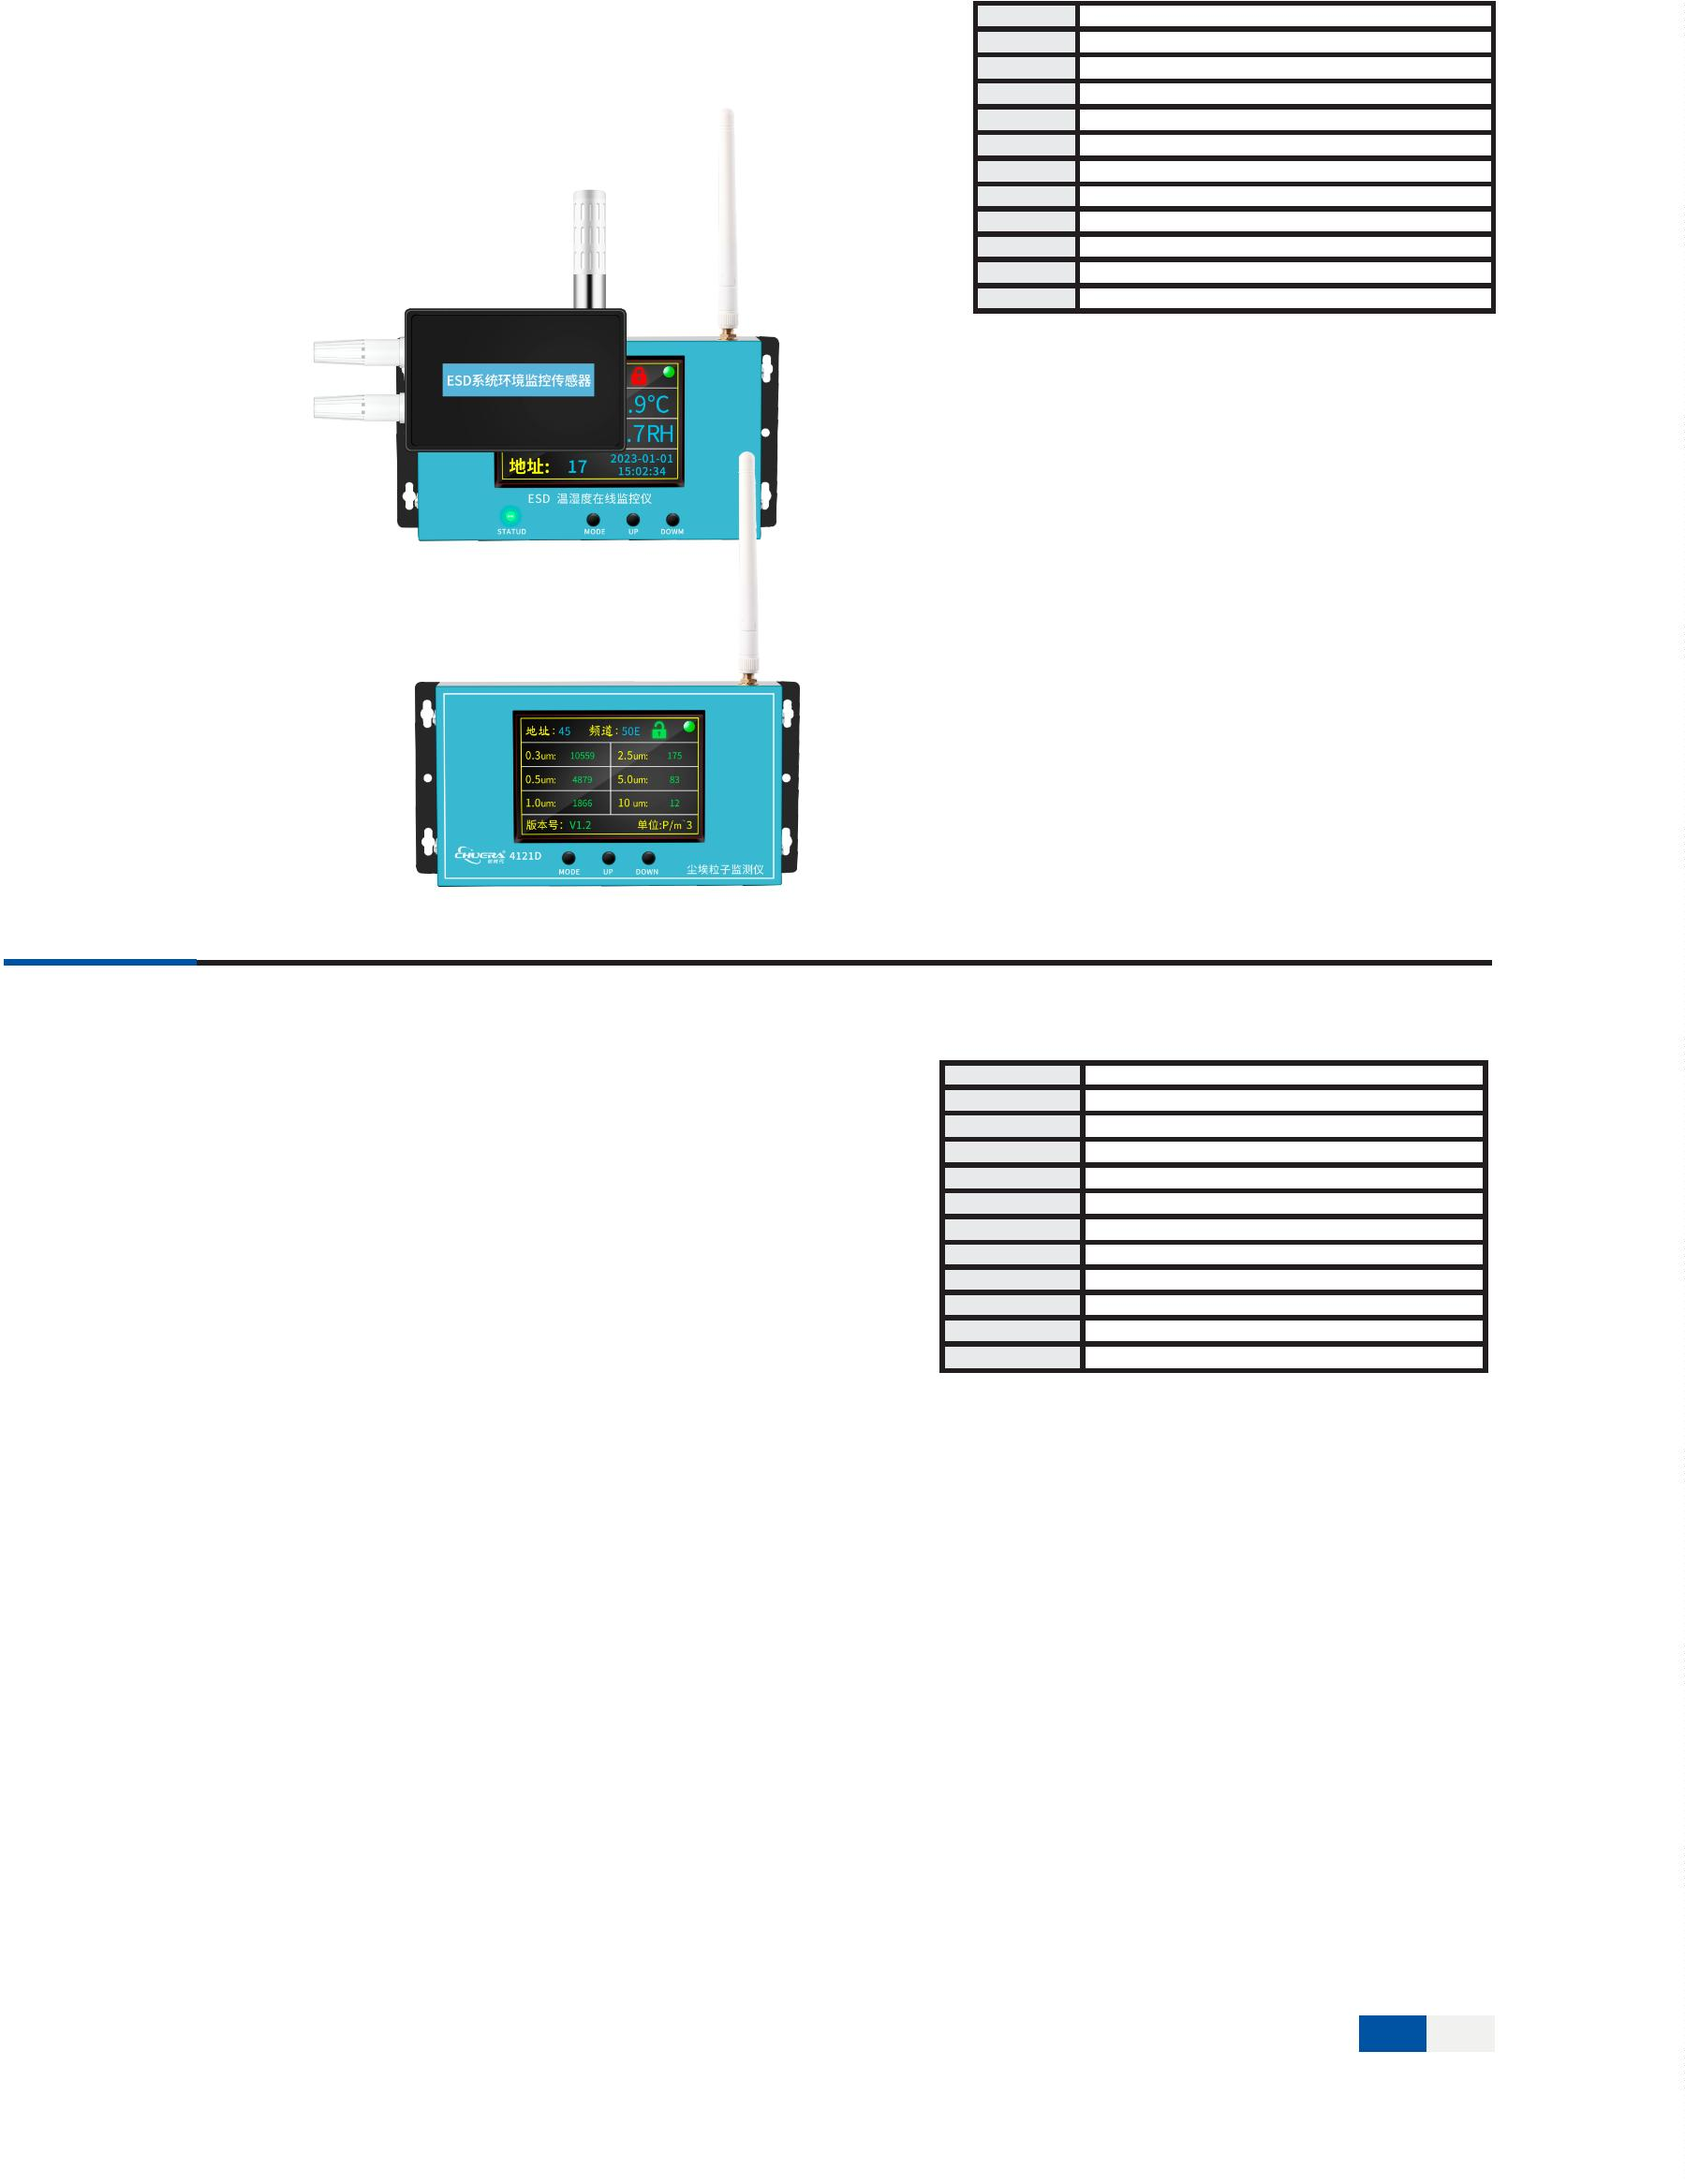

Anti-static electricity series
Wireless digital display noise
monitor
Features:
※
※
※
Wireless communication signal dynamic display and signal strength, monitoring
equipment supports online upgrade, and management software intelligently locks IP.
The detection value is dynamically displayed on the 3.5-inch LCD color screen and
supports online upgrade;
The alarm range can be set. If the range is exceeded, the buzzer will be triggered and
the alarm screen will be displayed with color reminders (unqualified: red and alarm;
qualified: green);
※
※
Visualization dynamically displays the noise in each unit volume at the same time;
Local storage function: Serial flash memory performs cyclic data storage to ensure
local storage of data when communication is poor;
Can be moved at will with the movable shelf.
※
※
You can connect external alarm lights and sound and light alarm prompts.
Speciﬁcation
Name
Rated voltage
Output signal
Working temperature
Working humidity
Measuring range
Frequency Range
Accuracy
Wireless digital display noise monitor
DC9V
Zigbee/LoRa
-10~+50°C
0-80%
30-130dB
20Hz-12.5KHz
±0.5dB （Reference intonation,94dB@lKHz）
Resolution
0.1dB
10S
1S
Boot stable time
Data refresh interval
Response time
1S
4130D
Wireless digital display noise
monitor
Features:
※
※
※
Wireless communication signal dynamic display and signal strength, monitoring
equipment supports online upgrade, and management software intelligently locks IP.
The detection value is dynamically displayed on the 3.5-inch LCD color screen and
supports online upgrade;
The alarm range can be set. If the range is exceeded, the buzzer will be triggered and
the alarm screen will be displayed with color reminders (unqualified: red and alarm;
qualified: green);
※
※
Visualization dynamically displays the noise in each unit volume at the same time;
Local storage function: Serial flash memory performs cyclic data storage to ensure
local storage of data when communication is poor;
Can be moved at will with the movable shelf.
※
※
You can connect external alarm lights and sound and light alarm prompts.
Speciﬁcation
Name
Rated voltage
Output signal
Operating temperature
Operating humidity
Measuring range
Accuracy
Wireless digital display noise monitor
DC9V
Zigbee/LoRa
-10~+50°C
0-80%
0-65535Lux/0-20WLux
±5%
0.1dB
10S
1S
Resolution
Boot stable time
Data refresh interval
Response time
1S
7
2

Anti-static electricity series
4129D
Wireless digital display noise
monitor
Features:
※
※
※
Wireless communication signal dynamic display and signal strength, monitoring
equipment supports online upgrade, and management software intelligently locks IP.
The detection value is dynamically displayed on the 3.5-inch LCD color screen and
supports online upgrade;
The alarm range can be set. If the range is exceeded, the buzzer will be triggered and
the alarm screen will be displayed with color reminders (unqualified: red and alarm;
qualified: green);
※
※
Visualization dynamically displays the noise in each unit volume at the same time;
Local storage function: Serial flash memory performs cyclic data storage to ensure
local storage of data when communication is poor;
Can be moved at will with the movable shelf.
※
※
You can connect external alarm lights and sound and light alarm prompts.
Speciﬁcation
Name
Wireless digital display noise monitor
Power supply
DC12-36V
Zigbee/LoRa
Output signal
Working temperature
Working humidity
Measuring range
Compensation temperature
Output signal
-20~+80°C
0-90%
-30KPa-100KPa
0-50℃
4-20mA/1-5V/0-10mA/0-20mA/0-5V/RS485
0.1dB
Resolution
Comprehensive accuracy
Working method
Response time
Level 0.2/0.5 optional
pressure diﬀerence
1s
±0.03%FS/℃
300%FS
Sensitivity temperature drift
Overload pressure
4130D
Wireless digital display noise
monitor
Features:
※
Wireless communication signal dynamic display and signal strength, monitoring
equipment supports online upgrade, and management software intelligently locks
IP.
※
※
The detection value is dynamically displayed on the 3.5-inch LCD color screen and
supports online upgrade;
The alarm range can be set. If the range is exceeded, the buzzer will be triggered
and the alarm screen will be displayed with color reminders (unqualified: red and
alarm; qualified: green);
※
※
Visualization dynamically displays the noise in each unit volume at the same time;
Local storage function: Serial flash memory performs cyclic data storage to ensure
local storage of data when communication is poor;
Can be moved at will with the movable shelf.
※
※
You can connect external alarm lights and sound and light alarm prompts.
Name
Power supply
Wireless digital display noise monitor
DC12V-36V
Zigbee/LoRa
0~50°C
Output signal
Operating temperature
Operating humidity
Measuring range
Resolution
≤90%RH
1.1～20m/s
0.1m/s
BF
1～8
Accuracy
±2%
1
S
Response time

73
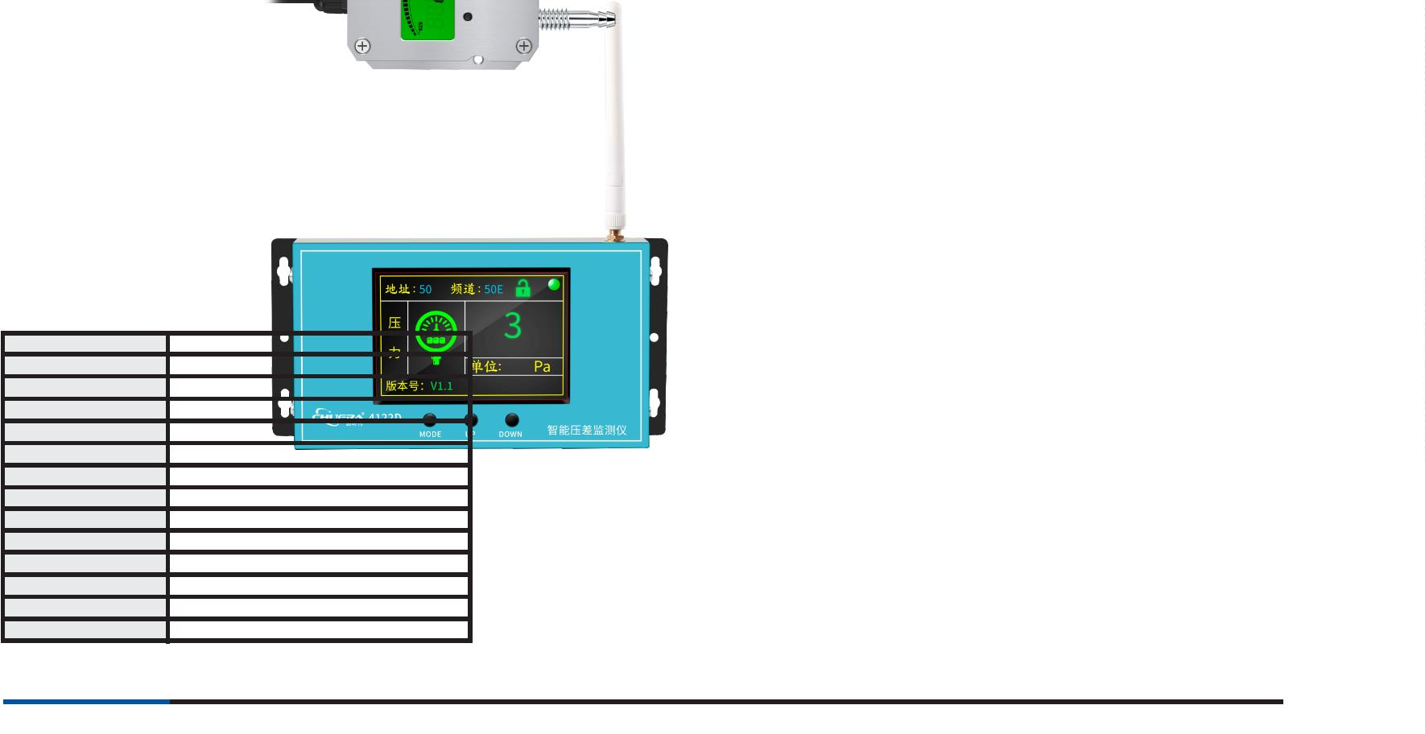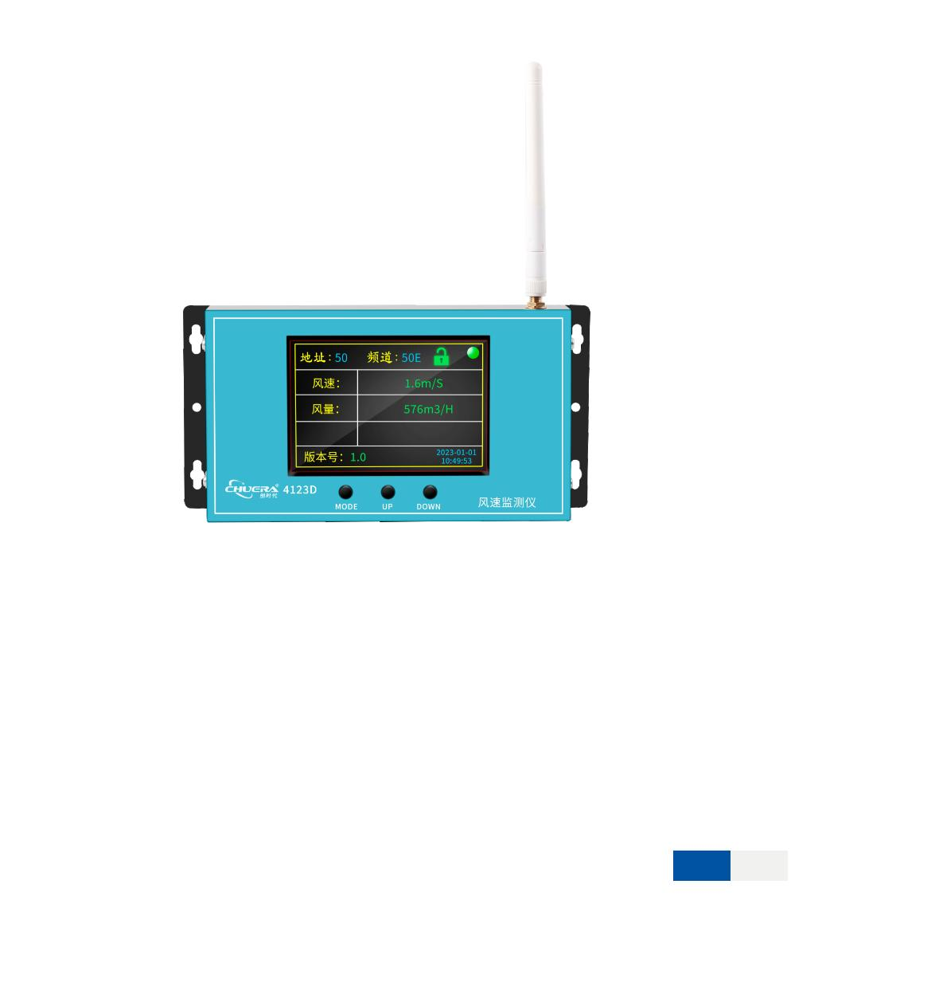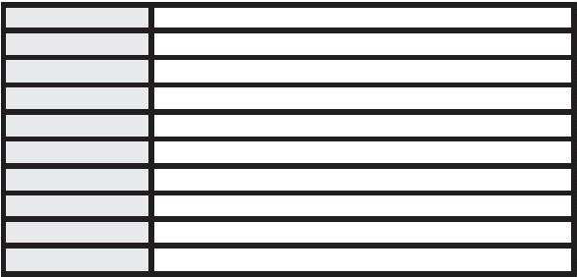

®
Anti-static electricity series
ESD environmental monitoring
digital management system
Real-time monitoring
Data analysis
Multi-level alarm
Automatic push
Electronic dot diagram
Communication docking
Authority management
Data traceability
Features:
ESD network monitoring system
Schematic diagram of ESD digital management and monitoring system networking
7
4

®
Anti-static electricity series
Comparative analysis interface display
Electronic map with statistical analysis
Electronic map mode
Dust particles/temperature and humidity curve graph
Historical data details
Historical data analysis

75
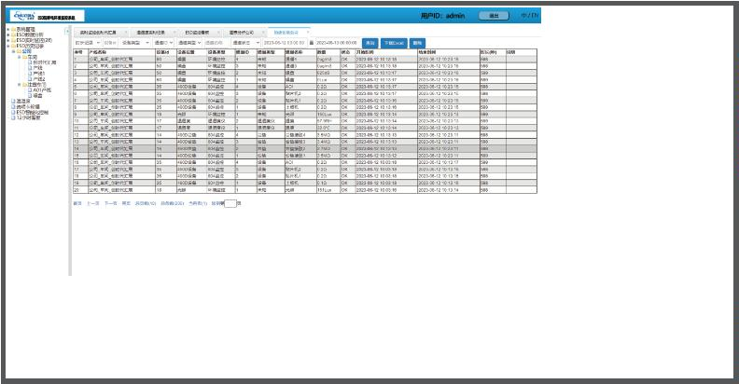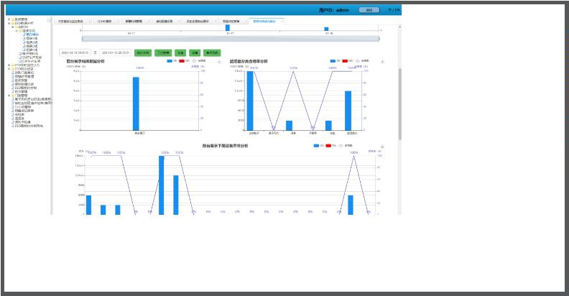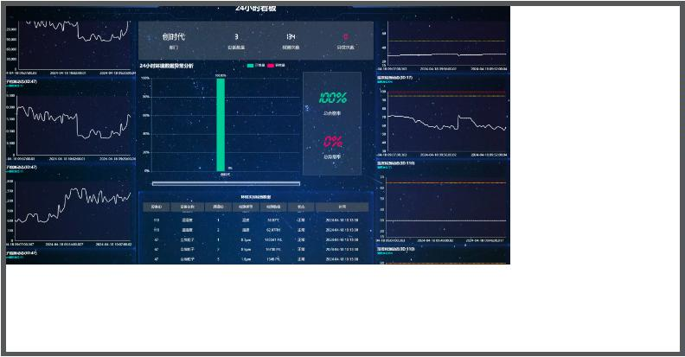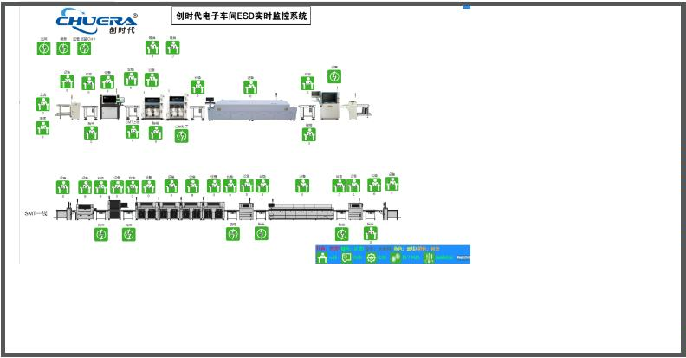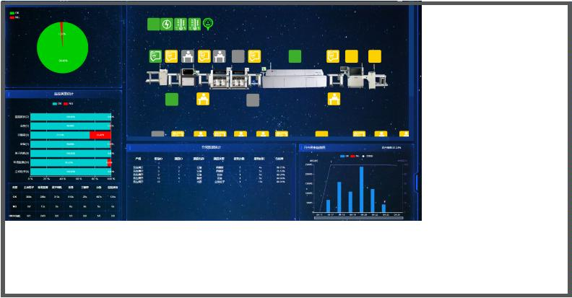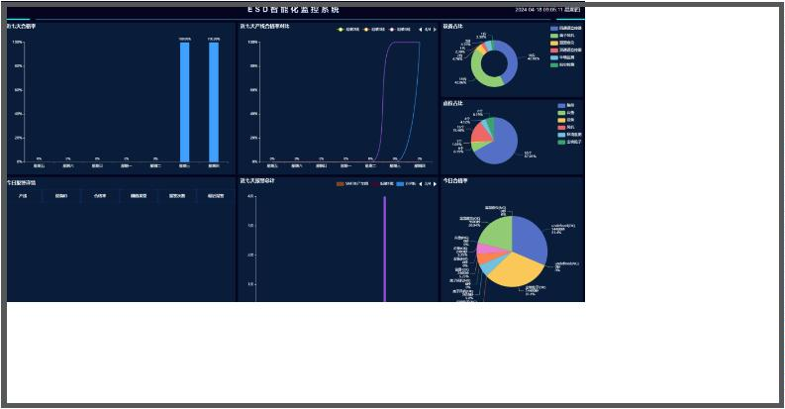

®
Anti-static electricity series
ESD access control system
Components of an ESD access control system
Gate door, electrostatic tester, dropout controller, foot pedal, personnel information collector, PC management
system, etc.
Function
ESD (electrostatic prevention) access control system is an access control system used to detect static electricity
before entering an electrostatic prevention work area. This system is an advanced product designed with the
combination of human static electricity comprehensive tester, dropout access control equipment and computerized
management software, which can be ensured that the preparation of personnel for proper protection against static
electricity has actually been done by the operators when entering the electrostatic protection area; And it is used as
the control equipment of the human ﬂow channel combined with the channel gate, and there is a variety of ways to
enter according to the card authority settings (hand test, shoe test, hand and shoe test, free test) The system can
provide an orderly and civilized way for people to pass in and out, eliminate illegal entry and exit, and in case of
emergency, quickly control the fall of the pole, and organize the evacuation of personnel.
Features:
※
※
High, low, and pass resistance values should be displayed on the test host;
The upper and lower limits of the test resistance of electrostatic shoes and wristbands can be adjusted
and easy to operate. A touch screen shall be employed to adjust the test resistance;
With fast testing speed, stable data, beautiful shape, using safe DC15V power supply and so on;
It supports ofﬂine work, channel gate, electric lock, air shower room series equipment can be
controlled separately;
※
※
※
※
It supports a variety of options such as swipe card, face recognition ﬁngerprint recognition SU;
It is equipped with a 7-inch touch screen, comes with system operation settings, in addition to support
the background PC system management; site electronic signage is available as an option for better
statistical display of personnel entry and exit information and statistical tables.
7
6

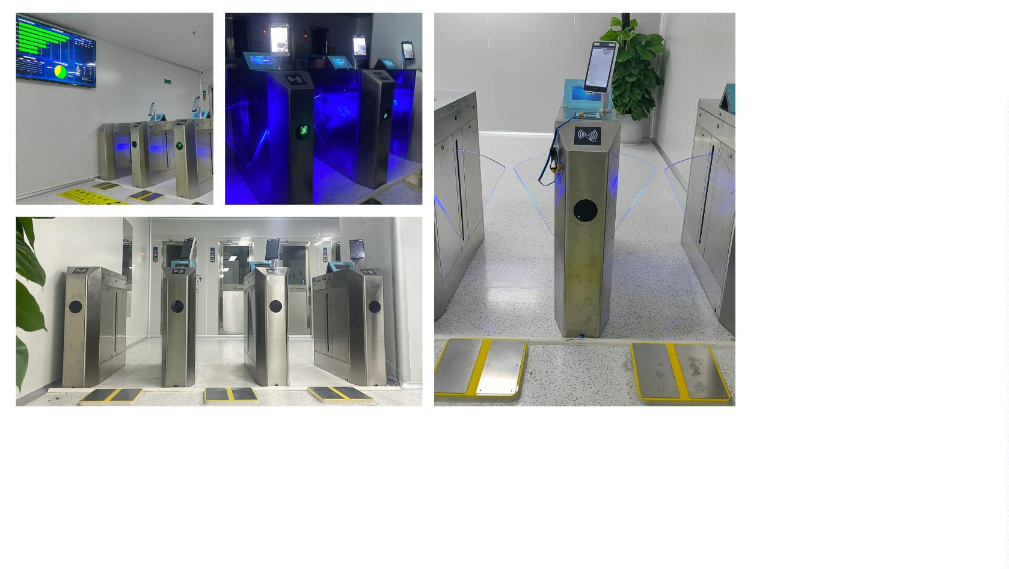

®
Anti-static electricity series
Specification
Wing gate
Tripod turnstile
Approx. 20-30 persons/minute
Recommendation 580
Outer frame chassis
Width of single channel
Occupied width of each group
Reference standards
Test range
Approx. 30 -40 persons/minute
Recommendation 580
About 1,180mm
About 1,180mm
ISO/CD8782-I ANSI/ESD-S20.20-2021
Wristband test range (0M-2,000M), ex-factory default 750K~35MQ
Test range
Shoe test range (0M-2,000M), ex-factory default 100K~100MQ
Measurement accuracy
Measurement accuracy
Wristband and shoe lower limit: 5%
Wristband and shoe upper limit: ±10%
-20℃~50℃
Operating temperature
Operating humidity
Material
1
0%~95% R.H
04 stainless steel case
3
Dimensions
Chassis size L1,200mm*W280mm*H980mm, other sizes can be customized.
TCP/IP, B/S architecture software web network query mode
E-mail push, online downloads and data analysis
Communication functions
Report function s
*
Wing gate size
*Dimensions of tripod turnstile

77
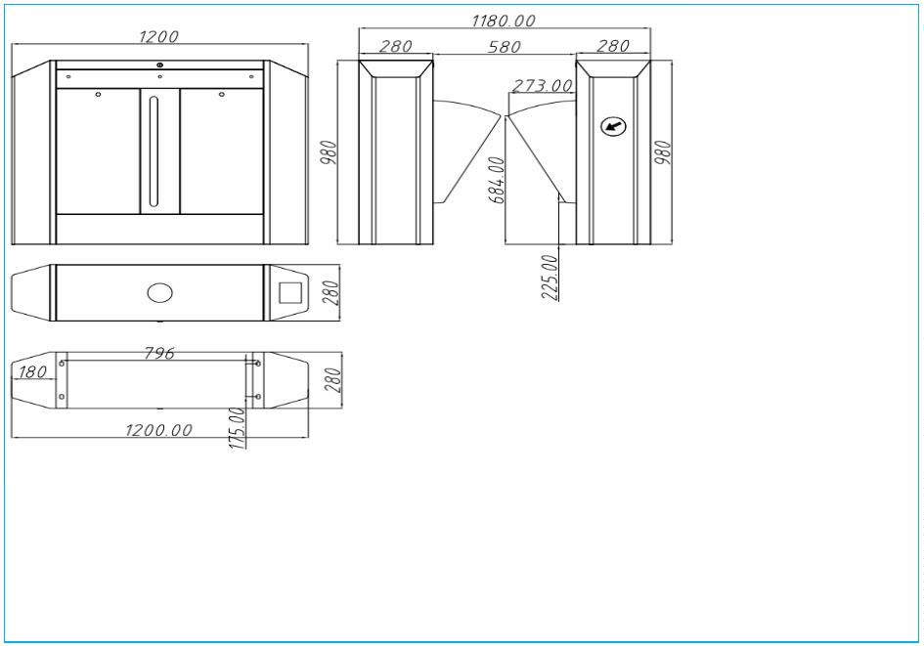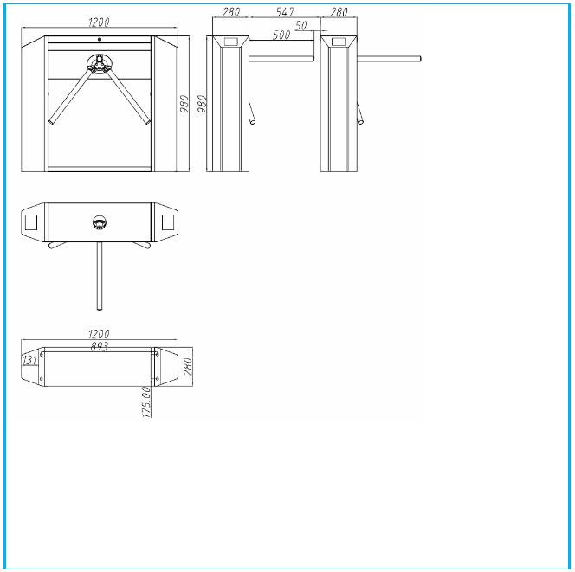

®
Anti-static electricity series
698A
Human body static electricity
comprehensive tester
Features:
※
※
※
※
※
Installation and operation are simple;
The integrated resistance has an alarm function when it is too high or too low;
There is an undercharge indication. When the BATTERY LOW light is on, it reminds the user to charge in time;
ESD equipment should be tested quickly, with three separate devices (left shoe, right shoe, and wristband) completing the ESD test at one time;
Three states: L. Red light (below the set value), PASS green pass (within the set value), HI red light (above the set value).
Speciﬁcation
Operating voltage
Instrument size
Pedal size
DC 9V/15V
96mm(L)*166mm(W)*40mm(H)
400mm(L)*300mm(W)*20mm(H)
±10%
Accuracy
Weight
About 6.5kg
Operating temperature 0℃-50℃
Operating humidity
Bracket adjustment
Activity distance
0%-90%RH
8
30-1430mm
Test Results:
Shoe setting
750KΩ-100MΩ
750KΩ-10MΩ
Red light（Fail Lo）
Wristband settings
≤
740KΩ
50KΩ
00MΩ
110MΩ
740KΩ
50KΩ
0.5MΩ
11.5MΩ
7
Green Light（Pass）
Shoe
1
Green Light（Pass）
Red light（Fail Hi）
Red light（Fail Lo）
Green Light（Pass）
Green Light（Pass）
Red light（Fail Hi）
≥
≤
7
Wristband
1
≥
4126A
Human body static electricity
comprehensive tester
Features:
※
The wristband test socket adopts a detachable design to facilitate later maintenance and replacement: high-performance integrated ARM
series microcontroller, new original imported chip;
Japanese NEC high-quality relay, higher switch life; card reading distance 3cm-6cm;
※
※
※
Supports automatic download and manual download of personnel data, and the network supports 10OM-1 000M speed.
The software adopts B/S architecture design, supports Windows 64-bit operating system or Linux 64-bit operating system, and can be
opened through a browser or mobile phone
Has certain scalability and supports third-party data access: such as MES/HR system, etc.;
Real-time display of test data, such as various test NG, card swiping, etc., with automatic data collection;
Authorization can be done in three ways: setting people for testers, setting testers for people, and setting permission groups by people,
whatever you want;
※
※
※
※
The system provides log records, and you can view operation and management history records to facilitate management tracking and
system maintenance:
The data provides import and export functions; it is convenient for customers to process;
The software automatically synchronizes time, and the personnel list is automatically synchronized to the ESD device to support multiple
report exports; unswiped card lists, test records are divided into left foot, right foot, wristband, etc.
※
※
※
Data update can be selected at will, with stable speed and free operation: the database can be connected with the attendance software to
support real-time management and monitoring of multiple users and multiple machines.
The simple style interface is friendly and the operation is smooth; the software design is perfect to meet various common needs.
※
Speciﬁcation
Operating voltage
DC 15V/1A
Operating temperature 20°C~50°C
Operating humidity
Traﬃc speed
Testing time
Weight
10%~95% R.H
>60 people/minute
<2S
15KG
Size
420x408x980mm
Measurement precision Lower limit for wrist straps and shoes: 5%
Upper limit for wrist straps and shoes: ±10%
Test range
Wristband test range (0M-2000M) factory 750K~35MQ
Shoe test range (0M-2000M) factory default 100K~100MQ
Reference standards
ISO/CD8782-1
7
8

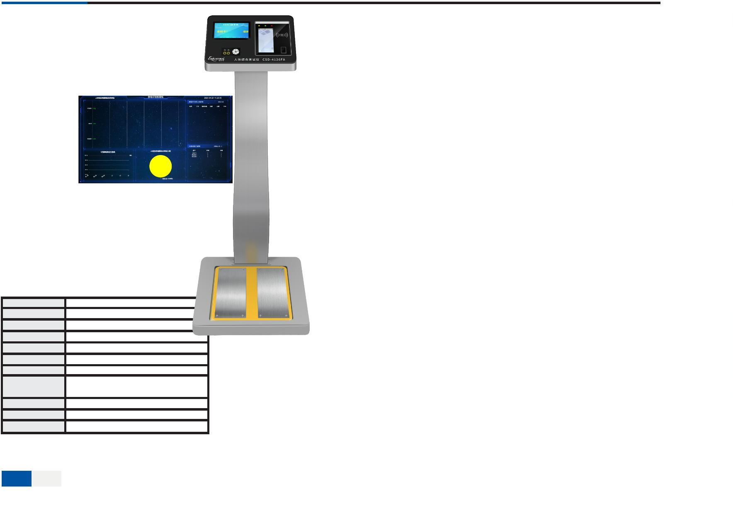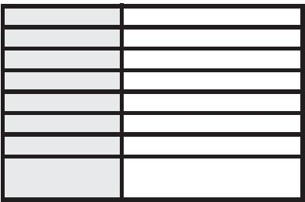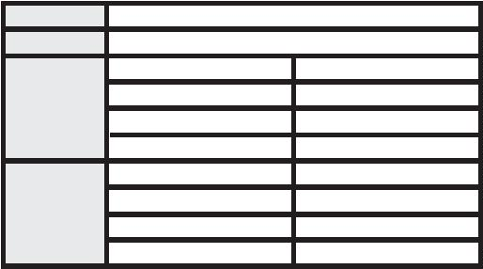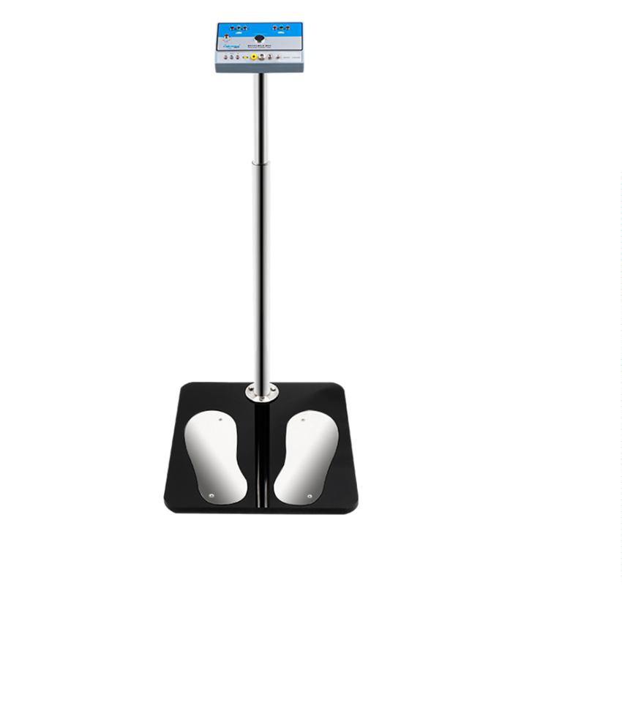

®
Anti-static electricity series
030B
Weight-loaded surface resistance tester
Features:
※
※
※
※
It has high measurement accuracy and is easy to operate;
The LOW BATTERY indicator flashes when the battery voltage is lower than 7.5V;
It has digital display of temperature and humidity;
It is a multifunctional tester that measures ambient temperature, humidity, and surface
resistance.
Speciﬁcation
Operating voltage
Instrument size
Test range
DC 9V
180mm(L)*95mm(W)*40mm(H)
103Ω-1012Ω
40 hours
±10%
Workload
Accuracy
Weight
About 7kg
Operating temperature 0℃-100℃
Operating humidity 0%-100%RH
003
ESD static ﬁeld tester
Features:
※
※
※
※
※
Easy to read and easy to operate
Light, compact design
Range light ensures accurate and repeatable measurements
Digital display and bar graph display.
LCD/level display detection data, test data retention, digital zero display, high/low range
automatically cuts off the power after 5 minutes.
Speciﬁcation
Operating voltage
Instrument size
Function
DC9V，6F22
123mm(L)*73mm(W)*25mm(H)
Eﬀectively detect electrostatic charges on ESD workplace equipment,
work surfaces, and tools
30 hours
Workload
Output
Red LCD shows positive charge, blue LCD shows negative charge
0~±200v (low range), plus or minus 0.01kv-24kv (high range)
Measuring range
Accuracy
±10%
Low range accuracy is: plus or minus 0.001kv;
high range accuracy is: plus or minus 1kv
About 0.17kg
Accuracy
Weight
Operating environment 0℃-50℃, 0-60% RH (non-condensing)
Standard ranging 25mm+/-1mm
Audible alarm Power on/automatically shut down when idle/out of measurable range
Automatic shut-down Idle for about 5 minutes
Lcd display not updating 5 times per second, reaction time: 1 second
Electrostatic ﬁelds can be
+/-(0.00-20.0kV)(Automatic display adjustment)
measured
Ion balance can be measured +/-(0-200V)

79
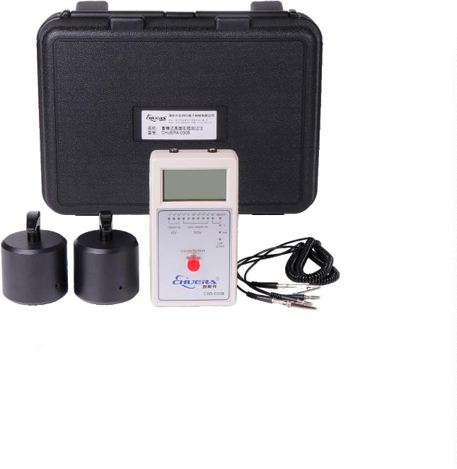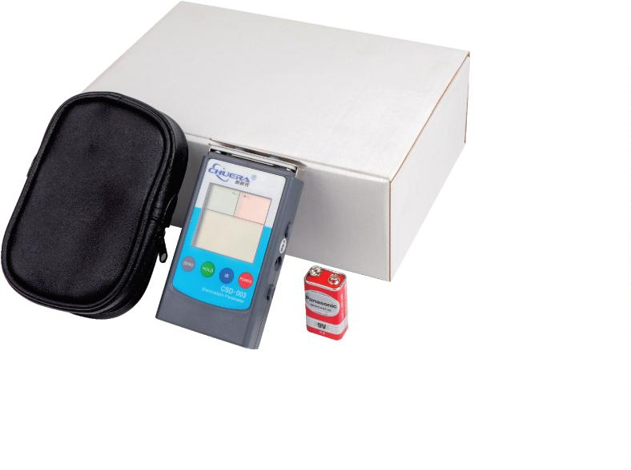

®
Anti-static electricity series
Electrostatic prevention wristband series
Dual circuit wrist strap
Dual circuit wrist strap
Single line wrist strap
Material: white yarn, white/black PU,
white/black PVC, etc.
Color: colorful blue, dark blue,
Material: silver yarn, PU thread
Colour: Black
Material: conductive yarn, PU thread
Color: blue
all black, etc. (can be customized)
Cordless metal wrist strap
Corded metal wrist strap
Dual circuit metal wrist strap
Color: natural color, blue, black, etc.
(can be customized)
Color: natural color, blue, black, etc.
(can be customized)
Color: natural color, blue, black, etc.
(can be customized)
Hamstring strap
Double safety hamstring strap
Static leather grounding buckle
Color: colorful blue, dark blue, all black, etc.
(can be customized)
Color: colorful blue, dark blue, all black, etc.
(can be customized)
Color: yellow, blue, black, etc.
(can be customized)
Sticky dust series
Anti-static desk mat
Table mat assembly
Surface resistance:10 ⁶~10Ω
9
Sticky mat
8
0

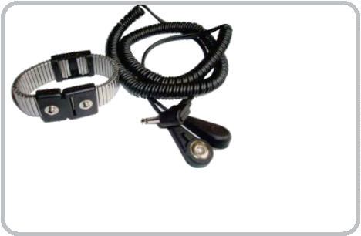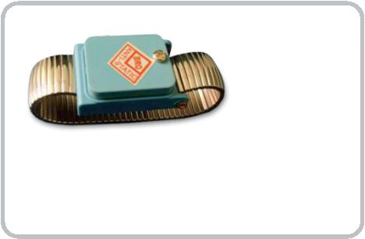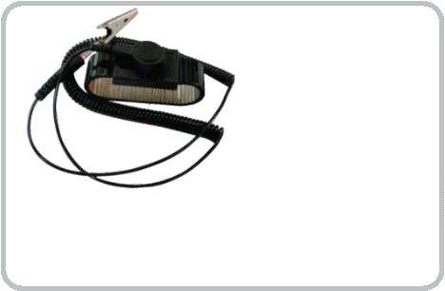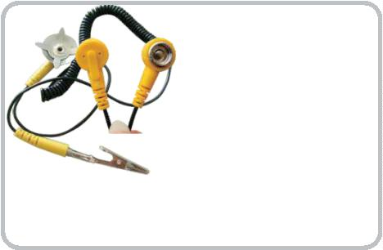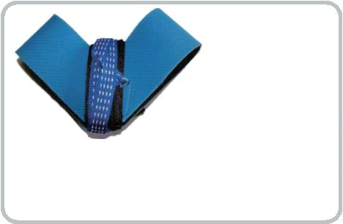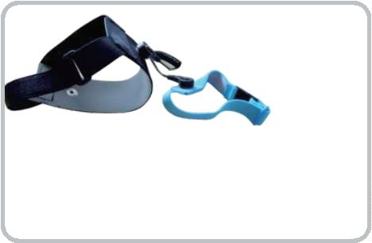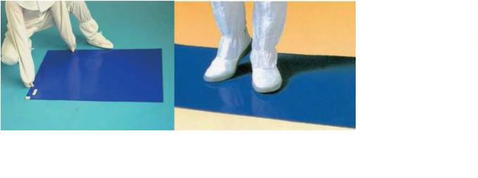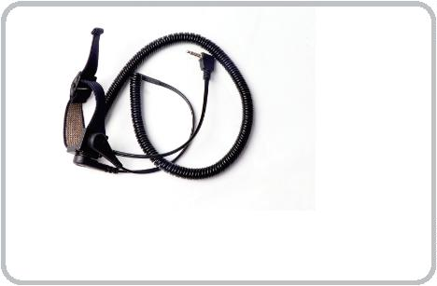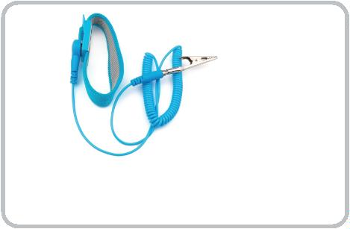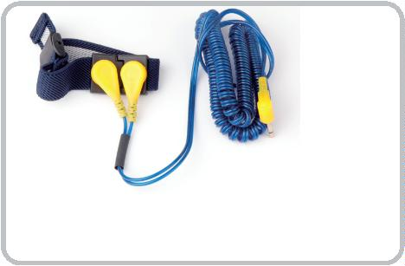

®
Anti-static electricity series
Anti-static tweezers series
High precision tweezers
ST non-magnetic super hard series
This series of products are used in electronics, watches, laboratories, high-tech and other fields
ST10 ST11 ST12 ST13 ST14 ST15 ST16 ST17
Anti-static ESD Tweezers
It can pass professional rigorous testing and is the best choice to replace professional brands such as Switzerland and Japan.
ESD10 长：110mm
宽：9mm
厚：2mm
ESD11 长：140mm
宽：7mm
厚：2mm
ESD12 长：135mm
宽：9mm
厚：2mm
ESD16 长：125mm
宽：11mm
厚：2mm
ESD13 长：120mm
宽：9mm
厚：2mm
ESD14 长：120mm
宽：9mm
厚：2mm
The surface of ESD series silver is made of special conductive plastic
material. It has good elasticity, is lightweight and can release static
electricity. It is suitable for the processing and installation of
electrostatic-sensitive components.
长：120mm
宽：9mm
厚：2mm
ESD15
ESD exchangeable head tweezers Product quality strictly follows Swiss famous brand standards.
Anti-static tweezers
ESD01 ﬂat head (standard)
ESD242
L：110+21mm
ESD250
L：110+21mm
ESD02 ﬂat head (strong)
ESD03 ﬂat head (specially made)
ESD242
L：110+23mm
ESD-250
L：103+12mm
ESD259
L：103+26mm
ESD249X
L：115+23mm
ESD04 round head
ESD05 pointed head
ESD06 right angle elbow
ESD259A
L：103+26mm
ESD7A
L：103+26mm
The head is made of a mixture of carbon ﬁber and special plastic. It has good elasticity, durability, no dust, acid and alkali resistance, and
high temperature resistance. It can avoid contamination of products due to carbon black in the anti-static mirror. It is suitable for precision
semiconductors, ICs, etc. Used in the production of electronic components.

81
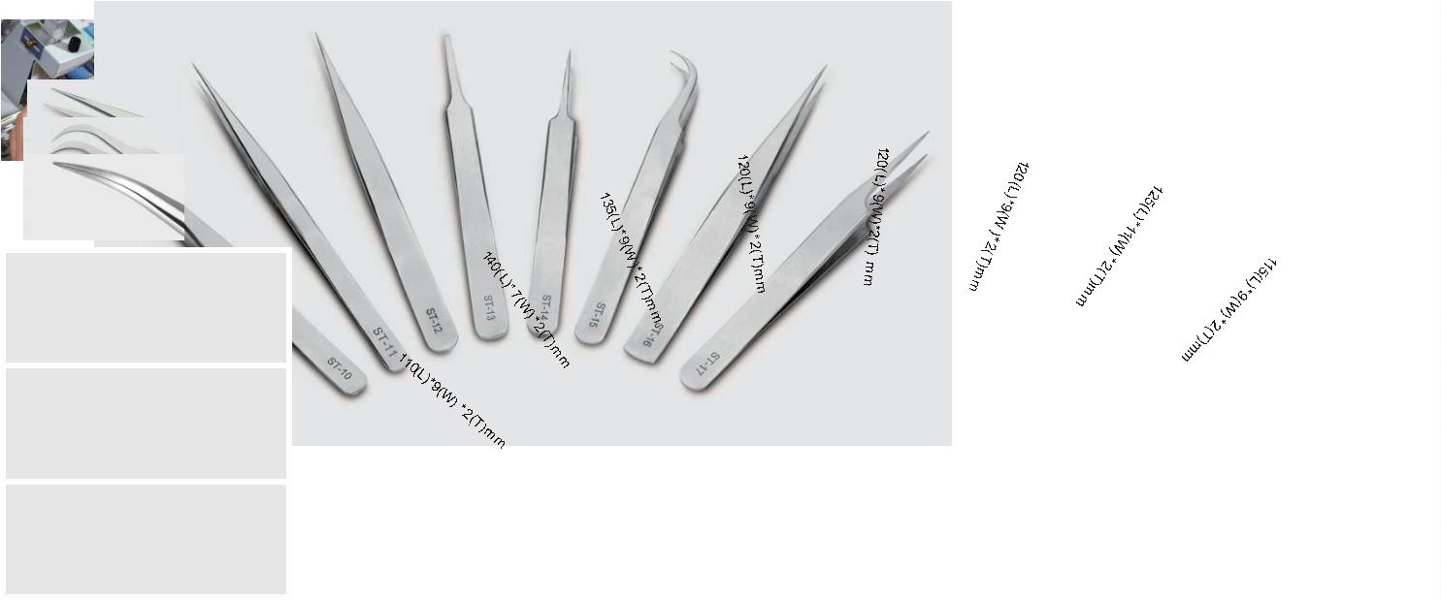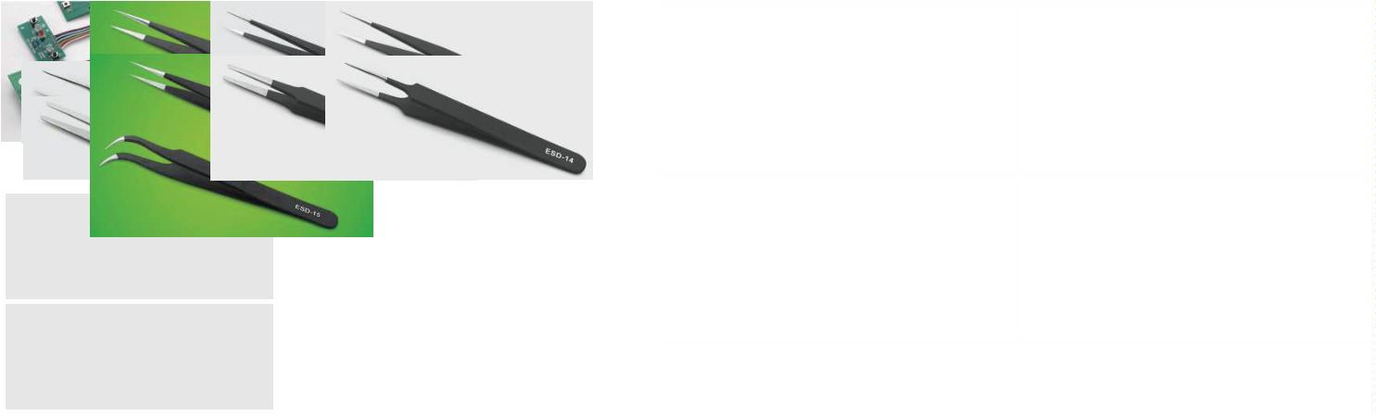

®
Anti-static electricity series
101
Electric screw driver
Features:
※
It is ergonomic, lightweight, short-proof, temperature-resistant, and has good operating
performance and smooth operation;
It comes with DC power controller and low voltage DC design;
It is highly stable and can work for a long time without being affected by voltage fluctuations;
It has adjustable torque, accurate and stable, no section adjustment, constant speed, fast
rotation speed, simple operation, time-saving and entertaining;
※
※
※
※
It is suitable for small appliances, toys, lamps, electronic assembly line work, household,
maintenance, etc.
Specification
Product number
Input voltage
Power
101
DC36V
36W
Idling speed
(r.p.m)
1100
Torque accuracy
±5%
Torque
Kgf.cm (N.m)
0.5-15（0.05-1.47）
Mechanical teeth 1.6-4.0
Self-tapping teeth 1.6-3.0
Applicable screw diameter
(mm)
Applicable batch
Weight
Φ5.0mm
450g
102
Electric screw driver
Features:
※
It is ergonomic, lightweight, short-proof, temperature-resistant, and has good operating
performance and smooth operation;
It comes with DC power controller and low voltage DC design;
It is highly stable and can work for a long time without being affected by voltage fluctuations;
It has adjustable torque, accurate and stable, no section adjustment, constant speed, fast
rotation speed, simple operation, time-saving and entertaining;
※
※
※
※
It is suitable for small appliances, toys, lamps, electronic assembly line work, household,
maintenance, etc.
Speciﬁcation
Product number
Input voltage
Power
102
DC36V
45W
Idling speed
(r.p.m)
1
100
Torque accuracy
±5%
Torque
Kgf.cm (N.m)
5-35（0.49-3.43）
Applicable screw diameter
(mm)
Mechanical teeth 2.6-5.0
Self-tapping teeth 2.6-4.0
Applicable batch
Weight
Φ6.35 (one-sixth)
520g
8
2

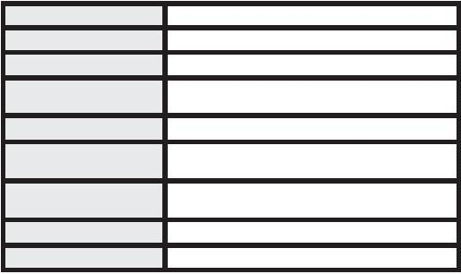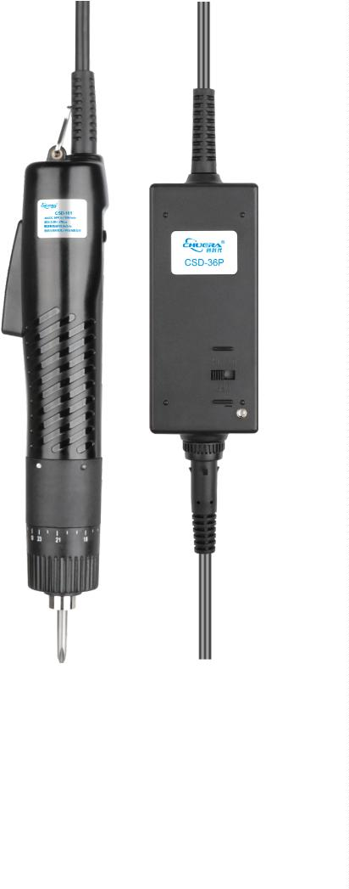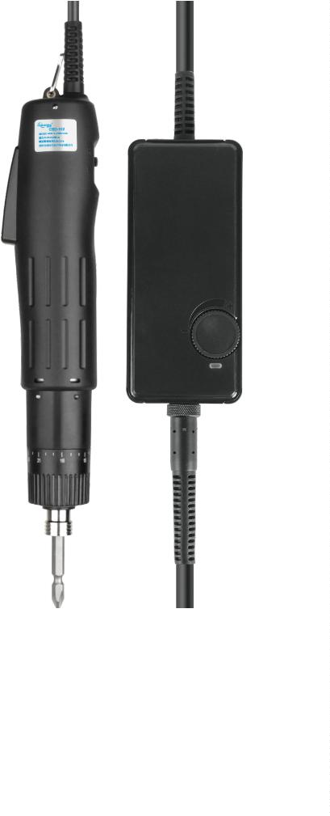

®
Tool series
CSD-4003LC/CSD-4007LC/CSD-4015LC/CSD-5015LC
Electric screw driver
※
Small size, light weight, low noise, streamlined appearance, high stability and simple
operation;
The screwdriver has two speeds to choose from: Hi/L. Has super lifespan and durability;
Stable torque output and automatic stop function for screw locking, suitable for assembling
various electronic products;
※
※
※
※
The torque is adjustable, accurate and stable, stepless adjustment, the speed remains
unchanged, and the rotation speed is fast;
Suitable for small household appliances, toys, lamps, electronic assembly line operations,
household use, maintenance, etc.
Speciﬁcation
Product model
Input voltage
CSD-4003LC
AC110V-240V
DC36V
CSD-4007LC
CSD-4015LC
CSD-5015LC
Power Adapter
Rated power
40W
No load speed
Torque Kgf.cm (N.m)
1400
0.03-0.29
0.05-0.69
0.15-1.47
0.15-1.47
Applicable screw diameter (mm) Mechanical tooth 1.0-2.3
Mechanical tooth 1.0-2.3
Mechanical tooth 1.0-2.3
Mechanical tooth 1.0-2.3
Self-tapping teeth 1.0-2.3 Self-tapping teeth 1.0-2.3 Self-tapping teeth 1.0-2.3 Self-tapping teeth 1.0-2.3
Weight
414g
397g
410g
Suitable screwdriver head
Applicable power adapter
Ø4
CSD-36P

83
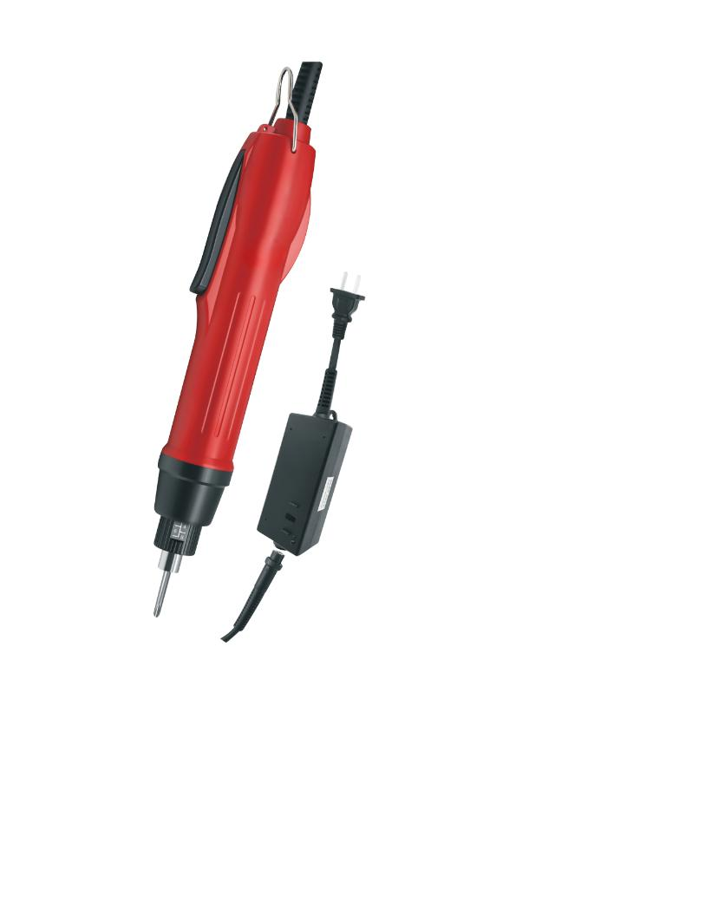

®
Tool series
CSD-B03L/CSD-B08L/CSD-B10L/CSD-B15L
Electric screw driver
※
※
※
※
※
It takes high-performance self-developed and manufactured brushless motor, with super life and durability motor, and no care
and maintenance is required;
It has compact size, light weight, low noise, streamlined appearance design, high stability, simple operation, because care and
maintenance is not necessary for the motor;
It has a brushless motor, more stable torque output, and it is suitable for locking and attaching screws under dust-free operation,
most suitable for the production of high-tech products without generating dust;
It has a stable torque output and is best used in the manufacture of watches, notebook computers, digital cameras, DVD players,
cellular phones, and high-tech precision products for communication instruments
The screwdriver has two speeds to choose from, Hi/L, (except for the fast model), the speed output is stable.
Specification
Product model
Input voltage
CSD-B03L
AC110V-240V
DC36V
CSD-B08L
CSD-B10L
CSD-B15L
Power Adapter
Rated power
30W
No load speed
Torque Kgf.cm (N.m)
1400
0.03-0.29
0.05-0.78
0.15-0.98
0.2-1.47
Applicable screw diameter (mm) Mechanical tooth 1.0-2.3
Mechanical tooth 1.4-2.6
Mechanical tooth 1.6-3.0
Mechanical tooth 2.3-3.5
Self-tapping teeth 1.0-2.0 Self-tapping teeth 1.4-2.3 Self-tapping teeth 1.6-2.6 Self-tapping teeth 2.3-3.0
Weight
459g
459g
459g
Suitable screwdriver head
Applicable power adapter
Ø4
CSD-36P-3
8
4

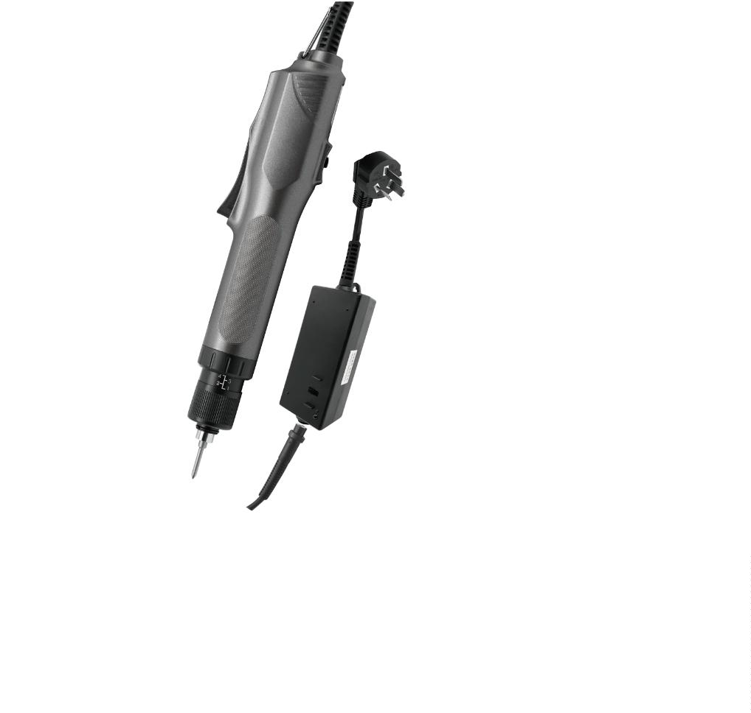

®
Tool series
CSD-1215E
Electric screw driver
※
Simple and beautiful appearance, straight wireless charging design, no wires tangled,
more convenient to use;
※
※
2600mAh large-capacity battery provides longer battery life without being heavy. ;
Suitable for general electronic products, lamps, and small household applications. Toys
and other general processing and assembly industries.
※
Semi-automatic clutch trip device, when the screw is locked, the clutch will automatically
slip and trip, and the screw will not be locked, so the user can use it with peace of mind.
Specification
Product model
CSD-1215E
Input voltage
AC110V-240V
Power Adapter
DC36V
Rated power
30W
No load speed
1100
Torque Kgf.cm (N.m)
Applicable screw diameter (mm)
0.05-1.47
Mechanical tooth1.6-4.0
Self-tapping teeth 1.6-3.0
Weight
474g
Suitable screwdriver head
Applicable power adapter
Ø5
2600(mAh)

85
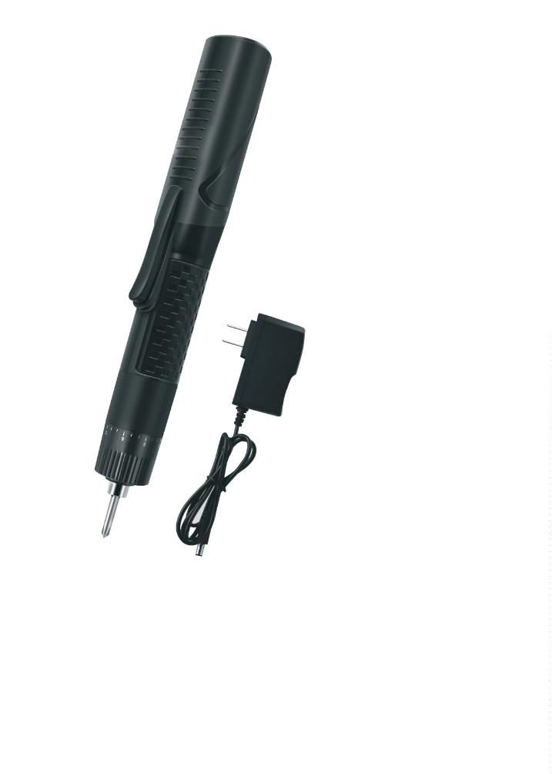

®
Tool series
615
Screw alignment machine
Product overview: 1. It is a machine that can be applied to a variety of
speciﬁcations screws (L0 1.2 1.4 1.7 2.0 2.3 2.6 3.0 3.5 4.0 5.0
adjustable), and it only needs to adjust the width of the track of the screw
machine, and the cost-eﬀective is higher; 2. It has no stuck screw
phenomenon; screws should be in the drum for movement drop bucket.
Any screws that do not enter the track are removed into the drum for the
next cycle; 3. The speed should be changed by adjusting the vibration
frequency, and the screws to the pickup point position will not aﬀect the
work eﬃciency due to back and forth jitter; 4. When the screw is removed,
for the screw head position, simply place the batch head into the batch
head guide, slide it down the guide, and pull the screw out toward the
front; 5. Feeding and loading drives should be controlled independently,
and the ideal delay stop time can be set freely. The fault alarm function
will be activated by the screwdriver when there is an abnormality such as
jammed screw or short circuit.
Features:
※
※
※
※
ML0-M5.0 screws are universally adjustable.
It does not require replacement of spare parts and can work continuously for 24 hours.
There is no screw jamming phenomenon in the work, and the quality is reliable.
The speed of screws is 60-180PCS/minute and the speed is adjustable.
Speciﬁcation
Suitable for screws Suitable for various types of screws, including screws with spacers (longest L=20mm)
Output speed
Input voltage
Product Size
Weight
60-180PCS/min, 2 capsules/S
DC power supply (input AC180-220V, output DC12V)
180x125x150mm
About 2.0Kg (net weight)
615C
Screw alignment machine
Product overview: 1. It is a machine that can be applied to a variety of
speciﬁcations screws (L0 1.2 1.4 1.7 2.0 2.3 2.6 3.0 3.5 4.0 5.0
adjustable), and it only needs to adjust the width of the track of the screw
machine, and the cost-eﬀective is higher; 2. It has no stuck screw
phenomenon; screws should be in the drum for movement drop bucket.
Any screws that do not enter the track are removed into the drum for the
next cycle; 3. The speed should be changed by adjusting the vibration
frequency, and the screws to the pickup point position will not aﬀect the
work eﬃciency due to back and forth jitter; 4. When the screw is removed,
for the screw head position, simply place the batch head into the batch
head guide, slide it down the guide, and pull the screw out toward the
front; 5. Feeding and loading drives should be controlled independently,
and the ideal delay stop time can be set freely. The fault alarm function
will be activated by the screwdriver when there is an abnormality such as
jammed screw or short circuit.
Features:
※
Screw machine counting function: 0-9999 can be set arbitrarily, and the machine will
stop and alarm when the measurement is reached.
※
※
※
※
※
※
The digital display can show the total number of screws used;
M1.0-M5.0 screws are universally adjustable;
No need to replace spare parts and can work continuously for 24 hours;
No stuck screws in operation, reliable quality;
The screw output speed is 60-180 PCS/minute, and the speed is adjustable;
It will automatically alarm when there is a fault.
Speciﬁcation
Suitable for screws Suitable for various types of screws, including screws with spacers (longest L=20mm)
Output speed
Input voltage
Product Size
Weight
60-180PCS/min, 2 capsules/S
DC power supply (input AC180-220V, output DC12V)
180x125x150mm
About 2.0Kg (net weight)
8
6

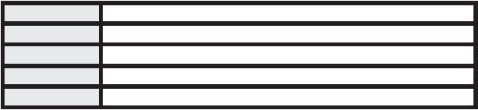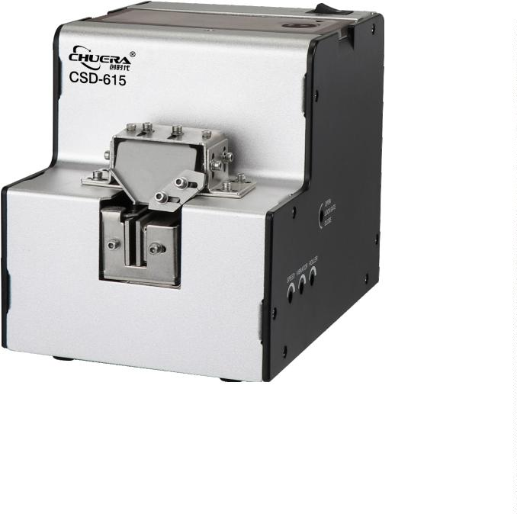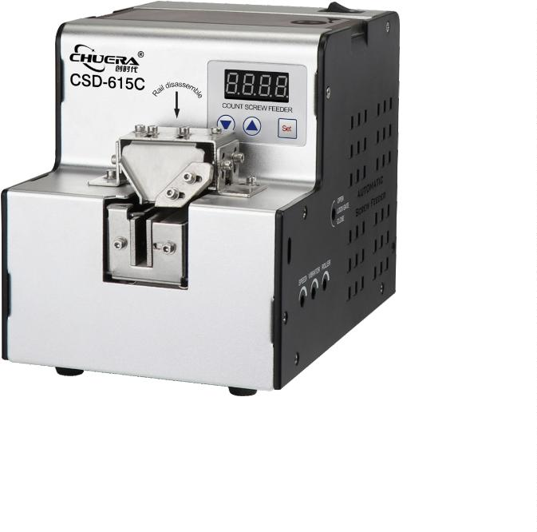

®
Tool series
CSD 1201/1202/1203/1204
Lead-free round tin oven
※
※
※
※
※
※
※
It has a small soldering area and is suitable for tinning of wires and other wires;
Its control part adopts microcomputer chip control, and the temperature is accurate with small fluctuations;
It has a sleep function that extends the life of the heater and the tin pan;
Tin pans are made of imported pure titanium metal, with high temperature resistance and corrosion resistance;
It has a fault indication function, so that the operator can find the fault in time;
It has a key lock function to prevent the set temperature from being adjusted by mistake;
It adopts closed light touch switch, which is easy to operate.
Stainless steel tray
Melting tin pot
Power switch
Set temperature
Actual temperature in the pot
Indicator light
Insurance tube
Button
Specification
Model
Rated power Temperature range Amount of molten tin Appearance dimensions(mm)
Tin pot size (mm)
Ф38x40
CSD 1201
CSD 1202
CSD 1203
CSD 1204
180W
250W
400W
500W
0~600℃
0~600℃
0~600℃
0~600℃
0.3kg
0.6kg
1.5kg
2.0kg
266(L)x145(W)x120(H)
266(L)x145(W)x120(H)
327(L)x175(W)x120(H)
327(L)x175(W)x120(H)
Ф50x40
Ф80x40
Ф100x40

87
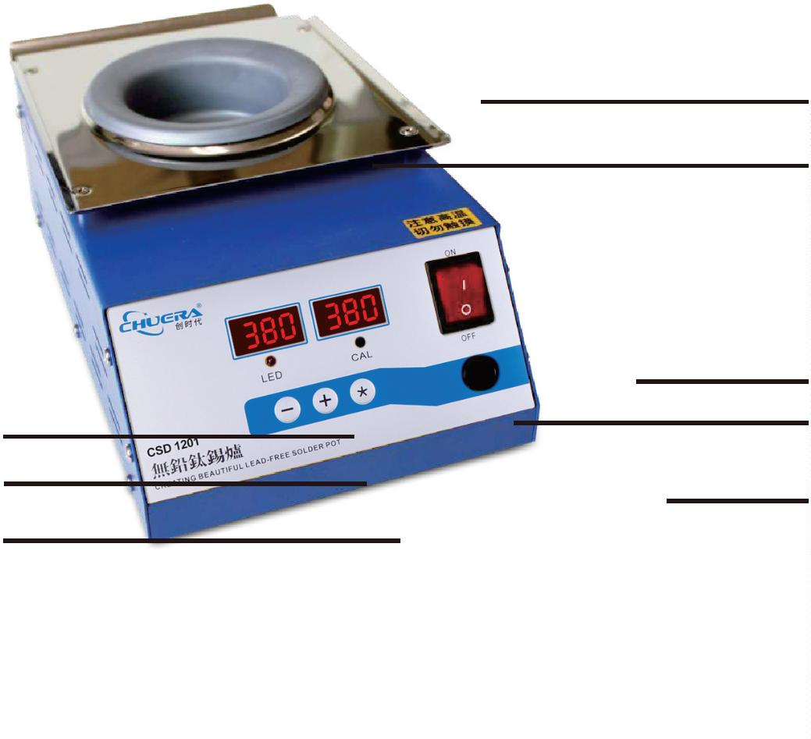

®
Tool series
CSD 1205/1206/1207/1208
Lead-free square tin furnace
※
※
※
※
※
※
※
It has a small soldering area and is suitable for tinning of wires and other wires;
Its control part adopts microcomputer chip control, and the temperature is accurate with small fluctuations;
It has a sleep function that extends the life of the heater and the tin pan;
Tin pans are made of imported pure titanium metal, with high temperature resistance and corrosion resistance;
It has a fault indication function, so that the operator can find the fault in time;
It has a key lock function to prevent the set temperature from being adjusted by mistake;
It adopts closed light touch switch, which is easy to operate.
Stainless steel tray
Melting tin pot
Power switch
Set temperature
Actual temperature in the pot
Indicator light
Insurance tube
Button
Specification
Model
Rated power
Temperature range Amount of molten tin Appearance dimensions(mm)
Tin pot size (mm)
55x55x45
CSD 1205
CSD 1206
CSD 1207
CSD 1208
250W
500W
600W
800W
0~600℃
0~600℃
0~600℃
0~600℃
1.32kg
2.3kg
2.7kg
3.2kg
266(L)x145(W)x115(H)
327(L)x175(W)x115(H)
327(L)x175(W)x115(H)
327(L)x175(W)x115(H)
100x70x45
100x80x45
100x100x45
8
8

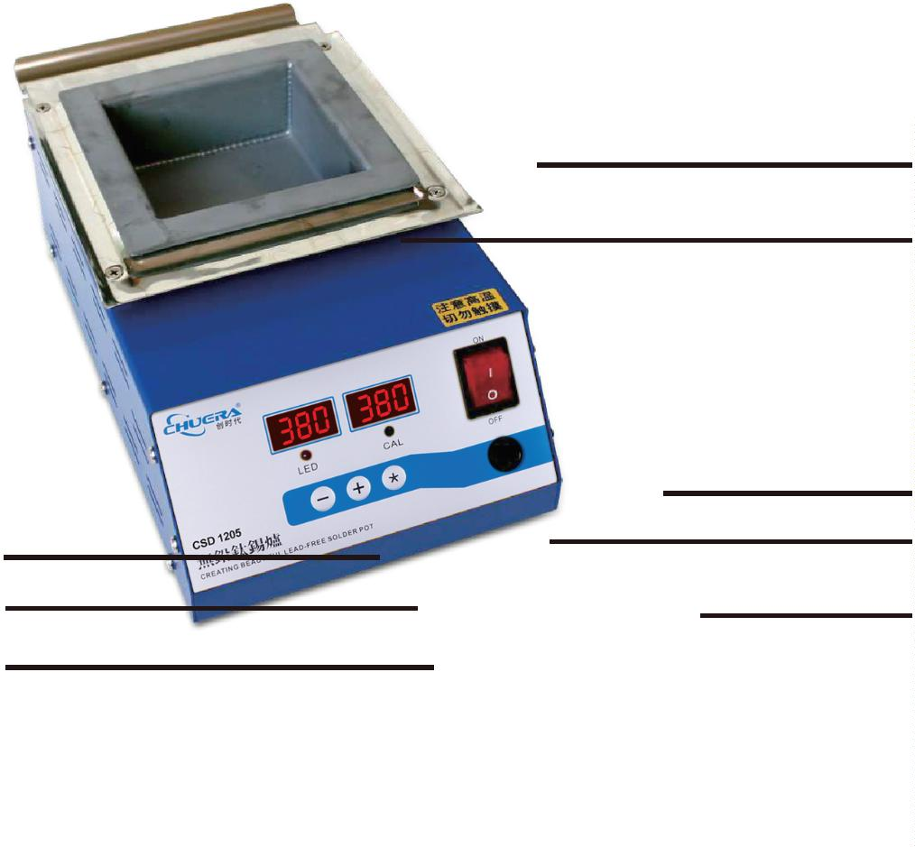

®
Tool series
CSD 1230/1231/1232/1233/1234/1235
Lead-free split desktop tin oven
※
※
※
※
※
※
※
※
※
It has a small soldering area and is suitable for tinning of wires and other wires;
It has a large soldering area and is suitable for the tinning of small and medium-sized circuit boards;
It has high power, fast temperature rise, and rapid temperature compensation, and is suitable for lead-free counterpart soldering;
Tin pans are made of 2mm imported pure titanium metal, with high temperature resistance and corrosion resistance;
It has a sleep standby function that extends the life of the heater and the tin pan;
It has a fault indication function;
It has a key lock function to prevent the set temperature from being adjusted by mistake;
It adopts closed light touch switch, which is easy to operate;
Its control part adopts microcomputer chip control, and the temperature is accurate with small ﬂuctuations.
Melting tin pot
Stainless steel tray
Actual temperature in the pot
Power switch
Set temperature
Indicator light
Insurance tube
Button
Specification
Model
Rated power Temperature range Amount of molten tin Appearance dimensions(mm)
Tin pot size (mm)
200x80x45
CSD1230
CSD1231
CSD1232
CSD1233
CSD1234
CSD1235
900W
0~600℃
0~600℃
0~600℃
0~600℃
0~600℃
0~600℃
5.2kg
6.3kg
7.9kg
6.5kg
8.2kg
9.8kg
300(L)x123(W)x120(H)
350(L)x123(W)x120(H)
400(L)x123(W)x120(H)
300(L)x143(W)x120(H)
350(L)x143(W)x120(H)
400(L)x143(W)x120(H)
1200W
1500W
900W
250x80x45
300x80x45
200x100x45
250x100x45
300x100x45
1000W
1500W

89
